






Build and maintain a team approach to service delivery
D2.TCS.CL5.03
Trainer Guide

Build and maintain a team approach to service delivery
D2.TCS.CL5.03
Trainer Guide





Project Base
William Angliss Institute of TAFE
555 La Trobe Street
Melbourne 3000 Victoria
Telephone: | (03) 9606 2111
Facsimile: | (03) 9670 1330
Acknowledgements
Project Director: | Wayne Crosbie
Project Manager | Jim Irwin
Chief Writer: | Alan Hickman
Subject Writer: | Quentin Derrick
Editor: | Jim Irwin
DTP/Production: | Daniel Chee, Mai Vu, Cindy Curran

The Association of Southeast Asian Nations (ASEAN) was established on 8 August 1967. The Member States of the Association are Brunei Darussalam, Cambodia, Indonesia, Lao PDR, Malaysia, Myanmar, Philippines, Singapore, Thailand and Viet Nam.
The ASEAN Secretariat is based in Jakarta, Indonesia.
General Information on ASEAN appears online at the ASEAN Website: www.asean.org.
All text is produced by William Angliss Institute of TAFE for the ASEAN Project on “Toolbox Development for Tourism Labour Divisions for Travel Agencies and Tour Operations”.
This publication is supported by the Australian Government’s aid program through the ASEAN-Australia Development Cooperation Program Phase II (AADCP II).
Copyright: Association of Southeast Asian Nations (ASEAN) 2015.
All rights reserved.
Disclaimer
Every effort has been made to ensure that this publication is free from errors or omissions. However, you should conduct your own enquiries and seek professional advice before relying on any fact, statement or matter contained in this book. The ASEAN Secretariat and William Angliss Institute of TAFE are not responsible for any injury, loss or damage as a result of material included or omitted from this course. Information in this module is current at the time of publication. Time of publication is indicated in the date stamp at the bottom of each page.
Some images appearing in this resource have been purchased from stock photography suppliers Shutterstock and iStockphoto and other third party copyright owners and as such are non-transferable and non-exclusive. Clip arts, font images and illustrations used are from the Microsoft Office Clip Art and Media Library. Some images have been provided by and are the property of William Angliss Institute.
Additional images have been sourced from Flickr and SXC and are used under Creative Commons licence: http://creativecommons.org/licenses/by/2.0/deed.en
File name: TG_Build_maintain_a_team_approach_to_service_delivery_270115





Table of contents
Competency Based Training (CBT) and assessment – An introduction for trainers 1
Competency standard 11
Notes and PowerPoint slides 23
Recommended training equipment 111
Instructions for Trainers for using PowerPoint – Presenter View 113
Appendix – ASEAN acronyms 115

Competency Based Training (CBT) and assessment – An introduction for trainers

Competency
Competency refers to the ability to perform particular tasks and duties to the standard of performance expected in the workplace.
Competency requires the application of specified knowledge, skills and attitudes relevant to effective participation, consistently over time and in the workplace environment.
The essential skills and knowledge are either identified separately or combined.
Knowledge identifies what a person needs to know to perform the work in an informed and effective manner.
Skills describe the application of knowledge to situations where understanding is converted into a workplace outcome.
Attitude describes the founding reasons behind the need for certain knowledge or why skills are performed in a specified manner.
Competency covers all aspects of workplace performance and involves:
- Performing individual tasks
- Managing a range of different tasks
- Responding to contingencies or breakdowns
- Dealing with the responsibilities of the workplace
- Working with others.

Unit of competency
Like with any training qualification or program, a range of subject topics are identified that focus on the ability in a certain work area, responsibility or function.
Each manual focuses on a specific unit of competency that applies in the hospitality workplace.
In this manual a unit of competency is identified as a ‘unit’.
Each unit of competency identifies a discrete workplace requirement and includes:
- Knowledge and skills that underpin competency
- Language, literacy and numeracy
- Occupational safety and health requirements.
Each unit of competency must be adhered to in training and assessment to ensure consistency of outcomes.

Element of competency
An element of competency describes the essential outcomes within a unit of competency.
The elements of competency are the basic building blocks of the unit of competency. They describe in terms of outcomes the significant functions and tasks that make up the competency.
In this manual elements of competency are identified as an ‘element’.

Performance criteria
Performance criteria indicate the standard of performance that is required to demonstrate achievement within an element of competency. The standards reflect identified industry skill needs.
Performance criteria will be made up of certain specified skills, knowledge and attitudes.

Learning
For the purpose of this manual learning incorporates two key activities:
- Training
- Assessment.
Both of these activities will be discussed in detail in this introduction.
Today training and assessment can be delivered in a variety of ways. It may be provided to participants:
- On-the-job – in the workplace
- Off-the-job – at an educational institution or dedicated training environment
- As a combination of these two options.
No longer is it necessary for learners to be absent from the workplace for long periods of time in order to obtain recognised and accredited qualifications.

Learning approaches
This manual will identify two avenues to facilitate learning:
Competency Based Training (CBT)
This is the strategy of developing a participant’s competency.
Educational institutions utilise a range of training strategies to ensure that participants are able to gain the knowledge and skills required for successful:
- Completion of the training program or qualification
- Implementation in the workplace.
The strategies selected should be chosen based on suitability and the learning styles of participants.

Competency Based Assessment (CBA)
This is the strategy of assessing competency of a participant.
Educational institutions utilise a range of assessment strategies to ensure that participants are assessed in a manner that demonstrates validity, fairness, reliability, flexibility and fairness of assessment processes.

Flexibility in learning
It is important to note that flexibility in training and assessment strategies is required to meet the needs of participants who may have learning difficulties. The strategies used will vary, taking into account the needs of individual participants with learning difficulties. However they will be applied in a manner which does not discriminate against the participant or the participant body as a whole.
Catering for participant diversity
Participants have diverse backgrounds, needs and interests. When planning training and assessment activities to cater for individual differences, trainers and assessors should:
- Consider individuals’ experiences, learning styles and interests
- Develop questions and activities that are aimed at different levels of ability
- Modify the expectations for some participants
- Provide opportunities for a variety of forms of participation, such as individual, pair and small group activities
- Assess participants based on individual progress and outcomes.
The diversity among participants also provides a good reason for building up a learning community in which participants support each other’s learning.
Participant centred learning
This involves taking into account structuring training and assessment that:
- Builds on strengths – Training environments need to demonstrate the many positive features of local participants (such as the attribution of academic success to effort, and the social nature of achievement motivation) and of their trainers (such as a strong emphasis on subject disciplines and moral responsibility). These strengths and uniqueness of local participants and trainers should be acknowledged and treasured
- Acknowledges prior knowledge and experience – The learning activities should be planned with participants’ prior knowledge and experience in mind
- Understands learning objectives – Each learning activity should have clear learning objectives and participants should be informed of them at the outset. Trainers should also be clear about the purpose of assignments and explain their significance to participants
- Teaches for understanding – The pedagogies chosen should aim at enabling participants to act and think flexibly with what they know
- Teaches for independent learning – Generic skills and reflection should be nurtured through learning activities in appropriate contexts of the curriculum. Participants should be encouraged to take responsibility for their own learning
- Enhances motivation – Learning is most effective when participants are motivated. Various strategies should be used to arouse the interest of participants
- Makes effective use of resources – A variety of teaching resources can be employed as tools for learning
- Maximises engagement – In conducting learning activities, it is important for the minds of participants to be actively engaged
- Aligns assessment with learning and teaching – Feedback and assessment should be an integral part of learning and teaching
- Caters for learner diversity – Trainers should be aware that participants have different characteristics and strengths and try to nurture these rather than impose a standard set of expectations.
Active learning
The goal of nurturing independent learning in participants does not imply that they always have to work in isolation or solely in a classroom. On the contrary, the construction of knowledge in tourism and hospitality studies can often best be carried out in collaboration with others in the field. Sharing experiences, insights and views on issues of common concern, and working together to collect information through conducting investigative studies in the field (active learning) can contribute a lot to their eventual success.
Active learning has an important part to play in fostering a sense of community in the class. First, to operate successfully, a learning community requires an ethos of acceptance and a sense of trust among participants, and between them and their trainers. Trainers can help to foster acceptance and trust through encouragement and personal example, and by allowing participants to take risks as they explore and articulate their views, however immature these may appear to be. Participants also come to realise that their classmates (and their trainers) are partners in learning and solving.
Trainers can also encourage cooperative learning by designing appropriate group learning tasks, which include, for example, collecting background information, conducting small-scale surveys, or producing media presentations on certain issues and themes. Participants need to be reminded that, while they should work towards successful completion of the field tasks, developing positive peer relationships in the process is an important objective of all group work.

Competency Based Training (CBT)
Principle of Competency Based Training
Competency based training is aimed at developing the knowledge, skills and attitudes of participants, through a variety of training tools.
Training strategies
The aims of this curriculum are to enable participants to:
- Undertake a variety of subject courses that are relevant to industry in the current environment
- Learn current industry skills, information and trends relevant to industry
- Learn through a range of practical and theoretical approaches
- Be able to identify, explore and solve issues in a productive manner
- Be able to become confident, equipped and flexible managers of the future
- Be ‘job ready’ and a valuable employee in the industry upon graduation of any qualification level.
To ensure participants are able to gain the knowledge and skills required to meet competency in each unit of competency in the qualification, a range of training delivery modes are used.
Types of training
In choosing learning and teaching strategies, trainers should take into account the practical, complex and multi-disciplinary nature of the subject area, as well as their participant’s prior knowledge, learning styles and abilities.
Training outcomes can be attained by utilising one or more delivery methods:
Lecture/tutorial
This is a common method of training involving transfer of information from the trainer to the participants. It is an effective approach to introduce new concepts or information to the learners and also to build upon the existing knowledge. The listener is expected to reflect on the subject and seek clarifications on the doubts.
Demonstration
Demonstration is a very effective training method that involves a trainer showing a participant how to perform a task or activity. Through a visual demonstration, trainers may also explain reasoning behind certain actions or provide supplementary information to help facilitate understanding.
Group discussions
Brainstorming in which all the members in a group express their ideas, views and opinions on a given topic, is a free flow and exchange of knowledge among the participants and the trainer. The discussion is carried out by the group on the basis of their own experience, perceptions and values. This will facilitate acquiring new knowledge. When everybody is expected to participate in the group discussion, even the introverted persons will also get stimulated and try to articulate their feelings.
The ideas that emerge in the discussions should be noted down and presentations are to be made by the groups. Sometimes consensus needs to be arrived at on a given topic. Group discussions are to be held under the moderation of a leader guided by the trainer. Group discussion technique triggers thinking process, encourages interactions and enhances communication skills.
Role play
This is a common and very effective method of bringing into the classroom real life situations, which may not otherwise be possible. Participants are made to enact a particular role so as to give a real feel of the roles they may be called upon to play. This enables participants to understand the behaviour of others as well as their own emotions and feelings. The instructor must brief the role players on what is expected of them. The role player may either be given a ready-made script, which they can memorise and enact, or they may be required to develop their own scripts around a given situation. This technique is extremely useful in understanding creative selling techniques and human relations. It can be entertaining and energising and it helps the reserved and less literate to express their feelings.

Simulation games
When trainees need to become aware of something that they have not been conscious of, simulations can be a useful mechanism. Simulation games are a method based on "here and now" experience shared by all the participants. The games focus on the participation of the trainees and their willingness to share their ideas with others. A "near real life" situation is created providing an opportunity to which they apply themselves by adopting certain behaviour. They then experience the impact of their behaviour on the situation. It is carried out to generate responses and reactions based on the real feelings of the participants, which are subsequently analysed by the trainer.
While use of simulation games can result in very effective learning, it needs considerable trainer competence to analyse the situations.
Individual /group exercises
Exercises are often introduced to find out how much the participant has assimilated. This method involves imparting instructions to participants on a particular subject through use of written exercises. In the group exercises, the entire class is divided into small groups, and members are asked to collaborate to arrive at a consensus or solution to a problem.
Case study
This is a training method that enables the trainer and the participant to experience a real life situation. It may be on account of events in the past or situations in the present, in which there may be one or more problems to be solved and decisions to be taken. The basic objective of a case study is to help participants diagnose, analyse and/or solve a particular problem and to make them internalise the critical inputs delivered in the training. Questions are generally given at the end of the case study to direct the participants and to stimulate their thinking towards possible solutions. Studies may be presented in written or verbal form.
Field visit
This involves a carefully planned visit or tour to a place of learning or interest. The idea is to give first-hand knowledge by personal observation of field situations, and to relate theory with practice. The emphasis is on observing, exploring, asking questions and understanding. The trainer should remember to brief the participants about what they should observe and about the customs and norms that need to be respected.
Group presentation
The participants are asked to work in groups and produce the results and findings of their group work to the members of another sub-group. By this method participants get a good picture of each other's views and perceptions on the topic and they are able to compare them with their own point of view. The pooling and sharing of findings enriches the discussion and learning process.
Practice sessions
This method is of paramount importance for skills training. Participants are provided with an opportunity to practice in a controlled situation what they have learnt. It could be real life or through a make-believe situation.

Games
This is a group process and includes those methods that involve usually fun-based activity, aimed at conveying feelings and experiences, which are everyday in nature, and applying them within the game being played. A game has set rules and regulations, and may or may not include a competitive element. After the game is played, it is essential that the participants be debriefed and their lessons and experiences consolidated by the trainer.
Research
Trainers may require learners to undertake research activities, including online research, to gather information or further understanding about a specific subject area.

Competency Based Assessment (CBA)
Principle of Competency Based Assessment
Competency based assessment is aimed at compiling a list of evidence that shows that a person is competent in a particular unit of competency.
Competencies are gained through a multitude of ways including:
- Training and development programs
- Formal education
- Life experience
- Apprenticeships
- On-the-job experience
- Self-help programs.
All of these together contribute to job competence in a person. Ultimately, assessors and participants work together, through the ‘collection of evidence’ in determining overall competence.
This evidence can be collected:
- Using different formats
- Using different people
- Collected over a period of time.
The assessor, who is ideally someone with considerable experience in the area being assessed, reviews the evidence and verifies the person as being competent or not.
Flexibility in assessment
Whilst allocated assessment tools have been identified for this subject, all attempts are made to determine competency and suitable alternate assessment tools may be used, according to the requirements of the participant.
The assessment needs to be equitable for all participants, taking into account their cultural and linguistic needs.
Competency must be proven regardless of:
- Language
- Delivery Method
- Assessment Method.
Assessment objectives
The assessment tools used for subjects are designed to determine competency against the ‘elements of competency’ and their associated ‘performance criteria’.
The assessment tools are used to identify sufficient:
- Knowledge, including underpinning knowledge
- Skills
- Attitudes
Assessment tools are activities that trainees are required to undertake to prove participant competency in this subject.
All assessments must be completed satisfactorily for participants to obtain competence in this subject. There are no exceptions to this requirement, however, it is possible that in some cases several assessment items may be combined and assessed together.
Types of assessment
Allocated Assessment Tools
There are a number of assessment tools that are used to determine competency in this subject:
- Work projects
- Written questions
- Oral questions
- Third Party Report
- Observation Checklist.
Instructions on how assessors should conduct these assessment methods are explained in the Assessment Manuals.
Alternative assessment tools
Whilst this subject has identified assessment tools, as indicated above, this does not restrict the assessor from using different assessment methods to measure the competency of a participant.
Evidence is simply proof that the assessor gathers to show participants can actually do what they are required to do.
Whilst there is a distinct requirement for participants to demonstrate competency, there are many and diverse sources of evidence available to the assessor.
Ongoing performance at work, as verified by a supervisor or physical evidence, can count towards assessment. Additionally, the assessor can talk to customers or work colleagues to gather evidence about performance.
A range of assessment methods to assess competency include:
- Practical demonstrations
- Practical demonstrations in simulated work conditions
- Problem solving
- Portfolios of evidence
- Critical incident reports
- Journals
- Oral presentations
- Interviews
- Videos
- Visuals: slides, audio tapes
- Case studies
- Log books
- Projects
- Role plays
- Group projects
- Group discussions
- Examinations.
Recognition of Prior Learning
Recognition of Prior Learning is the process that gives current industry professionals who do not have a formal qualification, the opportunity to benchmark their extensive skills and experience against the standards set out in each unit of competency/subject.
Also known as a Skills Recognition Audit (SRA), this process is a learning and assessment pathway which encompasses:
- Recognition of Current Competencies (RCC)
- Skills auditing
- Gap analysis and training
- Credit transfer.
Assessing competency
As mentioned, assessment is the process of identifying a participant’s current knowledge, skills and attitudes sets against all elements of competency within a unit of competency. Traditionally in education, grades or marks were given to participants, dependent on how many questions the participant successfully answered in an assessment tool.
Competency based assessment does not award grades, but simply identifies if the participant has the knowledge, skills and attitudes to undertake the required task to the specified standard.
Therefore, when assessing competency, an assessor has two possible results that can be awarded:
- Pass Competent (PC)
- Not Yet Competent (NYC).
Pass Competent (PC)
If the participant is able to successfully answer or demonstrate what is required, to the expected standards of the performance criteria, they will be deemed as ‘Pass Competent’ (PC).
The assessor will award a ‘Pass Competent’ (PC) if they feel the participant has the necessary knowledge, skills and attitudes in all assessment tasks for a unit.
Not Yet Competent’ (NYC)
If the participant is unable to answer or demonstrate competency to the desired standard, they will be deemed to be ‘Not Yet Competent’ (NYC).
This does not mean the participant will need to complete all the assessment tasks again. The focus will be on the specific assessment tasks that were not performed to the expected standards.
The participant may be required to:
a) Undertake further training or instruction
b) Undertake the assessment task again until they are deemed to be ‘Pass Competent’.

Competency standard
UNIT TITLE: BUILD AND MAINTAIN A TEAM APPROACH TO SERVICE DELIVERY |  |  |  | NOMINAL HOURS: 80
UNIT NUMBER: D2.TCS.CL5.03
UNIT DESCRIPTOR: This unit deals with skills and knowledge required to develop and lead a customer service team to provide identified standards of service delivery.
ELEMENTS AND PERFORMANCE CRITERIA | UNIT VARIABLE AND ASSESSMENT GUIDE
Element 1: Develop service standards  - Identify the internal and external factors impacting on the level of customer service to be provided  - Research customer expectations and opinions regarding current level, and expected level, of service delivery  - Integrate research findings into draft service standards  - Liaise with management to ratify service standards  - Produce written service standards for team use  Element 2: Establish service teams  - Nominate the service teams that are required to support required levels of service delivery | Unit Variables  The Unit Variables provide advice to interpret the scope and context of this unit of competence, allowing for differences between enterprises and workplaces. It relates to the unit as a whole and facilitates holistic assessment.  This unit applies to organisations that are involved in customer service delivery within the labour divisions of the hotel and travel industries and may include:  Travel Agencies  Tour Operation  Internal and external factors impacting on the level of customer service may be related to:  - Location of service delivery  - Customer expectations  - Advertised levels of service  - Customer profiles  - Customer service levels being implemented by the competition  - Image and past performance of host enterprise
- Identify membership of the nominated service delivery teams and oversee the establishment of teams  - Communicate established service standards to team members  - Train staff in service delivery standards  Element 3: Work to improve service  - Monitor team performance in terms of service delivery  - Review policies, procedures and standards relating to service delivery  - Allocate resources to enable the provision of identified service delivery standards  - Assist team members to resolve customer complaints regarding the provision of service delivery  - Support team members to rectify instances of deficient service delivery  - Monitor the extent to which service delivery targets are achieved  - Take action to address failure to meet service delivery targets  - Maintain records relating to service delivery  Element 4: Liaise with management regarding service delivery  4.1Discuss suggestions for improvements to service delivery with management | - Budget, including ratio of team members to clients/customers  - Safety issues, including consideration of the varying service levels that exist in an office environment and on a tour  - Reputation  - Workplace quality rating.  Research customer expectations and opinions should include:  - Studying customer complaints and compliments that have been received by the organisation  - Observation of current service delivery  - Interviewing customers and staff regarding their experiences and issues with the receipt of service and service delivery  - Determining the levels and standards of service being provided by the opposition  - Accessing existing industry research data regarding service delivery.  Service standards may be related to:  - Time taken to respond to customers, including waiting time for in-person interactions and transactions as well as electronic responses via e-mail and telephone  - Ratio of service delivery team members to customers  - Level(s) of service quality, including consideration of the varying quality standards that may legitimately apply within the one organisation under nominated and different circumstances  - Identification of objective monitoring parameters to determine whether or not service standards are being achieved or not  - Personal presentation, appearance and dress of service delivery team members, including personal hygiene, uniforms and attitude  - Setting mandatory minimum training and other requirements for service delivery team members before they are allowed to provide service delivery
4.2 Discuss significant instances of failure to deliver identified service delivery standards with management  4.3 Provide operational information regarding service delivery to management  4.4 Participate in developing service delivery teams and standards for emerging and new business activities and markets  Element 5: Lead service delivery team  5.1Interpret stated service delivery standards for team members  5.2Encourage team members to take advantage of opportunities to enhance service delivery  5.3Allocate service delivery tasks to team members  5.4 Advise team members of changes to service delivery standards and/or targets  5.5Provide feedback to team members regarding the provision of service delivery  5.6Encourage team members to contribute feedback in regard to achievement of service and performance targets  5.7Handle routine problems using appropriate problem-solving techniques | - Identifying prescribed communication strategies for dealing with nominated and regular service delivery requirements, including greeting customers, dealing with difficult customers, fare welling customers verbally and non-verbally  - Production of written material to be given to, or seen by, customers, including signage, web-based, forms, handouts and all enterprise-specific documentation.  Nominate the service teams that are required should include:  - Ensuring labour budget requirements are complied with  - Identifying the need for service delivery at every stage of customer interaction with the host enterprise and/or its staff  - Quantifying the size of service delivery teams  - Identifying individuals to become team members  - Ensuring established teams contain a mix of skills, knowledge and attitudes to deliver the identified service standards  - Developing permanent and ad hoc teams suitable to address contingency service provision requirements, including emergency situations, staff illness, unexpected peaks in trade and customer problems  - Obtaining agreement from team members, where appropriate, regarding their participation in a nominated team.  Oversee the establishment of teams should relate to:  - Managing the stages of team development, including forming, storming, norm-setting, performing and adjourning  - Providing directions, advice and support  - Explaining team goals and objectives in relation to service delivery.
Communicate established service standards may include:
- Providing verbal and written description and explanation of identified service standards
- Demonstration of service delivery techniques, strategies and procedures
- Incorporating service standards into staff operating manuals
- Posting hard copies of service standards in staff areas
- Adding coverage of required service standards in induction sessions and formal internal staff training.
Train staff may include:
- Demonstrating service delivery techniques, strategies and procedures
- Providing opportunities to practice required service delivery standards and procedures
- Conducting formal and/or informal assessment of staff competency in relation to the delivery of nominated service delivery standards
- Providing remedial training to team members as required
- Ensuring only suitable, trained staff are authorised to provide nominated service delivery.
Monitor team performance may include:
- Observing team members while they are providing service delivery
- Using objective checklists to evaluate the extent of individual team member compliance with identified service standards
- Obtaining feedback from the recipients of service delivery
- Exercising fairness in the evaluation of individual staff performance
- Ensuring team members are aware of the criteria against which their provision of service delivery is being assessed.
Review policies, procedures and standards may include:
- Establishing regular intervals at which service-related matters must be formally evaluated and reviewed
- Designating responsibility for undertaking formal service delivery reviews
- Providing resources for the scheduled reviews
- Researching service standards that are being implemented by the competition
- Seeking feedback from customers relating to their satisfaction with and expectations of, existing service delivery
- Creating new service standards and/or amending existing service standards on the basis of feedback, research findings and/or emerging necessity
- Re-prioritising nominated service delivery standards
- Participating in accreditation processes.
Resources to enable the provision of identified service delivery standards may include:
- Time
- Training
- Physical resources, including technology
- Information.
Assist team members to resolve customer complaints may include:
- Intervening when team members appear unable to resolve a customer complaint
- Supporting team members in their dealings with complaints
- Leading by example in the resolution of customer complaints
- Encouraging team members to deal with complaints and difficult customers so as to extend their expertise and build confidence
- Assisting team members in the completion of necessary internal documentation that must be completed following a complaint or other workplace service-related event
- Debriefing with team members about difficult customers and situations.
Support team members to rectify instances of deficient service delivery may include:
- Providing one-on-one demonstrations, mentoring and advice as required/requested and in a proactive manner
- Being approachable so that team members are encouraged to seek assistance
- Highlighting the positive action that team members have taken and limiting emphasis on any negatives that may have been involved
- Providing information to explain instances where assistance is required, in addition to providing physical demonstration
- Arranging top-up training, as required
- Arranging for team members to be transferred to other duties, where appropriate, until the required service standards can be demonstrated
- Implementing disciplinary and counselling for team members who fail to deliver the required service standards.
Monitor the extent to which service delivery targets are achieved may include:
- Adhering to practices that have been explained to team members regarding evaluation of service delivery
- Using objective evaluation accompanied by personal observation and reflection to determine levels of service being delivered
- Using an external ‘mystery shopper’ to assist in providing data to use in the monitoring process
- Observing team member practices
- Seeking feedback from customers and team members
- Checking complaints, compliments and accident/damage reports.
Take action to address failure may include:
- Revising policies, procedures and service standards, including consideration that initial service standards may have been set unrealistically high
- Integrating additional and/or different resources to assist in target achievement
- Re-training team members
- Supplying additional resources, including extra staff
- Re-forming the service delivery team.
Records relating to service delivery may include:
- Staff rosters and wage sheets
- Complaints and compliments received from customers
- Written records of personal observations
- Hard copy records of feedback from customers and staff
- Copies of documentation completed by team members to illustrate compliance with paper-based service requirements, including accuracy, correct prices, monitoring of detail, legibility and comprehensiveness
- Accreditation reports.
Discuss significant instances of failure to deliver identified service delivery standards may include:
- Describing the context of the situation
- Involving/inviting team members to participate in the discussion
- Supporting the team member in discussions with management
- Developing changes to existing protocols to reduce or eliminate the likelihood of repetition of sub-standard service delivery
- Completing incident reports.
Operational information may include:
- Explanation of the impact of service delivery standards on team members
- Identification of the impact of service standards on customers
- Cost of providing current level of service, including labour costs, training, and associated physical resources to support the delivery
- Opportunities that have been identified for improving or altering service delivery standards without adversely impacting on levels of service delivery
- Identifying technology that may be able to be used to replace or enhance existing service standards.
Interpret stated service delivery standards may include:
- Explaining service standards and service levels
- Prioritising service delivery standards and requirements
- Defining relevant terminology
- Clarifying service-related issues.
Encourage team members may include:
- Motivating individuals
- Providing examples of opportunities to provide high levels of customer service
- Demonstrating by example how opportunities for enhancing service delivery can be taken.
Allocate service delivery tasks may include:
- Nominating individual team members to undertake specified service delivery duties
- Assisting in staff rosters for customer service delivery duties
- Assigning extra duties to service team during interactions with customers
- Delegating duties.
Provide feedback may include:
- Praising team members for their efforts, including recognising and rewarding individual and team efforts
- Advising team members of non-compliance with service delivery standards and monitoring their efforts at remedying the situation
- Passing on instances of customer compliments and complaints.
Encourage team members to contribute feedback may include:
- Conducting regular team meetings
- Demonstrating personal preparedness to receive positive and negative information from team members
- Acting on information received
- Representing team members in discussions with management
- Ensuring that team members who contribute feedback are not victimised.
Handle routine problems may include:
- Demonstrating sympathy and empathy with team members
- Developing and communicating programmed decisions for routine problems
- Following recognised problem-solving techniques, including identifying the problem, considering options, making a decision, conveying the decision and reviewing the decision
- Factoring in short-term and long-term legal and operational issues
- Referring problems to management, where appropriate.
Assessment Guide
The following skills and knowledge must be assessed as part of this unit:
- The enterprise’s policies and procedures in regard to service delivery, complaint handling, staff supervision, team performance monitoring, disciplining staff, allocating responsibilities and staff meetings
- Principles of team management and team cohesion techniques
- Ability to use interpersonal, communication, coaching, feedback, motivation and leadership skills
- Knowledge of relevant service delivery codes of practice
- Knowledge of customer service expectations and general industry service delivery strategies and options available and being applied by the competition.
Linkages To Other Units
- Manage and resolve conflict situations
- Receive and resolve customer complaints
- Work effectively with colleagues and customers
- Work in a socially diverse environment
- Maintain quality customer/guest service
- Develop and supervise operational approaches
- Lead and manage people
- Manage the effective use of human resources
- Monitor staff performance
- Provide professional support to business colleagues
- Work as a tour guide
- Apply industry standards to team supervision.
Critical Aspects of Assessment
Evidence of the following is essential:
- Understanding of host enterprise policies and procedures in regard to service delivery, complaint handling, staff supervision, team performance monitoring, disciplining staff, allocating responsibilities and conducting staff meetings
- Demonstrated ability to develop and verbally communicate a set of written service delivery standards suitable for use in a nominated organisation
- Demonstrated ability to identify staff and individual service delivery responsibilities for a nominated organisation for a given time period and/or a given event or tour
- Demonstrated ability to provide ongoing leadership to a service delivery team in an operational environment including the monitoring, maintenance and improvement of service delivery throughout the nominated period.
Context of Assessment
Assessment must ensure:
- Actual or simulated workplace application of service delivery and team leadership.
Resource Implications
Training and assessment must include the use of real or simulated industry environments, real people and real or simulated service-related problems and issues.
Assessment Methods
The following methods may be used to assess competency for this unit:
- Observation of practical candidate performance
- Simulation exercises
- Analysis of written service standards that have been prepared
- Feedback from team members who have been led by the candidate in service-related contexts
- Feedback from customers who have received service delivered by team members who have been led by the candidate
- Role plays
- Oral and written questions
- Third party reports completed by a supervisor
- Project and assignment work.
Key Competencies in this Unit
Level 1 = competence to undertake tasks effectively
Level 2 = competence to manage tasks
Level 3 = competence to use concepts for evaluating
 | Key Competencies | Level | Examples
 | Collecting, organising and analysing information | 3 | Compiling information and data to use as the basis for revising service standards and/or providing feedback to team members
 | Communicating ideas and information | 1 | Sharing and explaining service standards to team members
 | Planning and organising activities | 2 | Organising team member training in relation to service delivery; scheduling revisions to service standards
 | Working with others and in teams | 1 | Providing support and advice to team members
 | Using mathematical ideas and techniques | 1 | Applying statistical parameters to service delivery standards
 | Solving problems | 2 | Assisting team members to deal with difficult customers and resolve customer service issues
 | Using technology | 1 | Using internet to research matters related to customer service delivery

Notes and PowerPoint slides
Slide

Slide No | Trainer Notes
 | Trainer to introduce the unit and explain any rules, procedures etc.

Slide
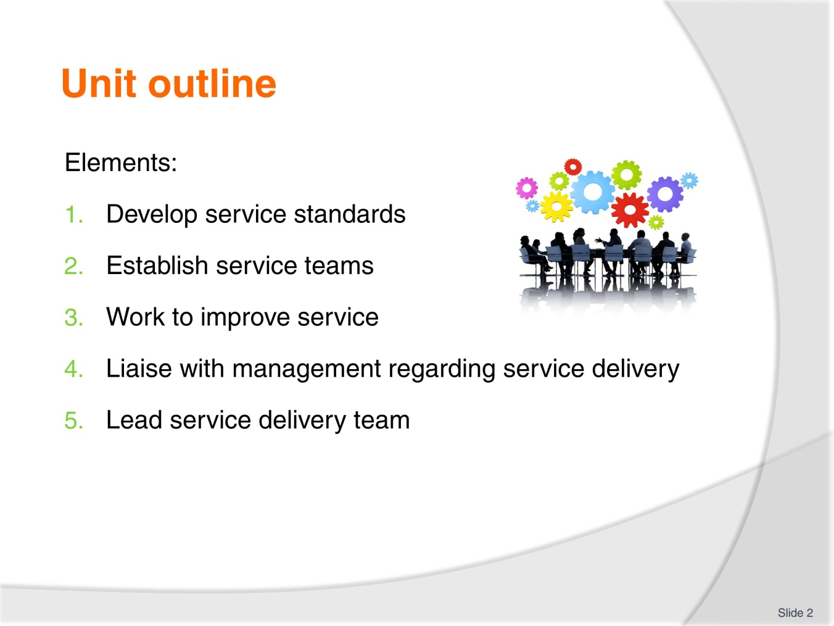
Slide No | Trainer Notes
Introduce the unit and take students through the course outline and assessment details. Ask students to introduce themselves and describe their work setting, role and duties.
Go through all housekeeping details such as fire exits, evacuation procedures, toilet location etc.
Explain that students will also have to complete work projects for each Element/performance criteria and that there will be oral questions and written questions to answer.
Students should be encouraged to keep a portfolio of their work.

Slide
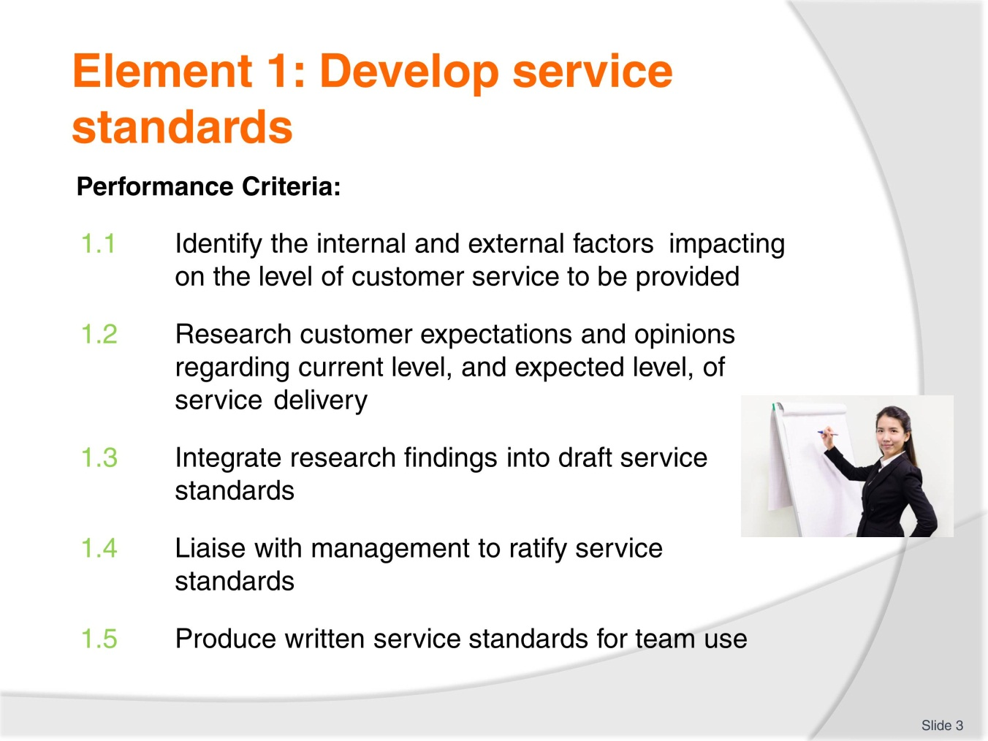
Slide No | Trainer Notes
Go through the performance criteria with participants.
Ask for any questions.

Slide
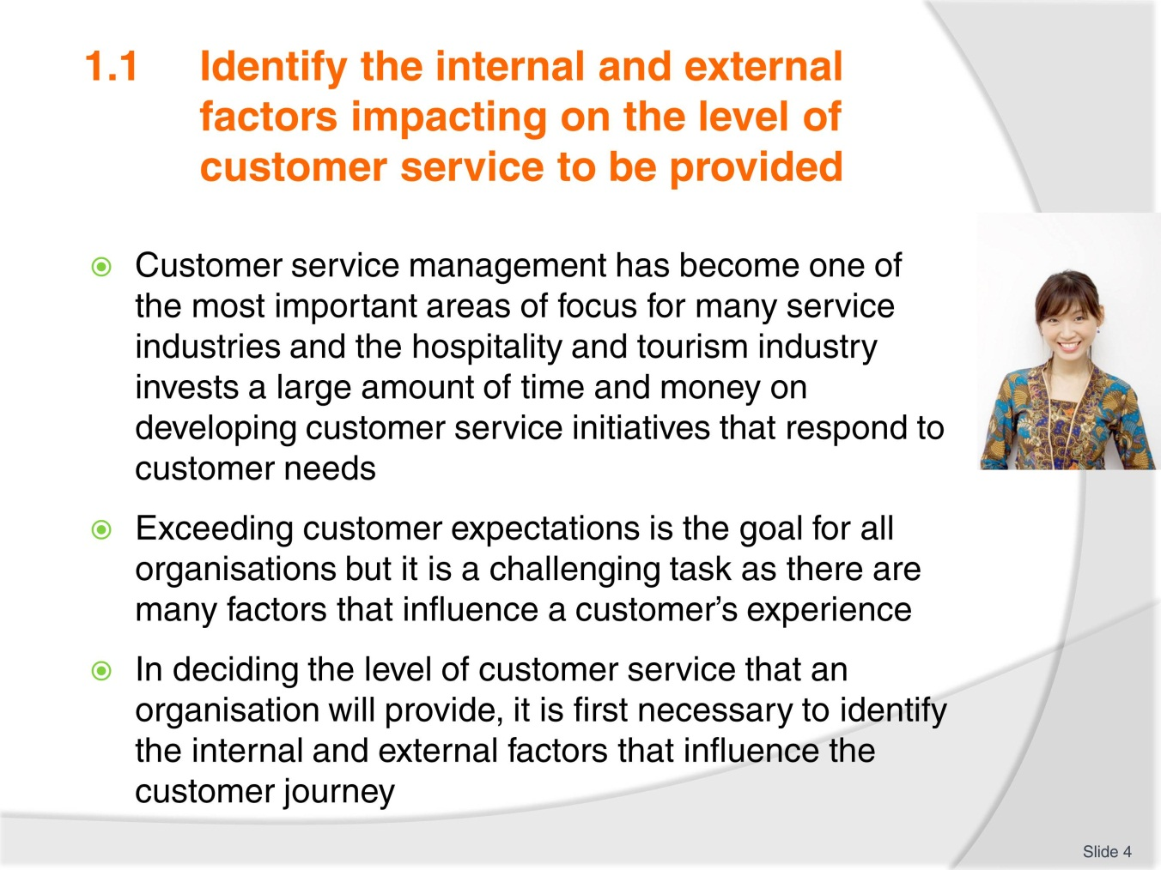
Slide No | Trainer Notes
Ask the group to read through the information in the introduction of the Training Manual (TM).
Ask students to describe their workplace and what level their organisation’s service standards are aimed at. For example, 5 star or 2 star, high level or mid-range.

Slide
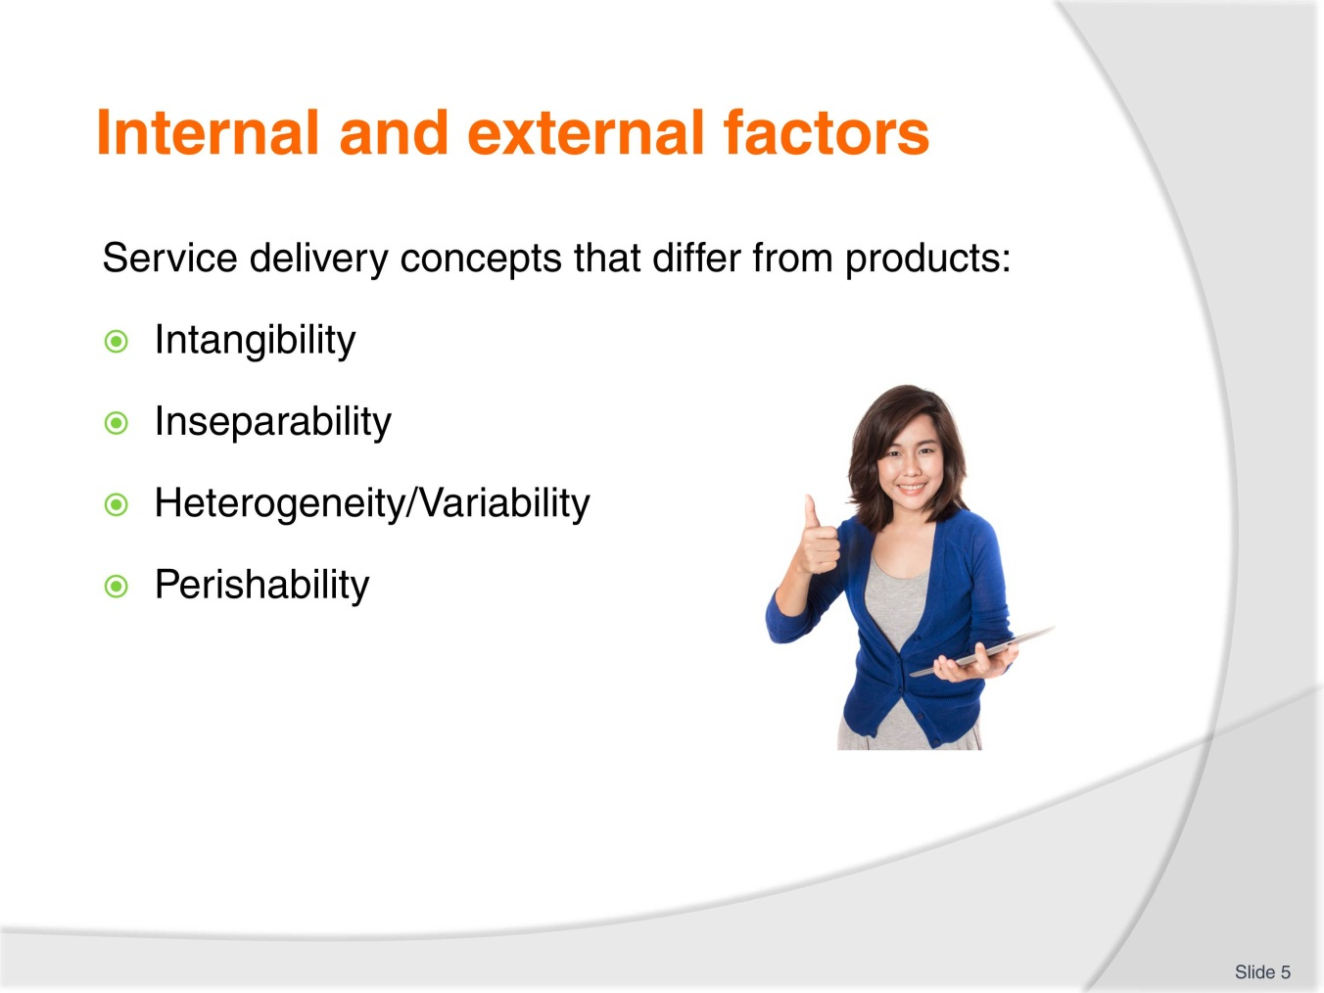
Slide No | Trainer Notes
Explain these concepts) Intangibility, Inseparability, Heterogeneity and Perishability) with participants.
Explain that services are different from products.
Use information from the TM and available online or from resource books.

Slide
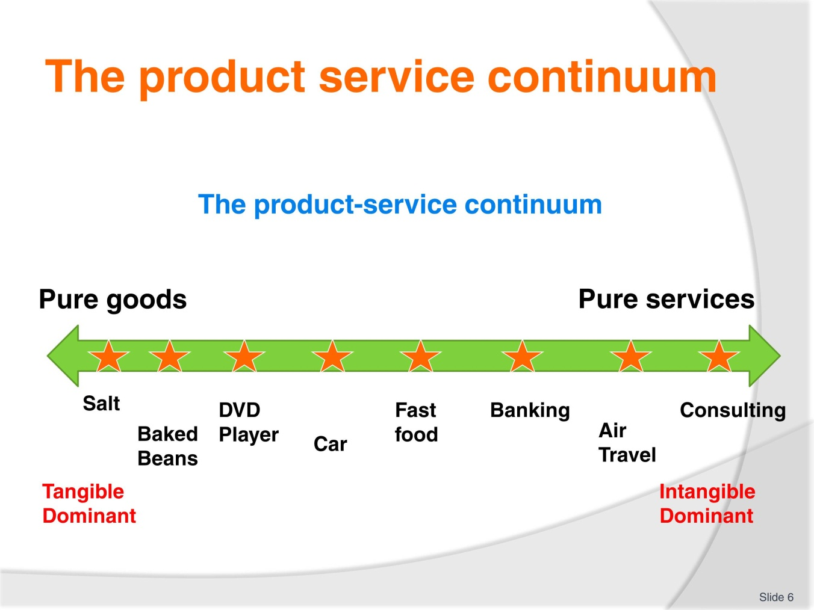
Slide No | Trainer Notes
Go through the continuum with participants.
Products are more tangible than services. Ask the group to provide other examples of products and services and where they would be placed on the continuum.

Slide
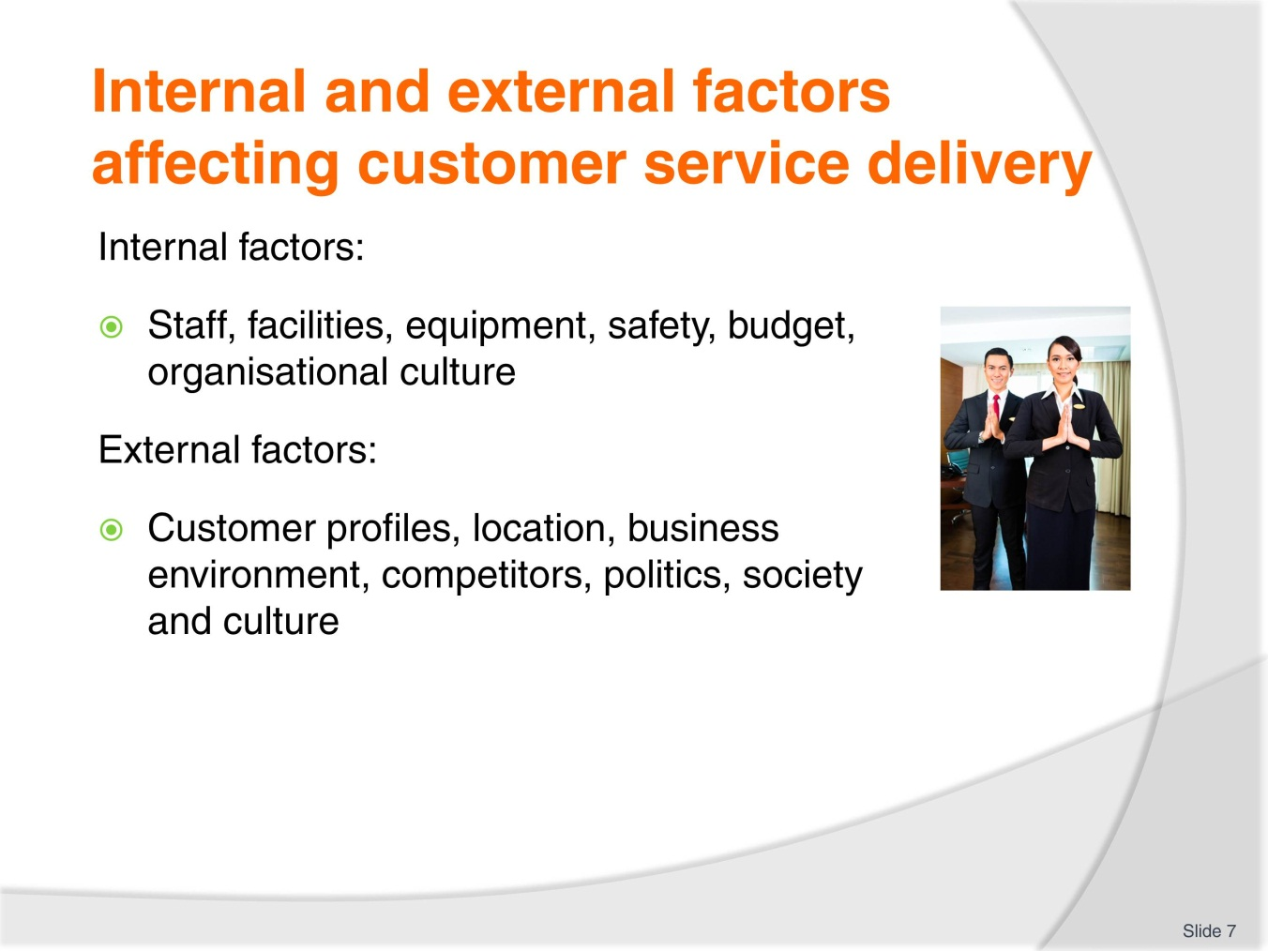
Slide No | Trainer Notes
Ask students to provide examples of internal and external factors which may influence customer service delivery.
Ask the class to read through their TM and look at internal and external factors that affect customer service. Ask the class to provide examples of their own or other workplaces where internal/external factors impact on service delivery.
Some external examples could be the economic, social, competitive, political and legal, and technological environment.
Remember to remind students about their work project for this performance criterion and let them know when it must be completed by.
1.1 Write a description of your workplace describing factors that impact on service which could include location, service standard level, facilities etc.

Slide
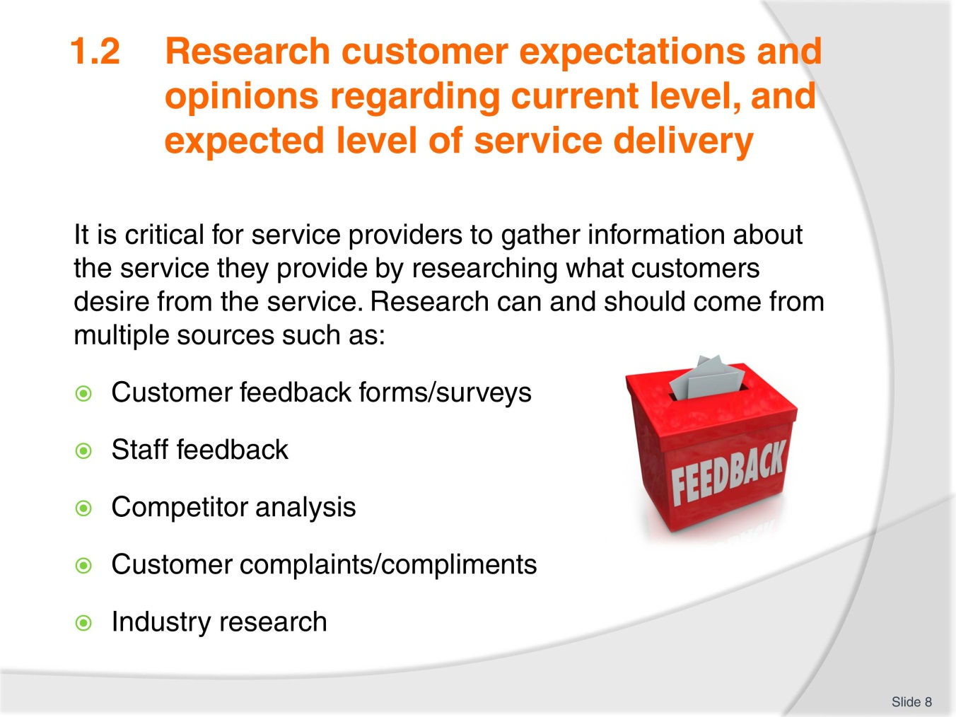
Slide No | Trainer Notes
Explain what this performance criterion will look at.
Ask students to identify other possible ways of gathering feedback.

Slide
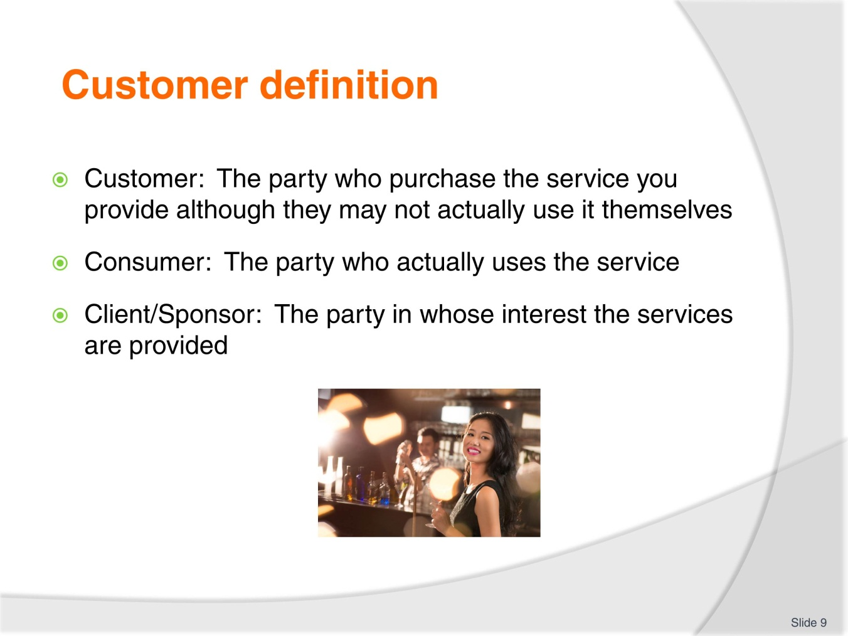
Slide No | Trainer Notes
Explain the difference between each of the customer definitions.
A customer could be a tour company who purchases room nights at a resort.
The consumer is the person who stays at the resort and the client could be a company who paid the tour company to organise the event for staff.
Ask students to provide other examples.

Slide
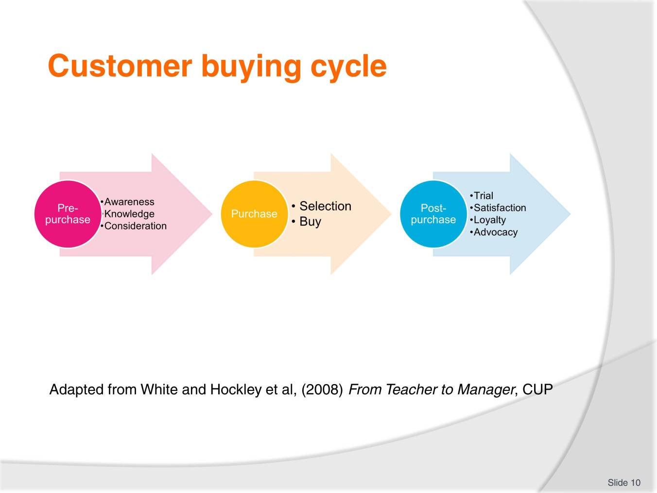
Slide No | Trainer Notes
Explain the customer buying cycle.
Ask students to work in pairs and talk about a customer buying cycle for their service.

Slide
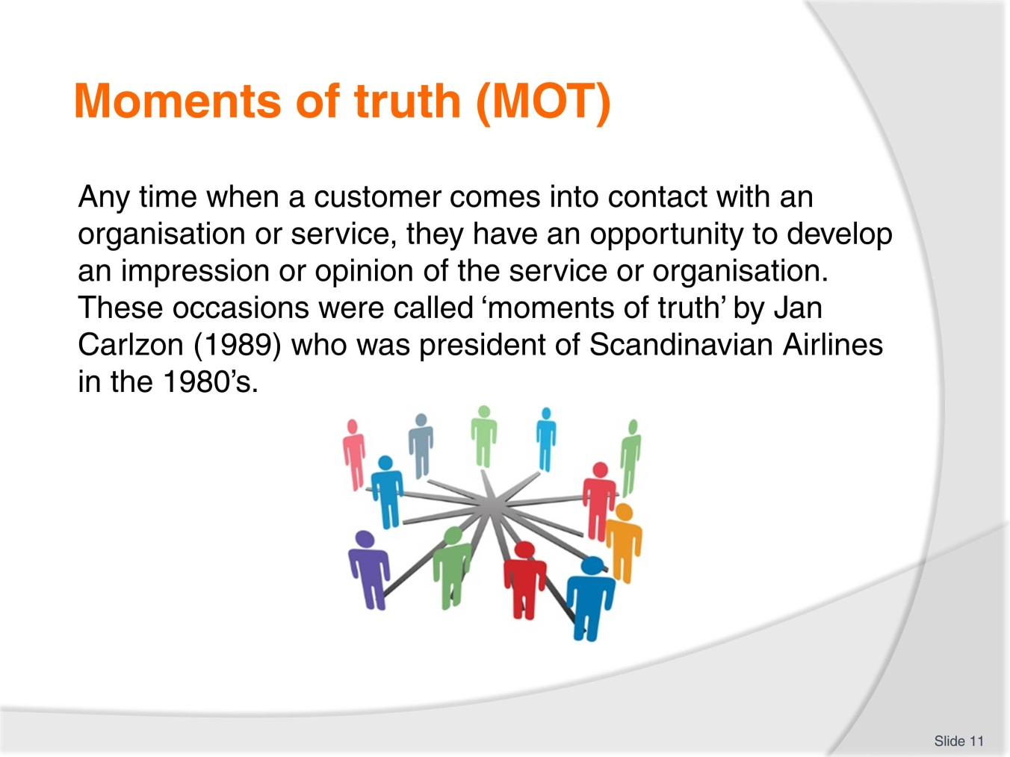
Slide No | Trainer Notes
Explain the idea of Moments of Truth.
Students can discuss and provide examples from their organisations.
These can be external or internal customers.

Slide
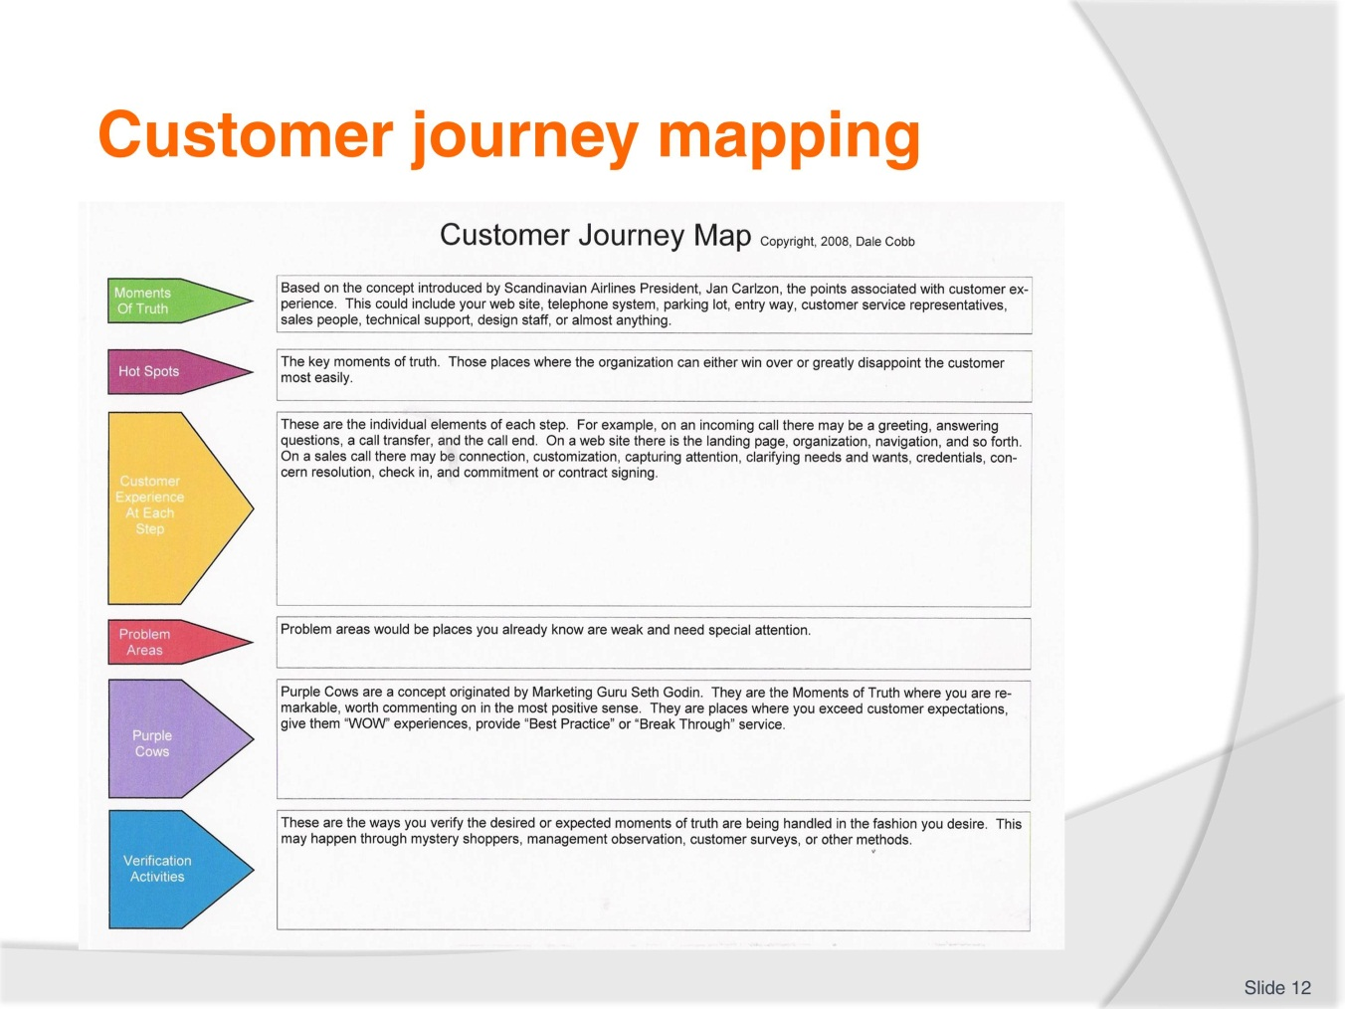
Slide No | Trainer Notes
Go through the slide with the class.
Ask students to work in small groups and to think about a customer journey through their organisation’s service delivery.
Which ‘moments of truth’ are the most important?
Trainer should prepare examples such as in dining at a restaurant, booking a hotel room or flight, or someone attending a conference or event.

Slide
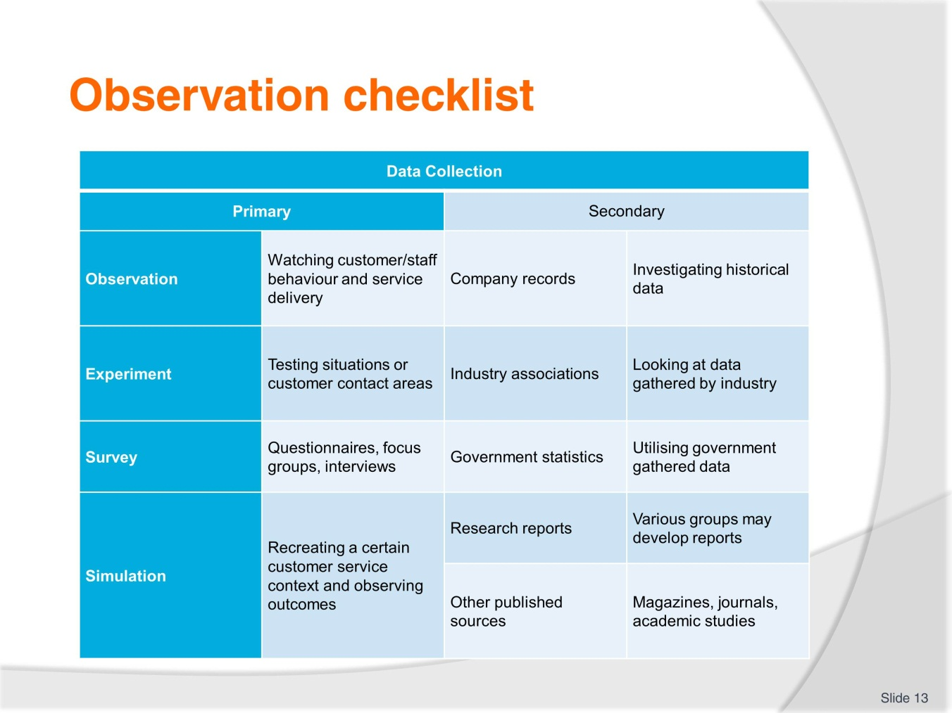
Slide No | Trainer Notes
Trainer goes through the slide with students and asks for other examples of data that could be gathered.
What feedback information is used at students’ organisations?

Slide
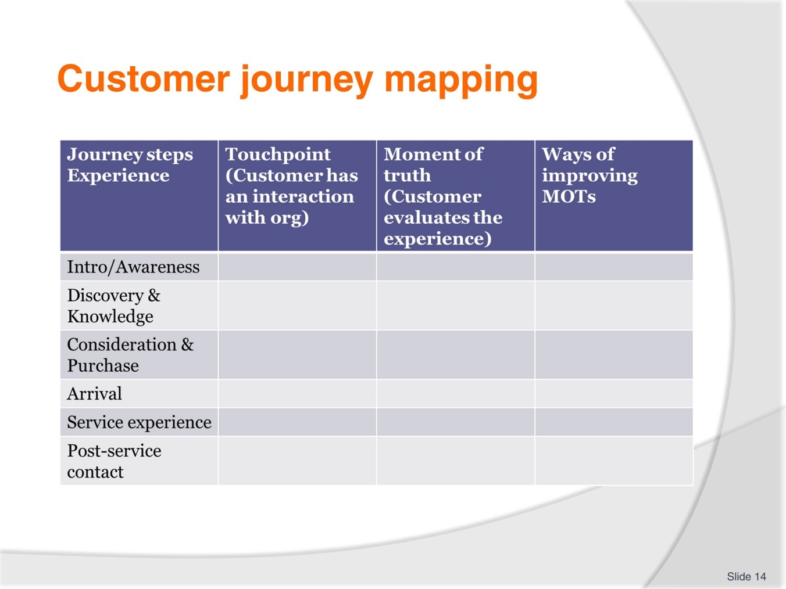
Slide No | Trainer Notes
Trainer goes through the slide with students and asks them to complete an example for a service oriented process.
Trainer could provide an example of a customer getting a spa treatment or flying economy class.
Trainer can explore examples on the internet.
Trainer checks examples and students discuss Moments of Truth.

Slide
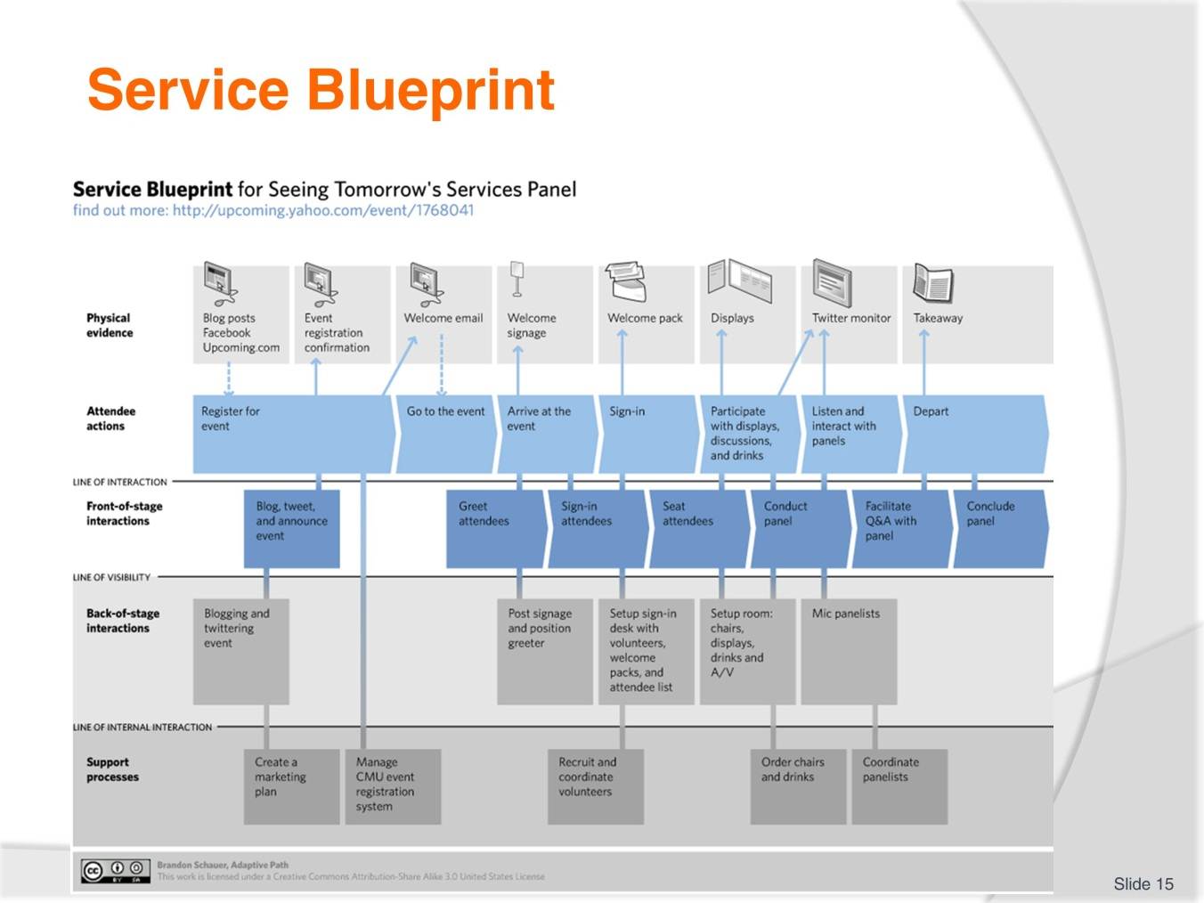
Slide No | Trainer Notes
Trainer explains the service blueprint process looking at front stage and back of stage interactions.
Trainer asks students if they have a service blueprint in their department or organisation.
Students can search the internet for more examples and present to the class.
Trainer reminds students to complete work project 1.2. This could be done in class and supported by the trainer.
1.2. Map out a customer journey process through your organisation, a part of your organisation or through another service oriented organisation. Use the stages of the customer buying cycle to help you.

Slide
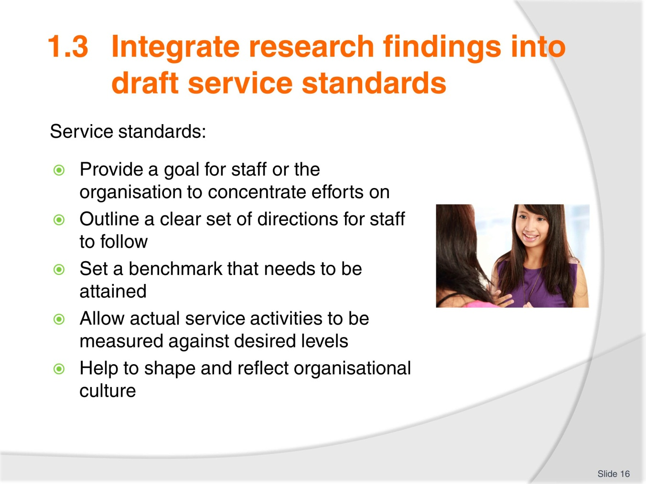
Slide No | Trainer Notes
Trainer goes through slide and asks students to provide example of service standards in their workplace.
Trainer provides examples of different standard levels such as different hotel brands within a hotel group: for example, Holiday Inn, Crowne Plaza, and InterContinental = IHG; or Mercure, Novotel, Pullman and Sofitel = Accor. Economy class, premium economy, business and first class in the airline industry.
Elicit from students that service standards may be different in each context.

Slide
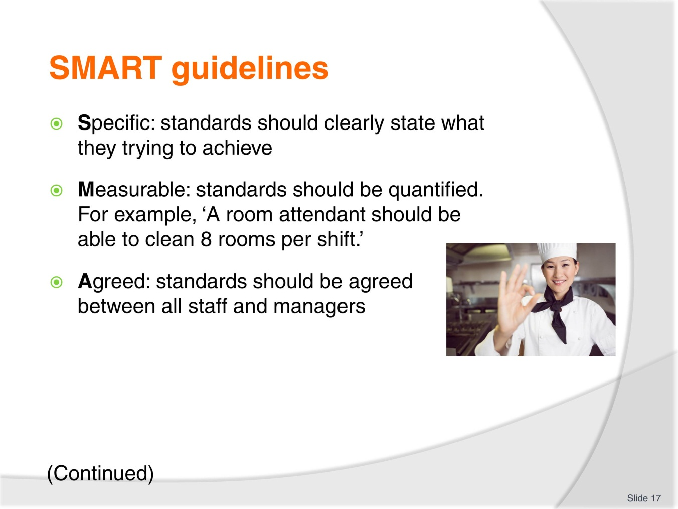
Slide No | Trainer Notes
Trainer explains the SMART concept and how it applies to the tourism sector.
Students read through service standard examples in the TM and answer the question. What changes could be made to the examples to utilise SMART guidelines?
Trainer asks students to complete activity below. Trainer monitors responses.
Activity
In small groups, discuss examples of service standards at your workplace and/or examples of customer service standards you have experienced. (Restaurants, booking hotels, buying things online, taxis)
Have you ever had to make a complaint or have you given a compliment about service you have received?
Have you received a compliment in your workplace?

Slide
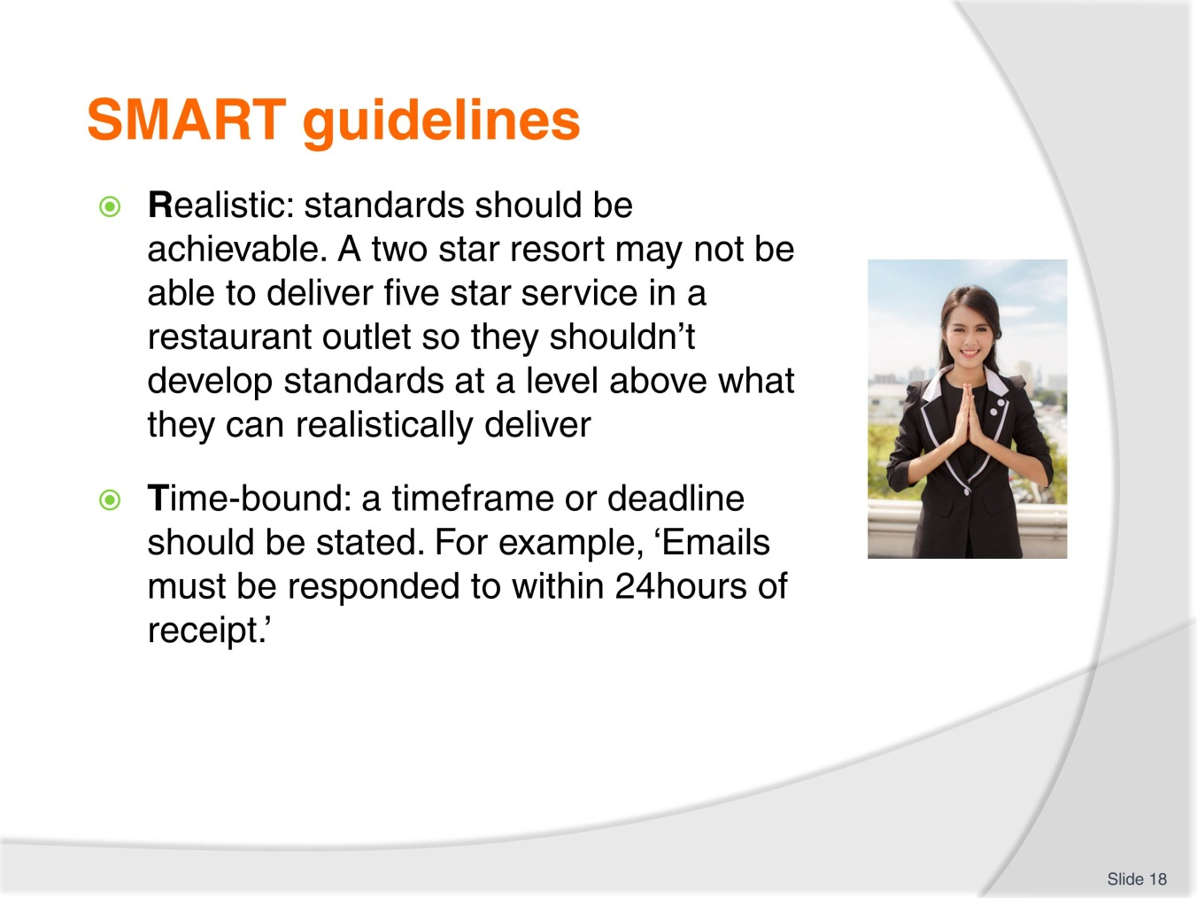
Slide No | Trainer Notes
Trainer explains the SMART concept and how it applies to the tourism sector.
Students read through service standard examples in the TM and answer the question. What changes could be made to the examples to utilise SMART guidelines?
Trainer asks students to complete activity below. Trainer monitors responses.
Activity
In small groups, discuss examples of service standards at your workplace and/or examples of customer service standards you have experienced. (Restaurants, booking hotels, buying things online, taxis)
Have you ever had to make a complaint or have you given a compliment about service you have received?
Have you received a compliment in your workplace?

Slide
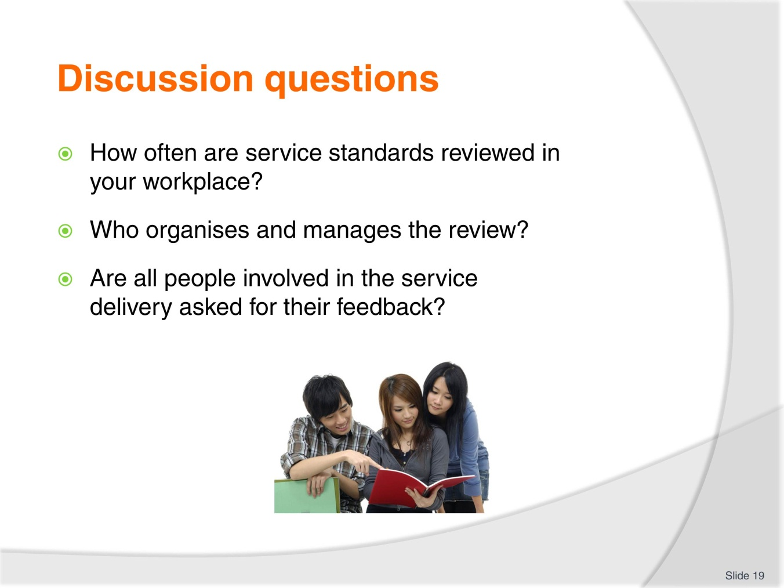
Slide No | Trainer Notes
Students discuss questions and trainer supports the discussion.
Students read TM and consider drafting service delivery standards. Have they ever drafted standards?
Trainer brings examples of service standards and asks students to check.
Trainer asks students to develop a draft standard for a service item. Examples could be for any service item in their workplace. They should complete the task in pairs.
Trainer reminds students of work project below and due date.
1.3. Bring to class two examples of service standards from your workplace or from service organisations. These could be found in Operation Manuals or online.

Slide
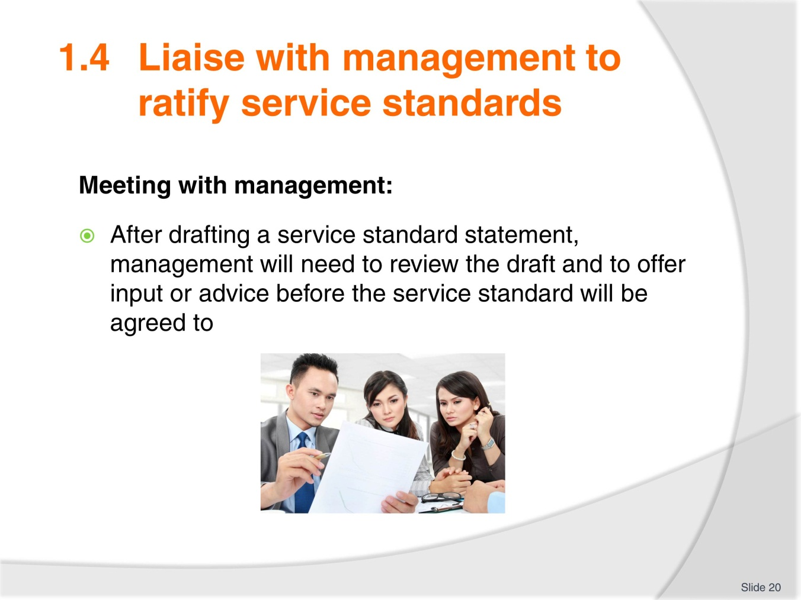
Slide No | Trainer Notes
Trainer goes through slide and explains the need to involve management.
Students read through TM and trainer explains that trainees should be well-prepared before they present a draft service delivery standard to management.

Slide
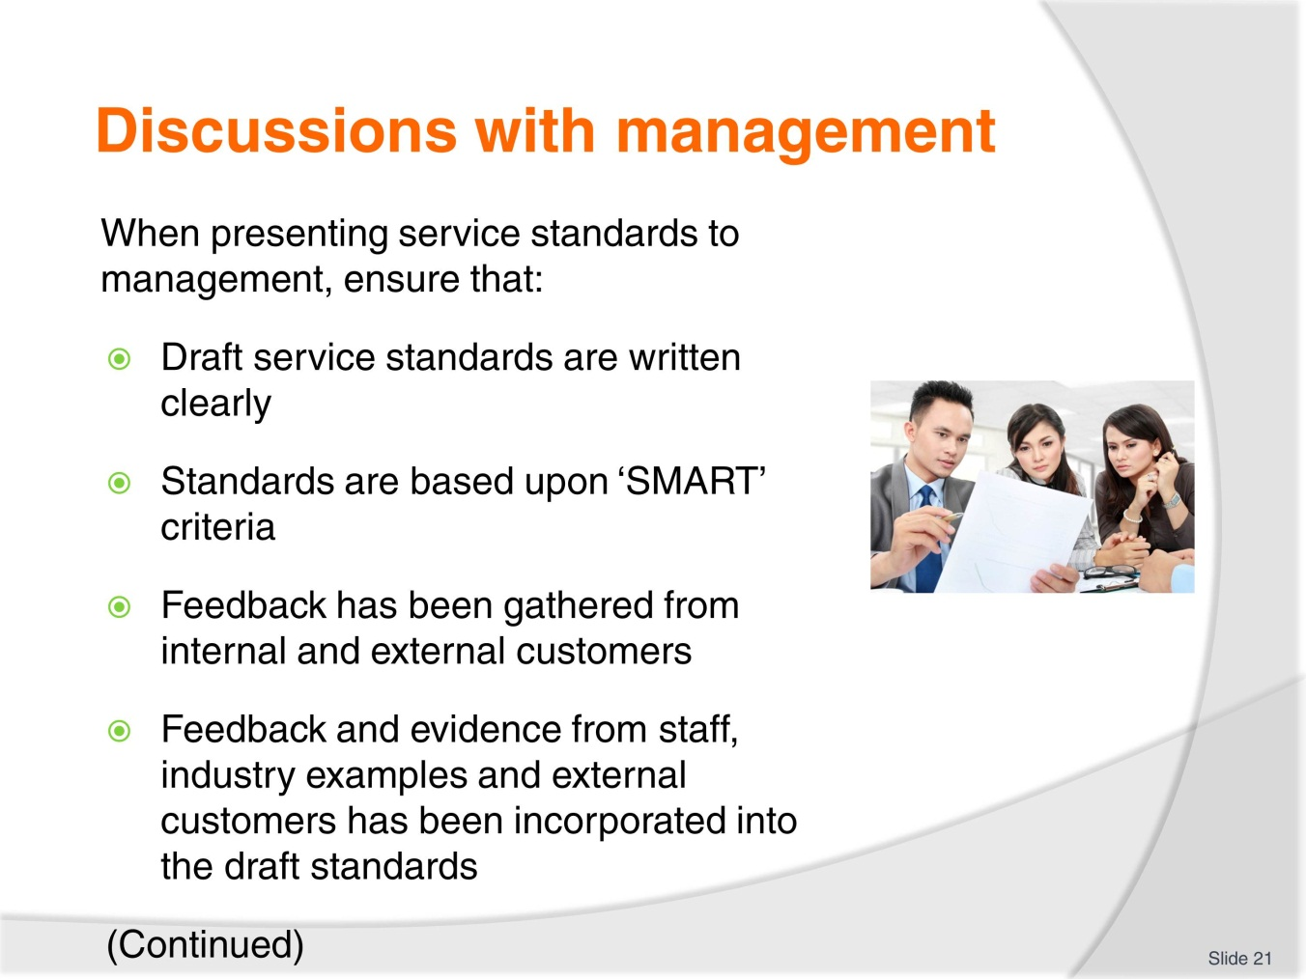
Slide No | Trainer Notes
Trainer goes through slide with trainees.
Trainees check information and provide comments.
Trainer reminds trainees of work project and due date. This could be done in class or as homework.
1.4. Write about an example where you have shared a suggestion or feedback with management. Outline the context, what the suggestion was and the outcome.

Slide
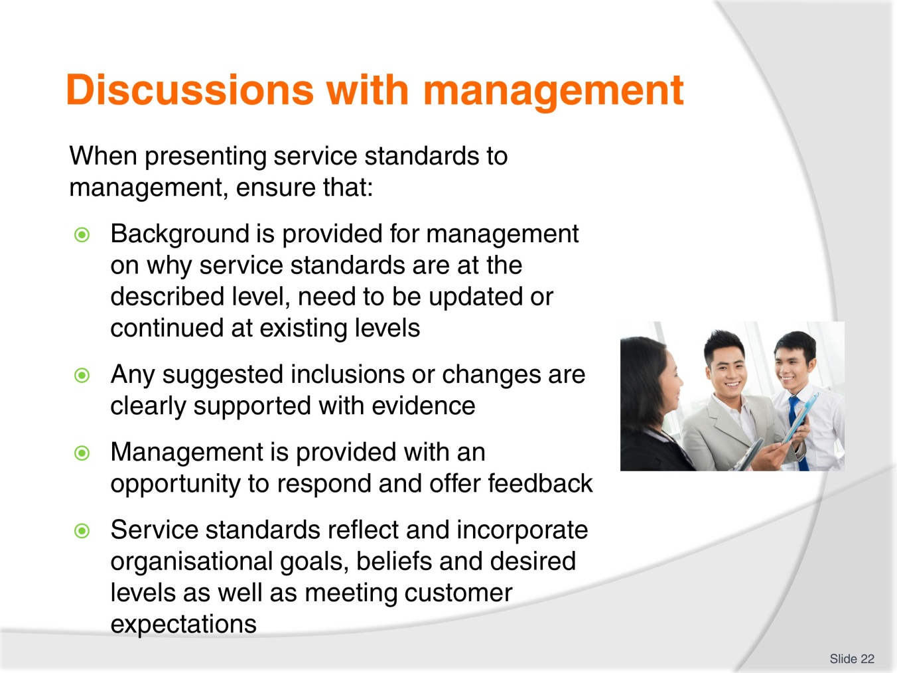
Slide No | Trainer Notes
 | Trainer goes through slide and explains that accessibility to service standards is critical for team members to deliver service at the expected level.

Slide
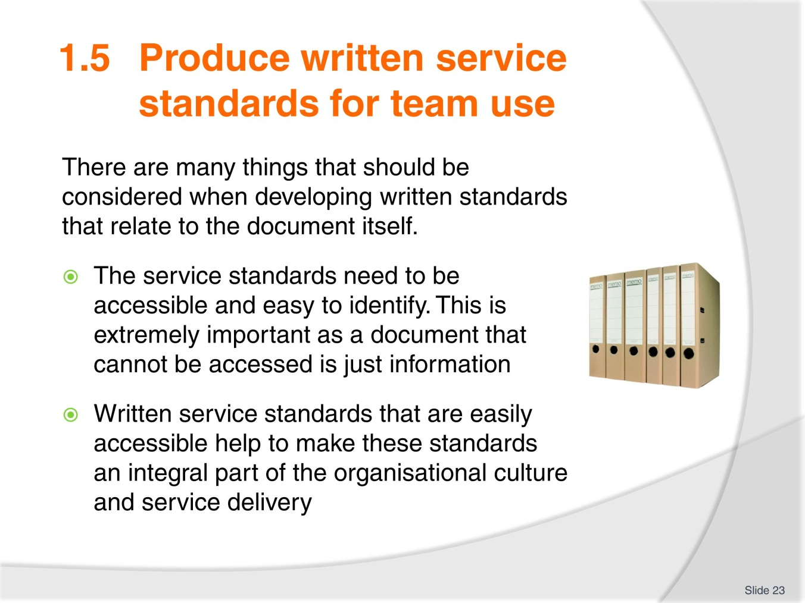
Slide No | Trainer Notes
 | Trainer goes through slide and explains that accessibility to service standards is critical for team members to deliver service at the expected level.

Slide
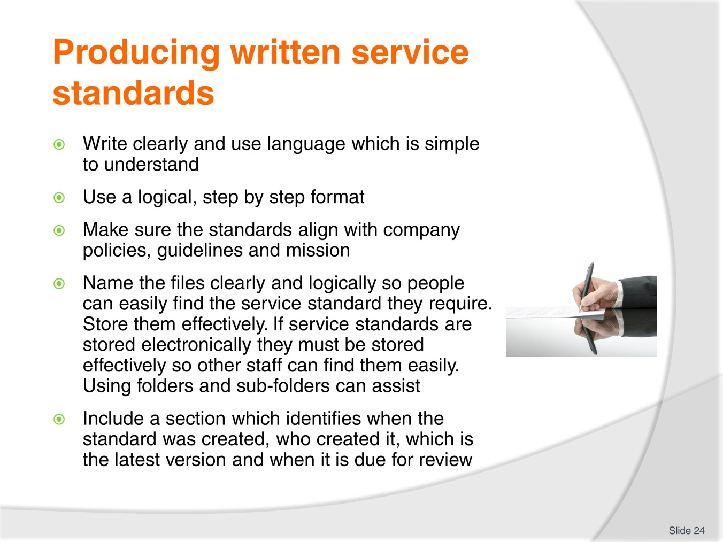
Slide No | Trainer Notes
Trainer brings shows students examples of service standards.
These can be obtained from the workplace or from examples from the internet.
Trainer could ask students to bring in examples from their workplace.
Trainees read through the slide/TM and ask questions.
Trainer reminds students of work project and due date.
1.5 Provide three examples of service standards that your team uses.

Slide
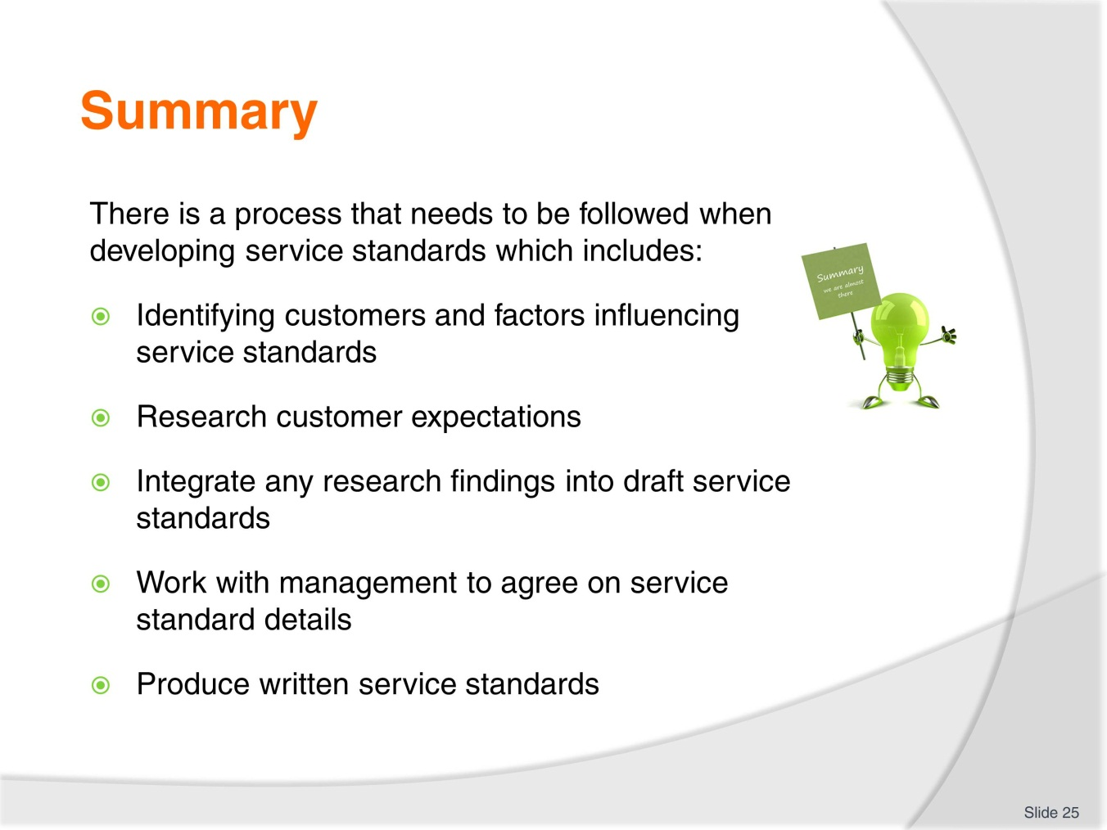
Slide No | Trainer Notes
 | Trainer goes through summary slide and could assess students’ understanding using written questions and oral questions from the assessment manual.

Slide
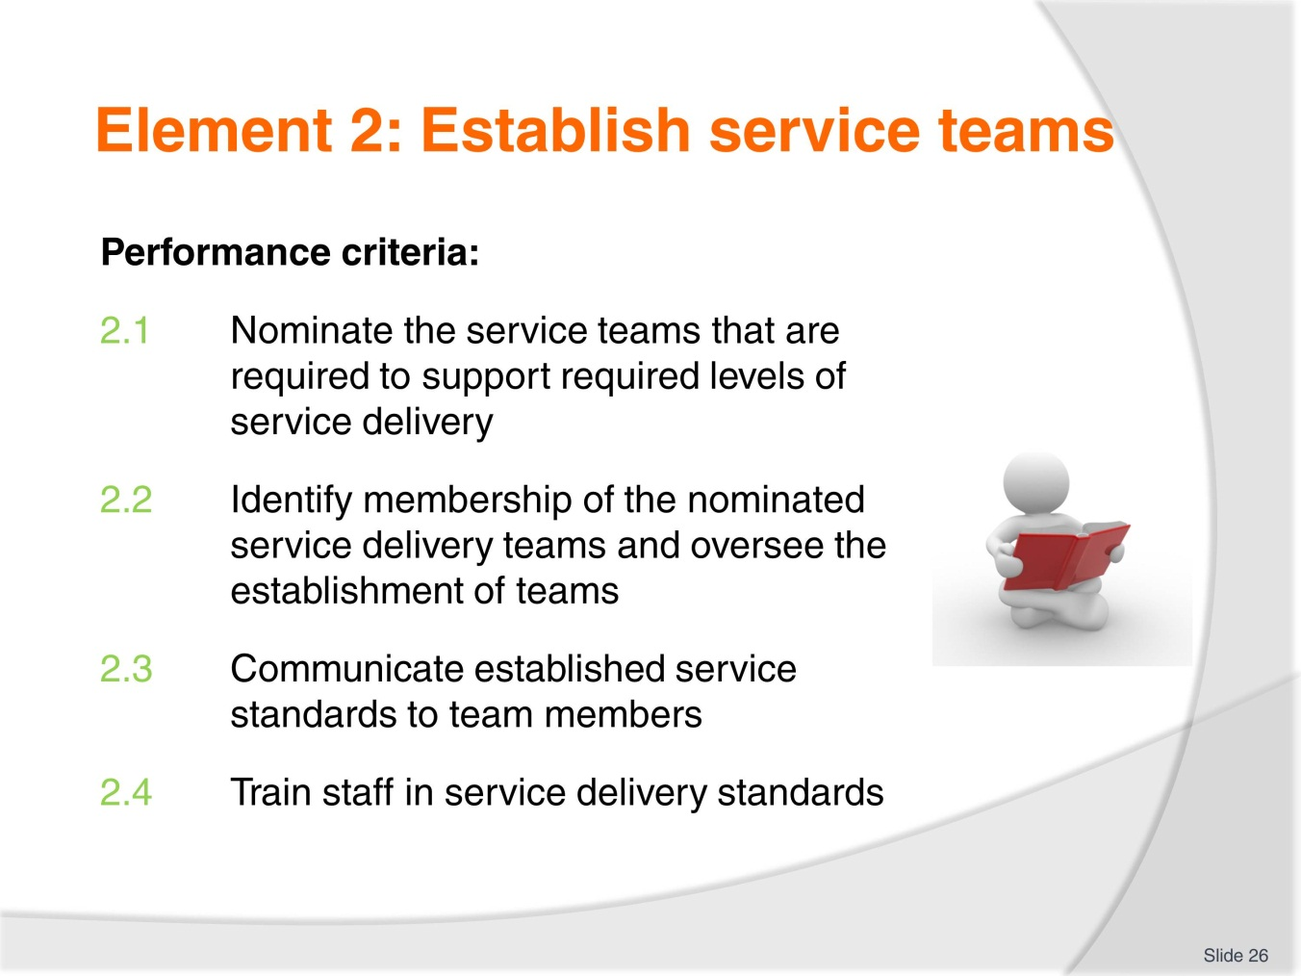
Slide No | Trainer Notes
 | Trainer goes through performance criteria for this element and reminds students about work projects and assessment written and oral questions.

Slide
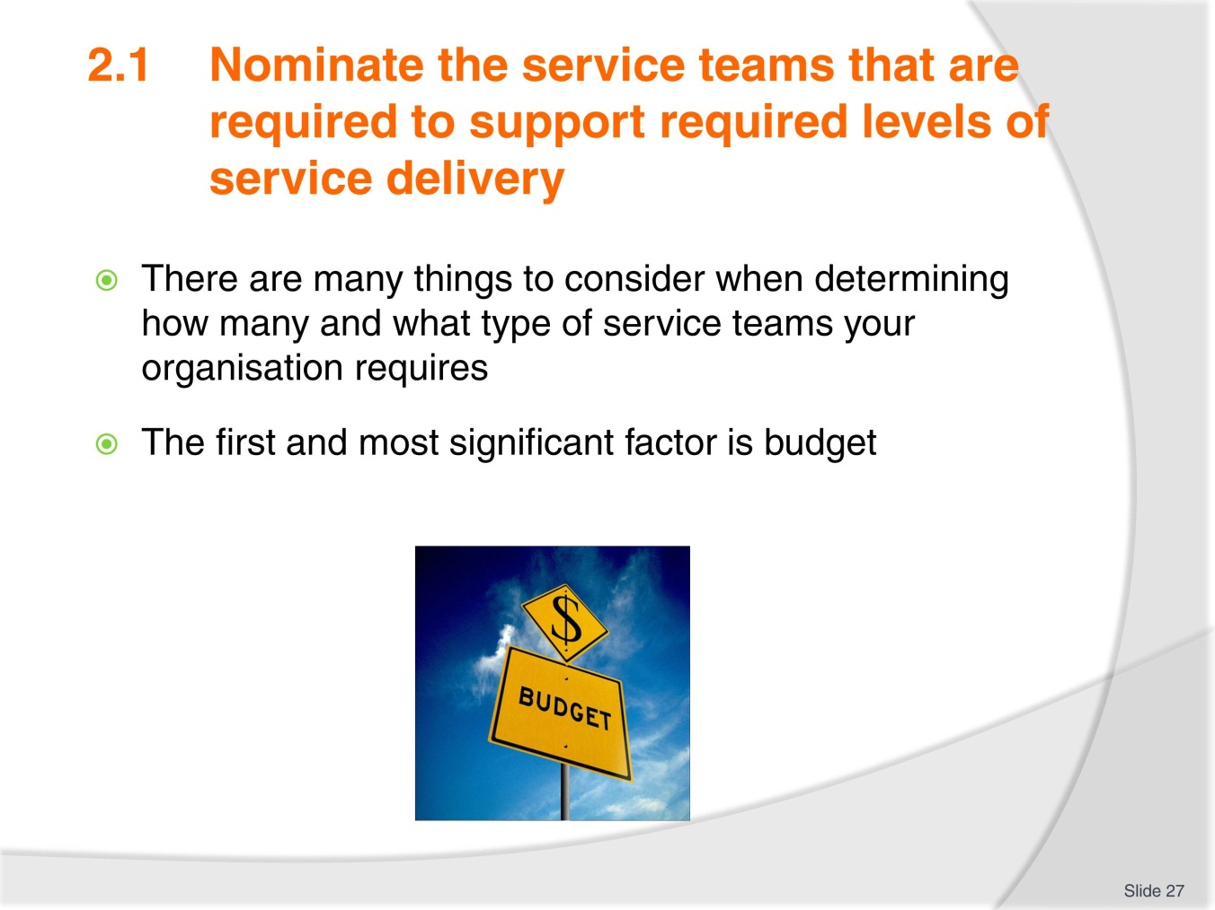
Slide No | Trainer Notes
 | Trainer explains that budget is a major constraint on the creation of service teams.

Slide
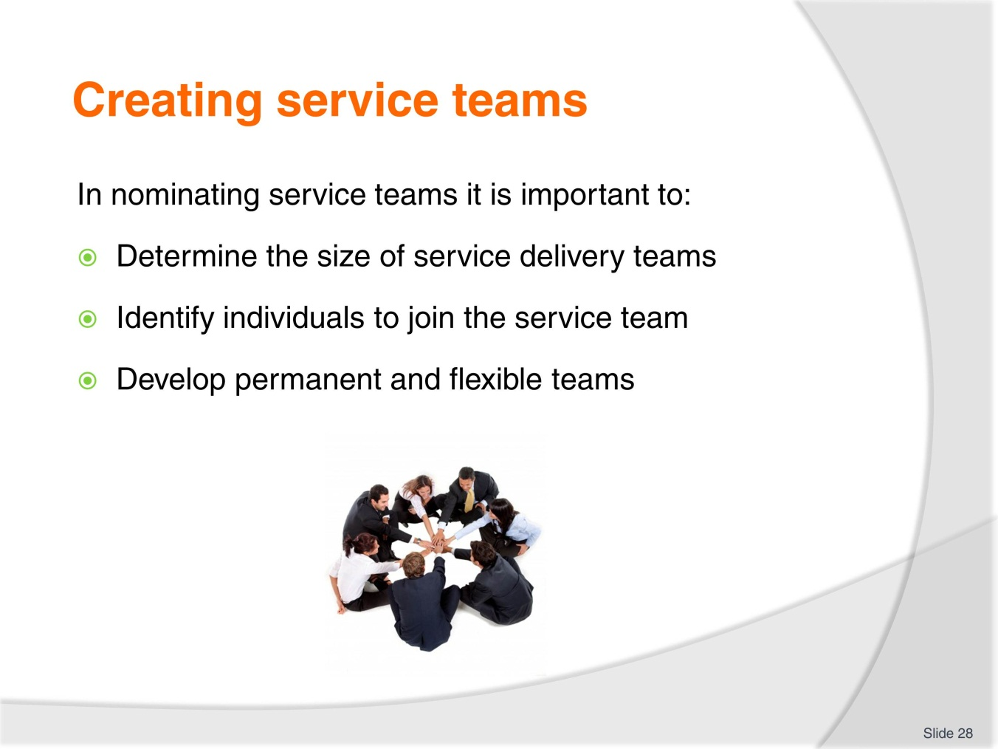
Slide No | Trainer Notes
Trainer goes through slide and explains that service team size will depend upon budget, the type of service and the outlined level.
Individuals with suitable skills and experience are then invited or directed to join the service team.
Trainer explains that some teams will be permanent but there may be flexible teams created who can assist other teams when required.
Trainer asks trainees to describe the service teams they have been or are a member of.
Trainer asks students to describe how team are created in their workplace.
Trainer reminds students of work project and due date.
2.1 Identify one area of service delivery at your organisation and outline:
- How many people you think should be in the team or how many are in the team?
- What are the services that are delivered?
- Is there a determined budget for the service team in this service area?

Slide
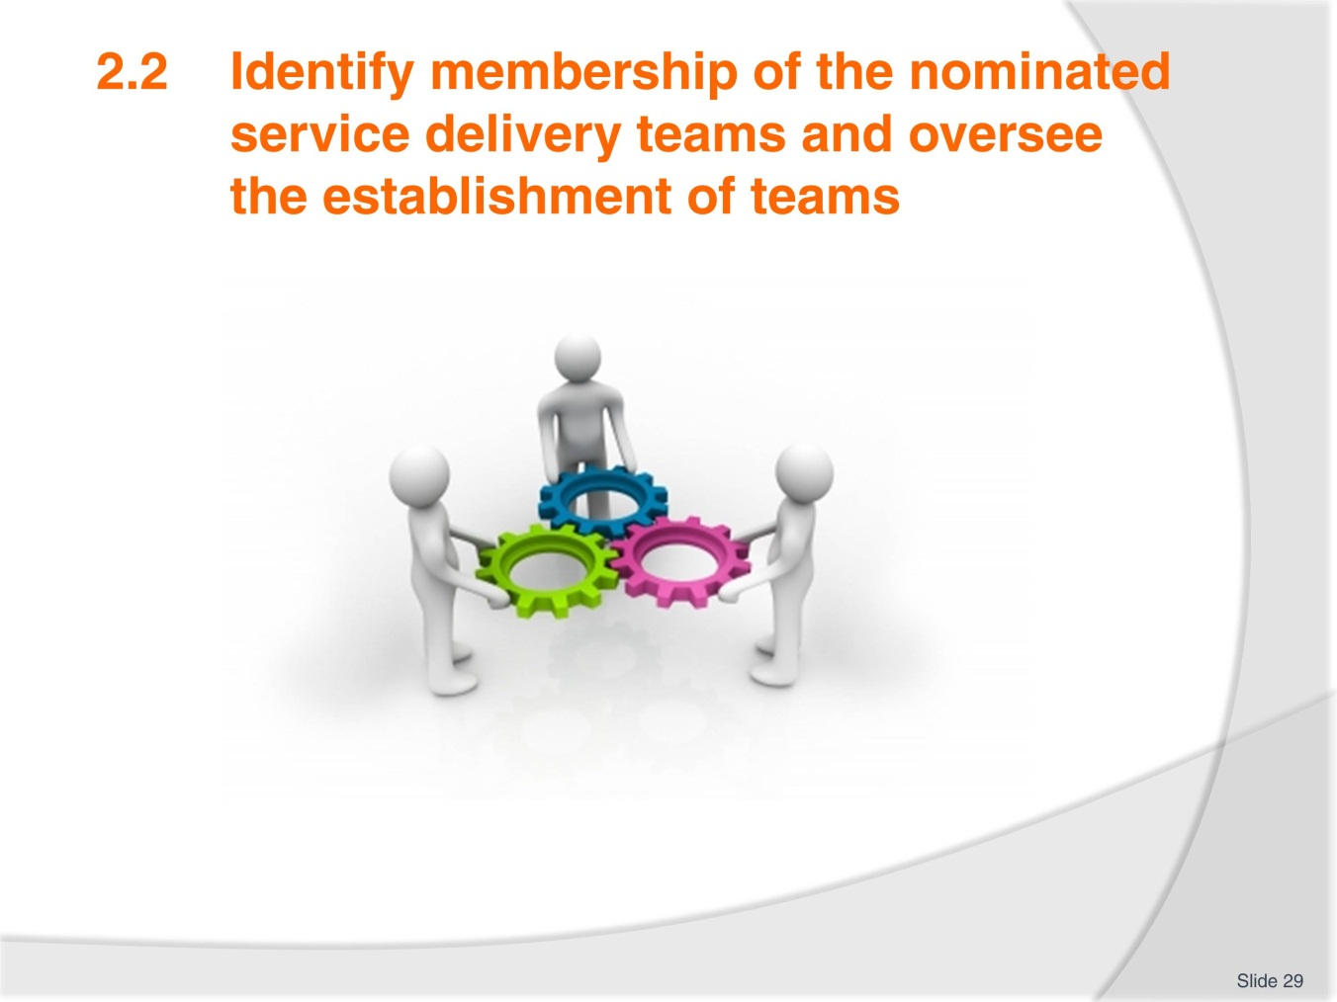
Slide No | Trainer Notes
Trainer goes through TM and slide with students.
After suitable candidates for service teams have been identified and they have agreed to join the service team, it is crucial that the establishment of the service team is effective.
Successful teams require a lot of support and effort from all members. It is vital that employees work as a team in order to deliver the best service.

Slide
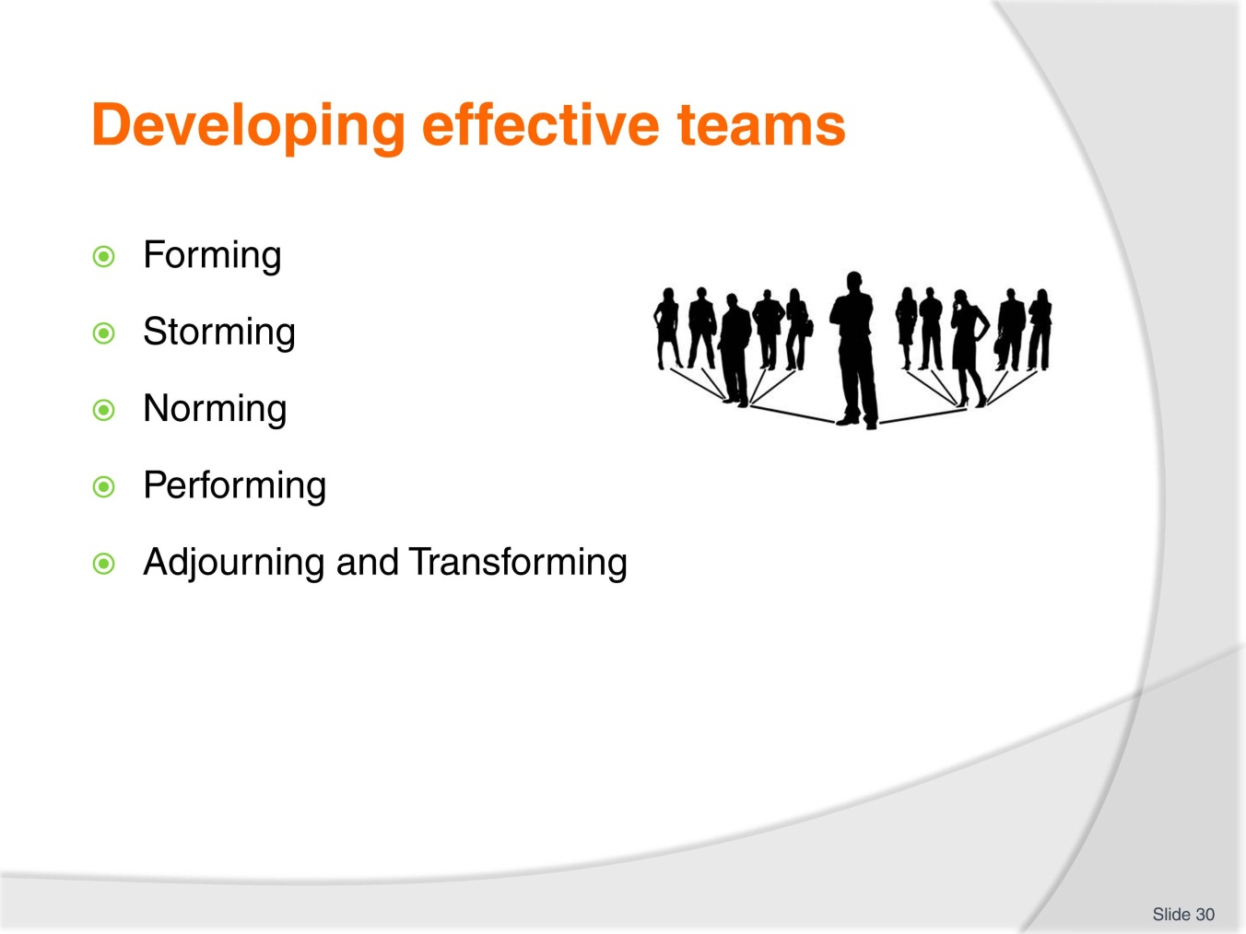
Slide No | Trainer Notes
Trainer goes through slide and concepts with students.
Trainees refer to their TMs for more information.

Slide
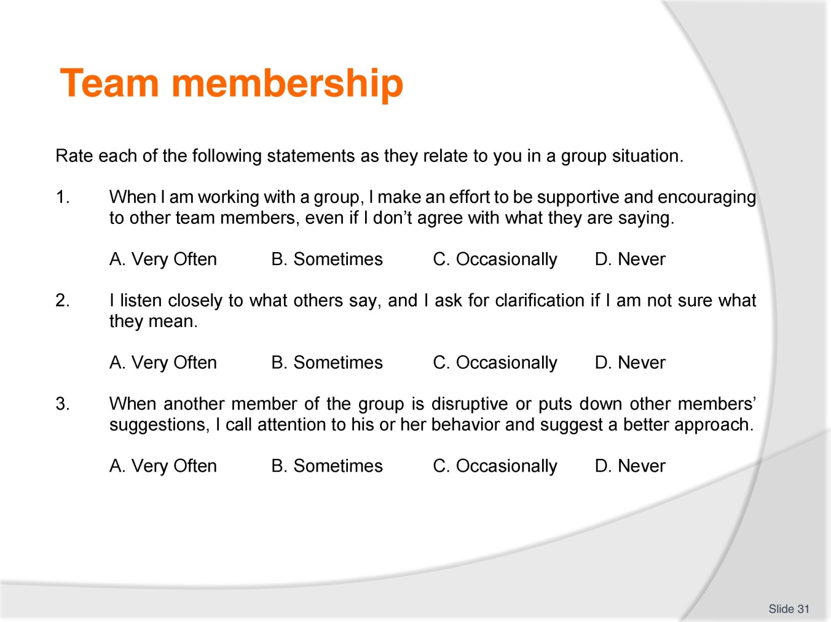
Slide No | Trainer Notes
Trainer asks students to complete the survey in the slide.
Trainees discuss their answers with the class. Trainer facilitates a discussion.
Trainer explains this saying: Better person, better staff member, better team, and better organisation.
Trainer reminds students of work project and due date.
2.2. Describe a service team or other team that you have been involved in. Outline:
- How the team was formed
- Were there any issues or problems within the team
- What role did you play in the team?

Slide
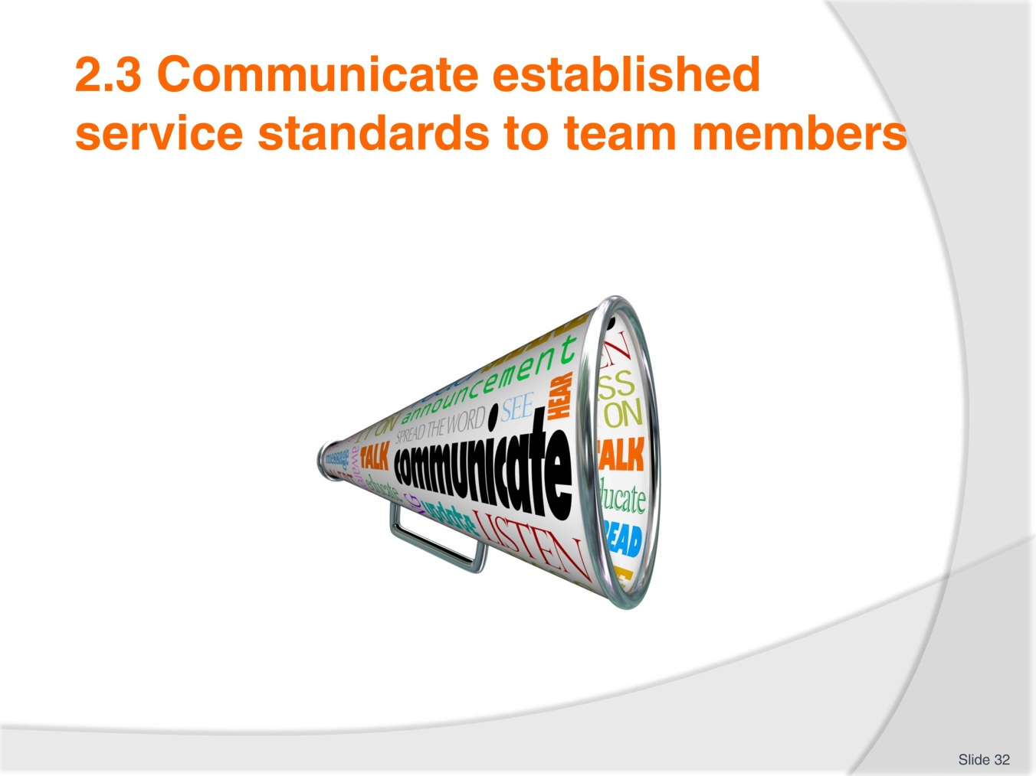
Slide No | Trainer Notes
Trainer explains the importance of effective communication. Trainer can use ideas below to assist.
Communication occurs when a sender expresses an emotion or a feeling, creates an idea, or senses the need to communicate. The communication process is triggered when the sender makes a conscious or an unconscious decision to share the message with another person—the receiver.
Every communicative act is based on something that conveys meaning, and that conveyance is the message. The message may be either verbal (spoken or written) or nonverbal (body language, physical appearance, or vocal tone). Messages may also come from the context—or place and time—of the communication. For instance, if you choose to make a critical comment to someone, the place and the time you choose to make that comment will make a big impact on how it will be received.
Every message is sent and received through one of our five senses—it is seen, heard, touched, tasted, or smelled. The sensory media through which messages are sent and received are communication channels. In a work setting, messages may be seen through body movement, letters, memos, newsletters, bulletin board notices, signs, emails, and so on. Messages that are heard come through conversations, interviews, presentations, telephones, radios, and other audio media. Sight and sound are the two most frequent communication channels used in our society.
When the receiver gets the message (through seeing, hearing, feeling, touching, or smelling), he or she will usually give feedback (return message) unconsciously or consciously. Thus, the communications process is on-going.
The worst assumption a sender of a message can make is that the message will be received as intended. So many things can go wrong during the communications process that we should always assume that something will go wrong and take steps to prevent that occurrence. Barriers to good communications are always present. For instance, the language itself can be a barrier—unclear wording, slang, jargon, the tone. The channel used to convey the message might be wrong. For instance, you would not use the telephone to relay a lot of statistical information; you would need to write that message on paper. Poor listening skills can constitute a barrier also.

Slide
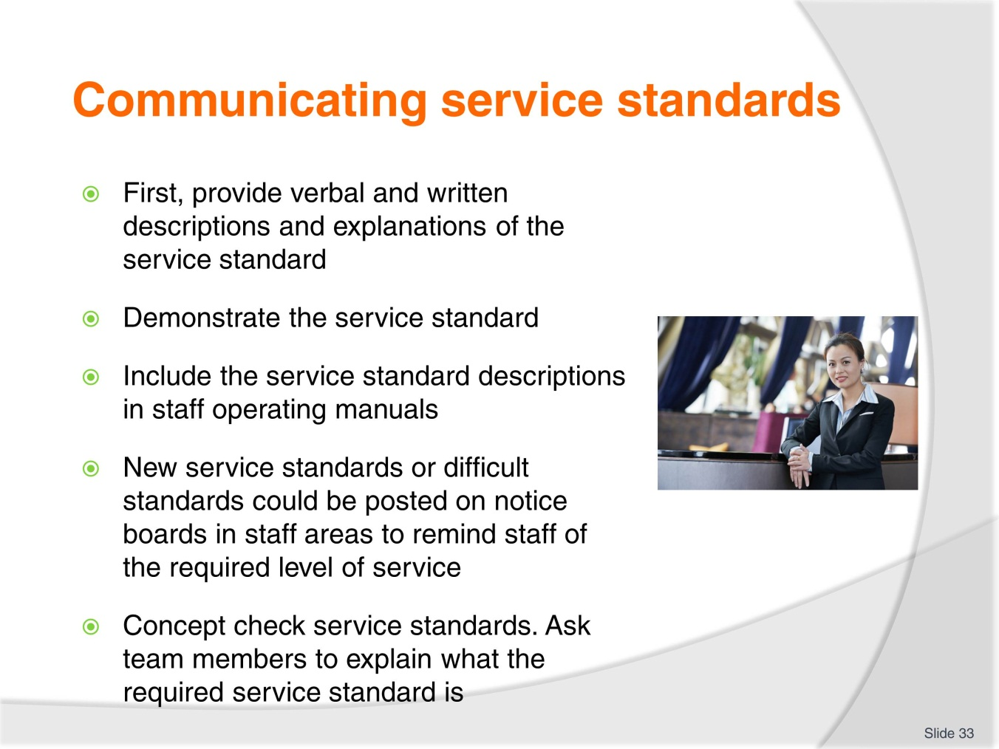
Slide No | Trainer Notes
Trainer goes through slide with trainees and trainees share thoughts about the content.
Trainer asks which step trainees think is the most important. Why? There is no right answer and trainer facilitates a discussion.
Trainer prints survey below and trainees complete. Trainees discuss their results with each other. Trainer reminds students of work project and due date.
2.3. Bring an example of a service standard to your class and in groups share how you would or have explained the standard. Were there any difficulties?
Self-Appraisal Survey—Communications
The purpose of this survey is to determine your susceptibility to being a source of communication breakdown. Since no one but you will see the results of this questionnaire, answer the questions as honestly as possible. Respond not as you would like to be seen as a communicator but as you really are. Indicate how frequently you engage in the following behaviours when communicating with another person or persons. Use this scale to describe your behaviour.
4 – I always do this.
3 – I often do this.
2 – I sometimes do this.
1 – I seldom do this.
0 – I never do this.
1. When I have something to say, I am open and honest about my need to say it.
2. I communicate with an awareness that the words I choose may not mean the same thing to other people that they do to me.
3. I recognise that the message I receive may not be the same one the other person intended to send.
4. Before I communicate, I ask myself questions about who my receiver is and how that will affect his or her reception of my message.
5. As I communicate to someone, I keep a watchful eye and ear out for an indication that I am understood.
6. I make my messages as brief and to the point as possible.
7. I consciously avoid the use of jargon with those who may not understand it.
8. I consciously avoid the use of slang words and colloquialisms with those who may be put off by them.
9. I try not to use red-flag words (words that might trigger an emotional response) that may upset or distract the receiver of my message.
10. I recognise that how I say something is just as important as what I say.
11. I analyse my communication style to determine what nonverbal messages I send and how well they conform to the meaning I desire to get across.
12. I carefully consider whether my message would be best understood by my receiver in a face-to-face meeting, over the telephone, or in writing.
13. I form opinions about what others say to me based on what I hear them saying rather than what I think of them as a person.
14. I make a genuine effort to listen to ideas with which I don't agree.
15. I look for ways to improve my listening skills.
TOTAL SCORE
Analyse Survey Results
Find your score on the following table.
Score Interpretations
50 – 60
Are you sure you were honest? If so, you are an extremely effective communicator who almost never contributes to misunderstanding.
40 – 49
You are an effective communicator who only infrequently causes communication breakdown.
30 – 39
You are an above average communicator with occasional lapses. You cause some misunderstandings but less than your share.
20 – 29
Many people (at least those who are honest) fall into this category. While things could be worse, there is much room for improvement in your communication style.
10 – 19
You are a frequent source of communication problems.
Less Than 9
Your honesty is commendable, but it will take more than honesty to improve your communication effectiveness. Consider taking a communication course.

Slide
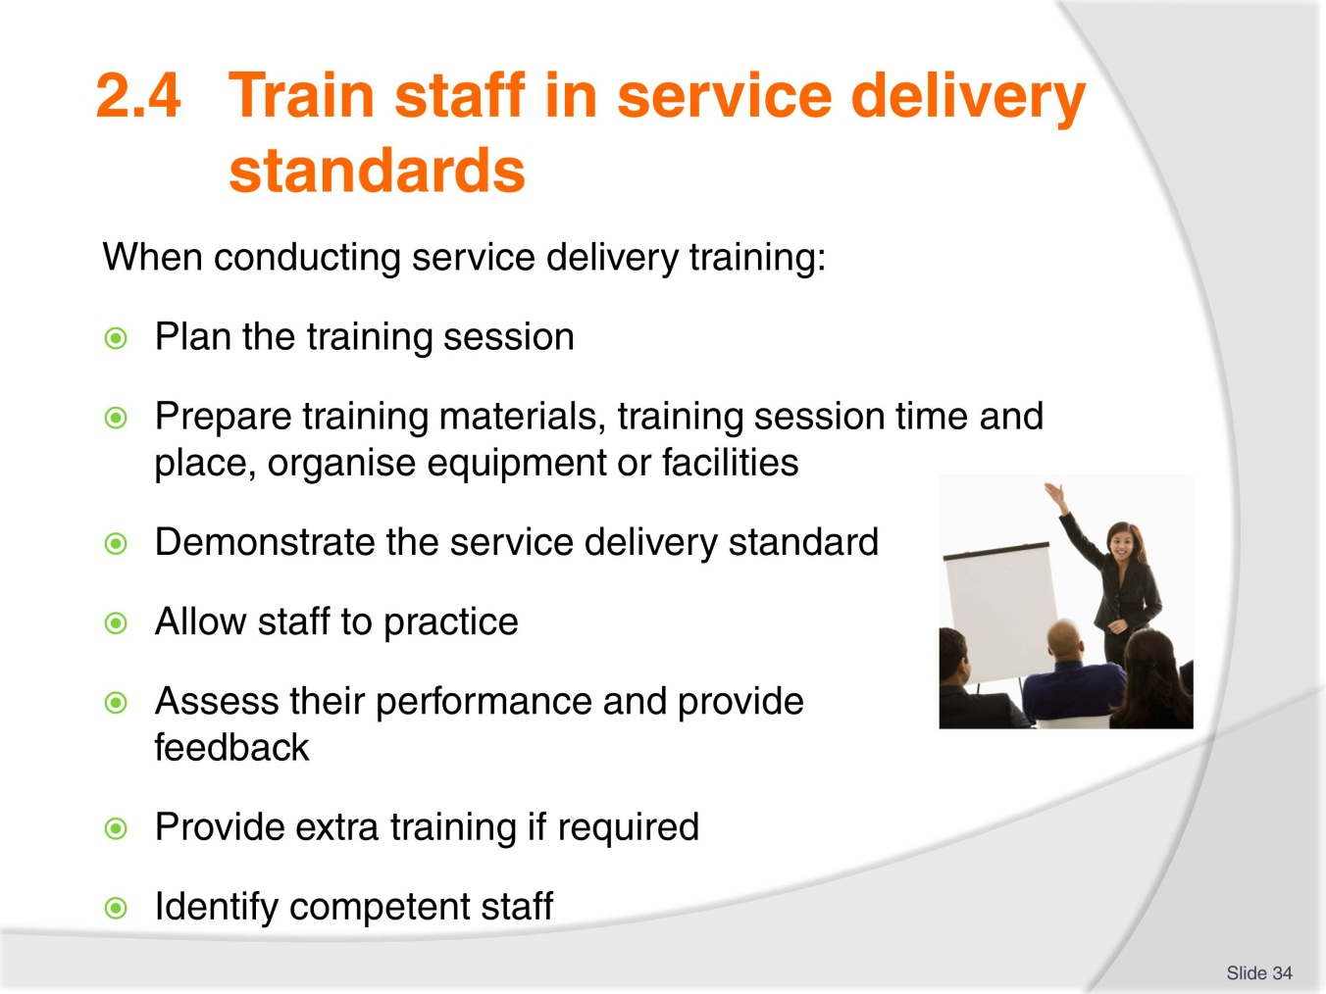
Slide No | Trainer Notes
Trainer goes through the stages of training with trainees.
Trainees add other details if they consider relevant.
Trainer can print details below and distribute to students.
Trainer assesses students using written and oral questions from the Assessment Manual.
Trainer reminds students of work project and due date.
2.4. Prepare a training session for your class. Choose a specific service standard and deliver the session in your class. Arrange a time with your trainer and submit a training outline before delivering the training session.
Specify training goals and objectives. List your objectives and refer to them often as you prepare subject matter so that you keep on message and achieve your training goals.
Present subject matter in a logical order. Explain the basics of the topic—and make sure trainees understand them—before going on to more detailed and technical information.
Emphasise the points that are most important. What facts or practices do trainees absolutely need to have or need to know how to do? Plan to spend most of your training time on these. Allocate less time to less important but still pertinent training points.
Customise training materials to your company’s situation. Relate information to your company’s policies, procedures, tools, equipment, machines, personal protective equipment, etc. Update this section as tools or equipment is replaced or procedures are changed.
Incorporate interactive methods into your training. Find ways to keep trainees involved.
Write a training session plan. Some plans may be less detailed than others depending on the subject matter, but a plan should be written for every training session. Trainer asks Why?
Written plans help ensure that all required information is presented.
They document what is covered.
They provide a library of customised training materials for your company’s training program. By retaining every plan in your training files, you make sure that no matter who does training, they will cover the objectives and goals that you have
indicated need to be covered.
Plan for a question-and-answer session. Compose a list of potential questions and prepare answers. Sometimes planned material turns out to be only half the session. Good information is often passed both ways through Q&A sessions—trainees can clarify points or make trainers aware of current practices that may need updating; trainers can use this interactive method as a good indicator of how well trainees understand the material.
General Outline of a Lesson Plan:
- Title of the training program
- General goal of the training
- Specific goal(s) of the training
- Key points to be covered during the training
- Company specifics (tools, machines, personal protective equipment, policies, procedures)
- Audience makeup (beginners, refresher trainees, computer-literate, Spanish speaking)
- Training materials required for classroom instruction (videos, flip charts)
- Training materials required for "hands on" training (blender, tools, materials)
- Interactive activities
- Anticipated questions along with correct answers.
Prepare the Training Space
Prepare classroom and hands-on training areas by checking for:
- Adequate seating arrangements
- Comfortable environmental conditions
- Sufficient lighting
- Required equipment, such as video player/monitor, slide projectors, flip charts and other media, are available.
Classroom preparation is extremely important. Even if your training space is a cordoned off part of the plant, cafeteria, or other work area, you need to get it ready for training. For example, make sure the area will accommodate the number of trainees for the session. If trainees have to stand or if they are packed uncomfortably tight, they will not be as receptive as possible to the material you present.
Make sure you have enough handouts or other materials for trainees. Ensure tools, equipment, machines, or other props for demonstration or practice are working properly. The need for proper preparation cannot be overstated. Trainees will gather first impressions in the first few minutes of the session, and they will judge the material and the trainer on how prepared the training environment is. Everything should run smoothly at the start of the session.
As the person in charge of training, it's up to you to develop standard preparation procedures to ensure a high standard of training. Every detail counts.
Prepare Yourself
Each trainer has different qualifications, experience, expertise, and methodology of training. Even trainers who are intimately familiar with a subject must properly prepare for the training session. The following guidelines are designed to review the basics of preparing trainers for learning sessions.
Practice Makes Perfect
Practice your presentation. The best instructors always do at least one dry run before the training session. Practicing improves presentation skills and confidence levels. It allows trainers to foresee any technical or logistical difficulties and prepare back-up plans for any contingencies.
Overcome Presentation Phobia
Many times, especially with lectures, trainers conduct sessions in front of large groups. Many people are uncomfortable with public speaking even when they have a well-prepared presentation.
Here’s a two-step process for overcoming stage fright:
- Prepare the mind by putting everything in perspective. Trainees are here to learn from you, they want you to be a good trainer, because they’ll learn more that way. Focus on them and making sure they understand the material. Don’t worry about your performance, you’re just the messenger. Deliver the message. Accept the fact that you will be nervous and, in fact, put that nervous energy into an energetic delivery
- Prepare the body. Trainers need to familiarise themselves with the training environment, including the lighting, temperature, and layout of the classroom. You can do this during your practice session and also by arriving early on the day of training to check that everything is in order. Drink non-dairy fluids to soothe your vocal cords and prevent a dry or sore throat from extensive talking during the session. You may also want to learn relaxation techniques and develop a standard ritual before training sessions to relax and prepare yourself.
Prepare Trainees
You’ve taken the time to prepare the training materials, the training space, and yourself. To ensure the most productive training session, you also need to prepare trainees.
You want trainees to be highly motivated before they walk through the training doors. Consider using some of these pre-training techniques to put trainees in a receptive frame of mind, get them geared up for the topic, and prepare them to learn.
Distribute a session outline or agenda before the meeting. Trainees who might be anxious about training will be put at ease when they know ahead of time what will be covered. And since knowledge is power, all trainees benefit from knowing what’s on the agenda. You benefit when trainees enter the room already thinking about the topic.
Distribute pre-session activities. Along with the outline, include fun and simple open-ended questions or situations, such as these:
General questions:
- What do you already know on the training topic?
- Why do you think this training is needed?
- How will this training benefit you and the company?

Case studies involving the upcoming training followed by debriefing questions:
- In this case, what would you do?
- What would you have done differently than the characters?
Ask trainees to be prepared for a brief class discussion on the case study. Take a few minutes at the beginning of the session to ask trainees for their answers.
Distribute an expectation questionnaire. Via survey, e-mail, group meeting, etc., ask what trainees expect from the session. Use the results to customise the session as much as possible to the audience while still meeting all training objectives.

Slide
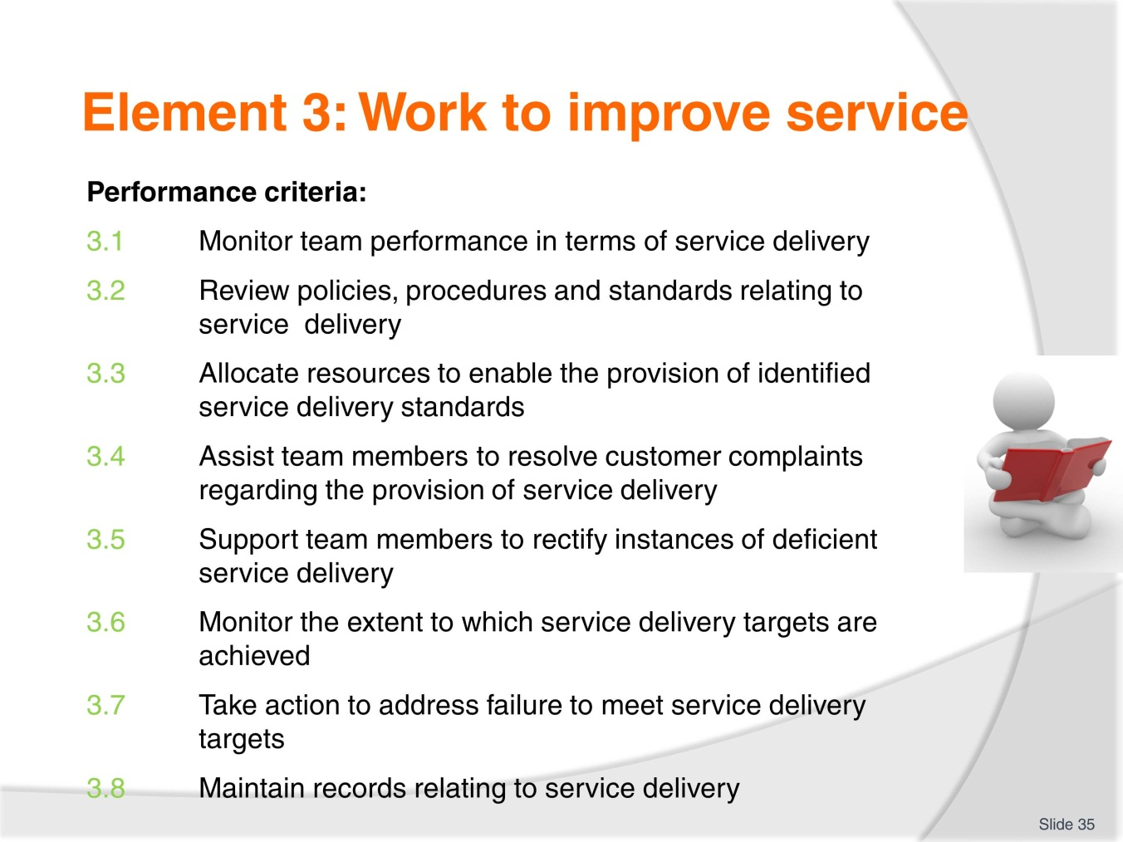
Slide No | Trainer Notes
Trainer goes through the element with trainees and trainees ask any questions.
Trainer explains work projects and assessment for this element.

Slide
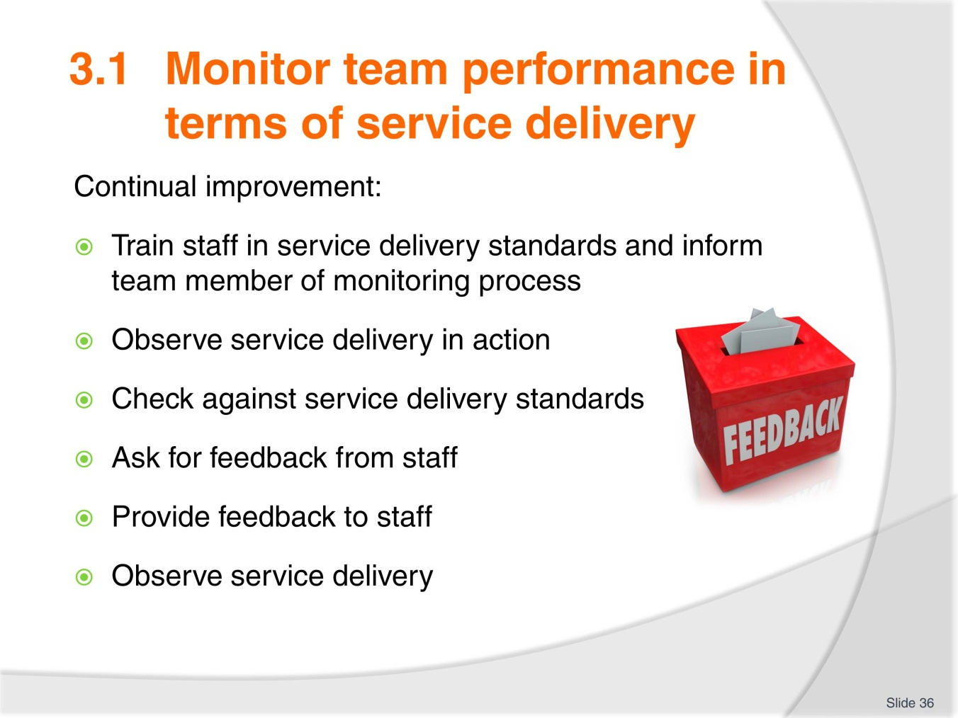
Slide No | Trainer Notes
Trainer explains that a continual improvement cycle involves constant monitoring of service delivery standards.
Trainer goes through the slide with students and shows that the cycle is repeated in order to maintain service standards.

Slide
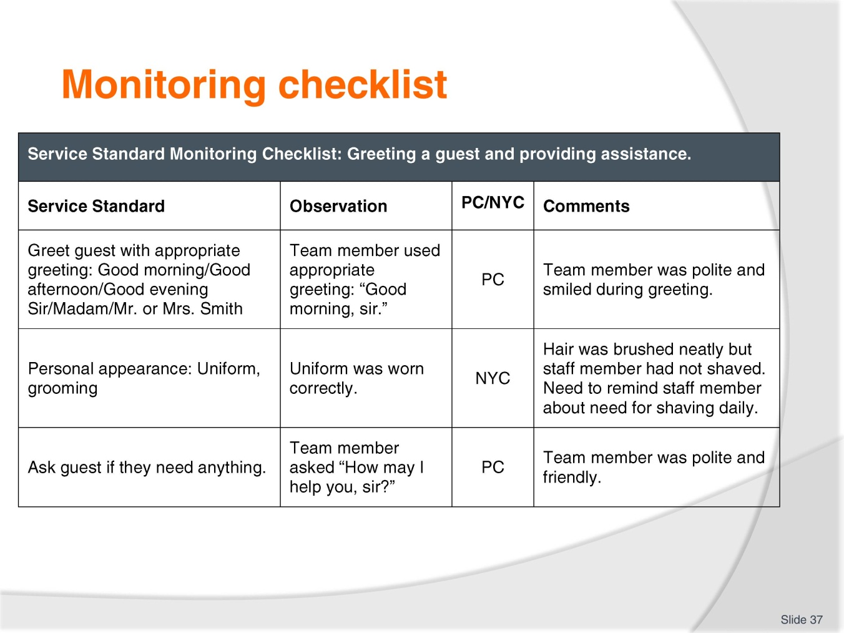
Slide No | Trainer Notes
Trainer shows students the checklist and example.
Trainer explains that checklists are a good way to show service standards required and to show these to team members before monitoring or observing actual service delivery.
They help to remind staff of the standard required but also provide a transparent and fair way to assess staff competency in a service delivery item.
Students complete the activity from the TM.
Activity
Develop a checklist for a service delivery standard and provide examples of appropriate service standards.
What else needs to be included in the checklist?
Look at the assessment checklist and plan below to help you.

Slide
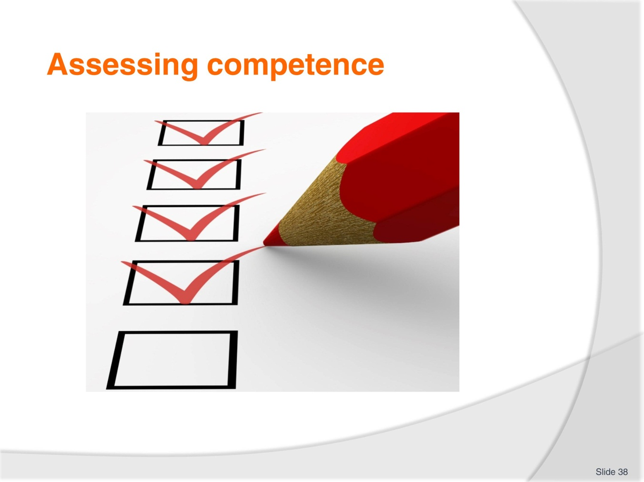
Slide No | Trainer Notes
Trainer takes students through the assessment checklist example in the TM.
Students look at all of the information and decide which the most important information is.
Students can describe examples of service delivery monitoring and assessment from their experience.
Trainer reminds students of work project and due date.
3.1 Complete a spread sheet that includes suitable information for monitoring team performance in a service delivery team. Print out and show to your trainer.

Slide
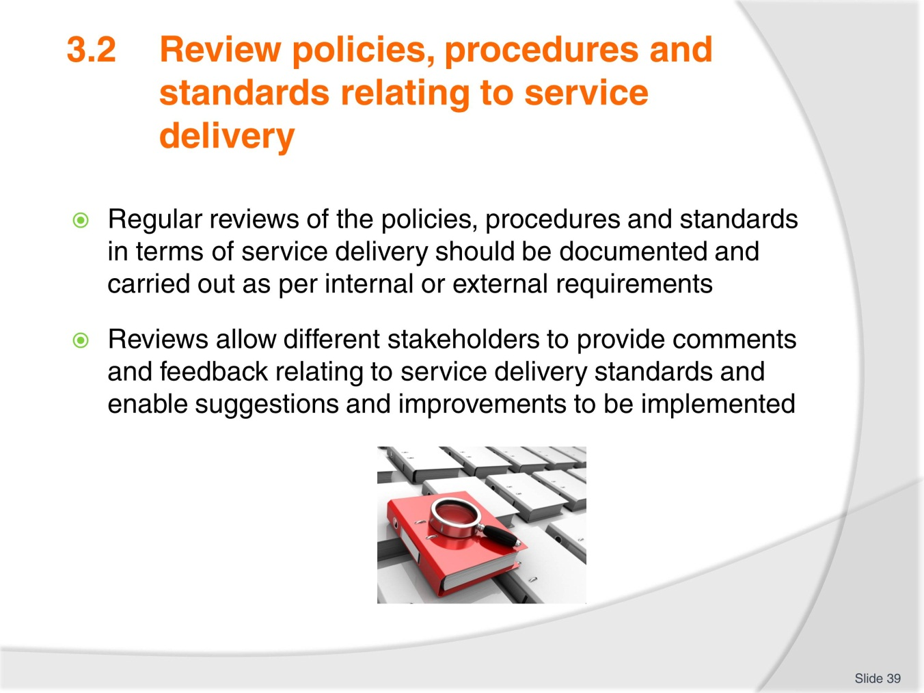
Slide No | Trainer Notes
Trainer explains the need for reviews.
Reviews should be scheduled regularly and everyone should be informed of the review time, content and when the results will be shared.
Reviews should include all stakeholders connected to the service delivery.

Slide
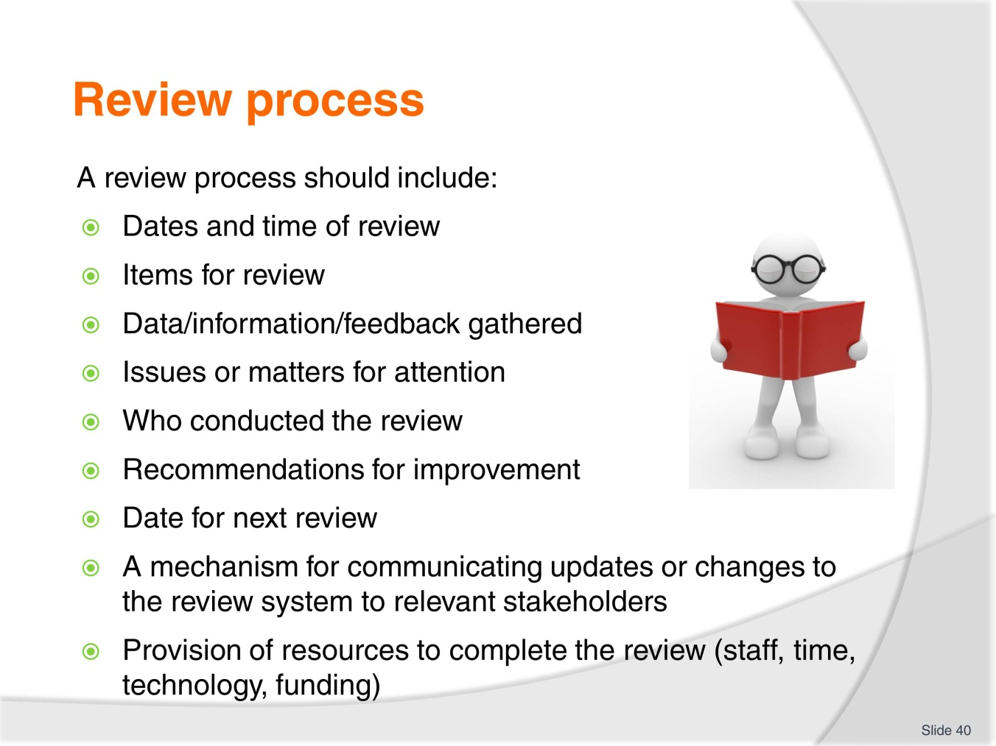
Slide No | Trainer Notes
Trainer takes trainees through the review process outline.
Trainer can bring in examples of reviews from different workplaces or from the internet or industry association reviews.
Trainees discuss their workplace practice in terms of reviews of service delivery standards and decide if they follow the same outline as in the slide.
Trainer asks if any parts of the process are missing or if there are other aspects included in the review process at their workplace.

Slide
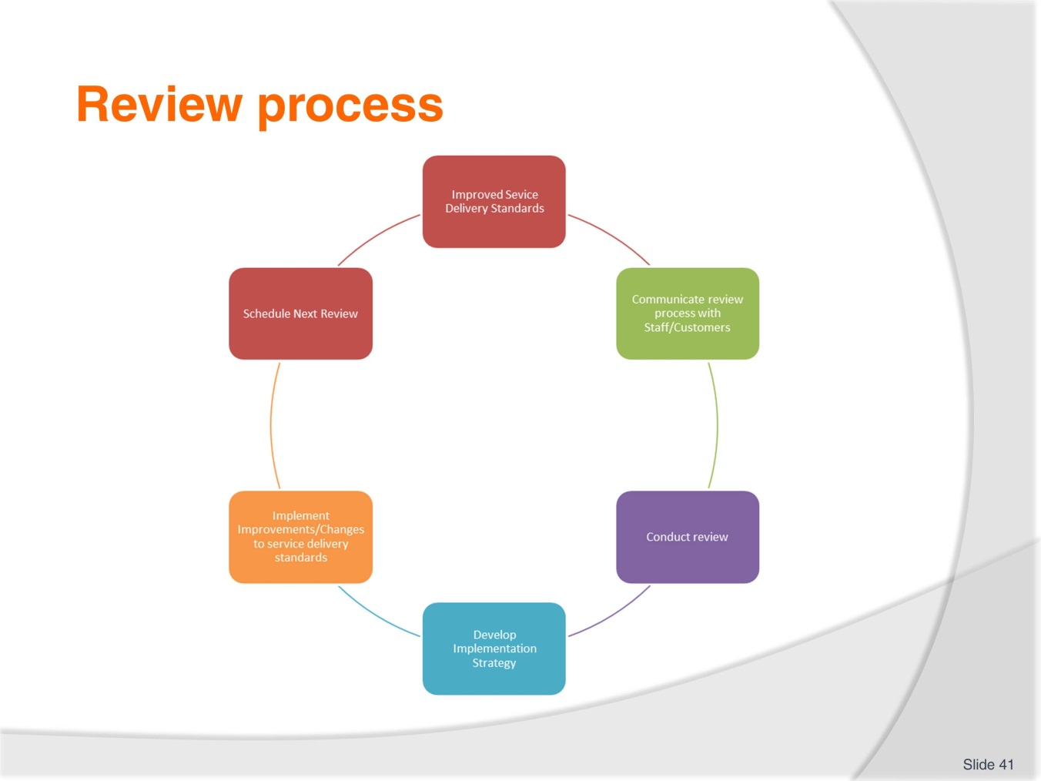
Slide No | Trainer Notes
Trainer shows slide and students discuss the process.
Trainer highlights the continual improvement cycle and explains that it is repeated.
Trainer reminds students of work project and due date.
3.2. Outline a procedure, policy and service standard that your organisation has developed and determine if there needs to be any changes to the standard. Include feedback from staff, customers, managers and suppliers if available. Explain why the item needs to be updated.

Slide
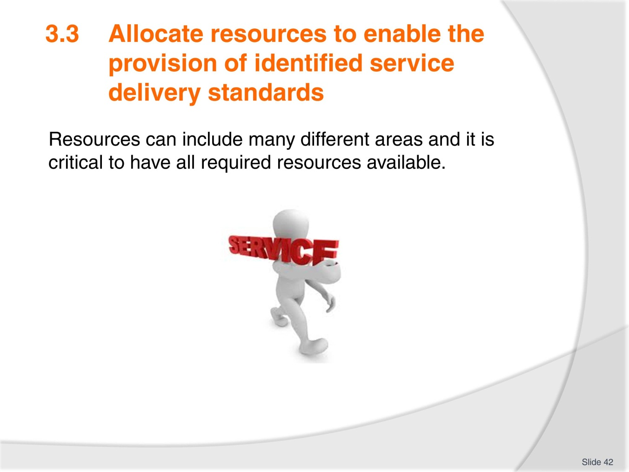
Slide No | Trainer Notes
Trainer introduces the performance criterion.
Trainer asks trainees to outline all of the different resources that may be required for a particular service delivery item.
Students discuss if they have enough resources in their workplace to complete service delivery tasks effectively.

Slide
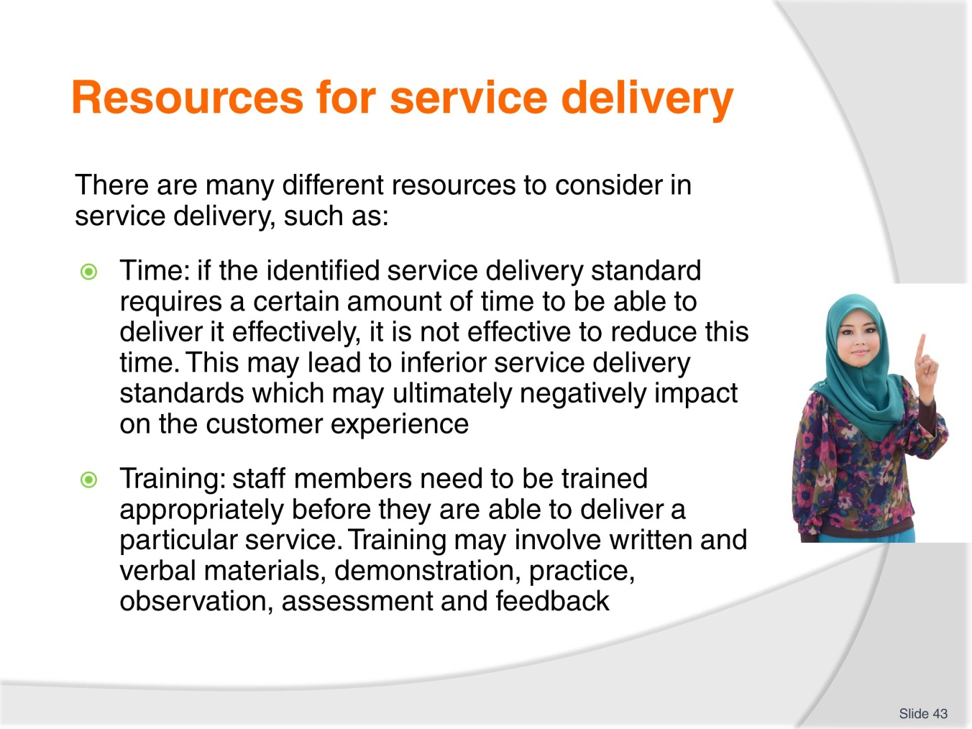
Slide No | Trainer Notes
Trainer goes through the slide content with students.
Students discuss if they have enough time to complete their service delivery tasks.
Trainer asks for examples of time allocation within their workplace setting.
What training is provided for trainees in their workplace? Is it effective? How do they know it is effective?

Slide
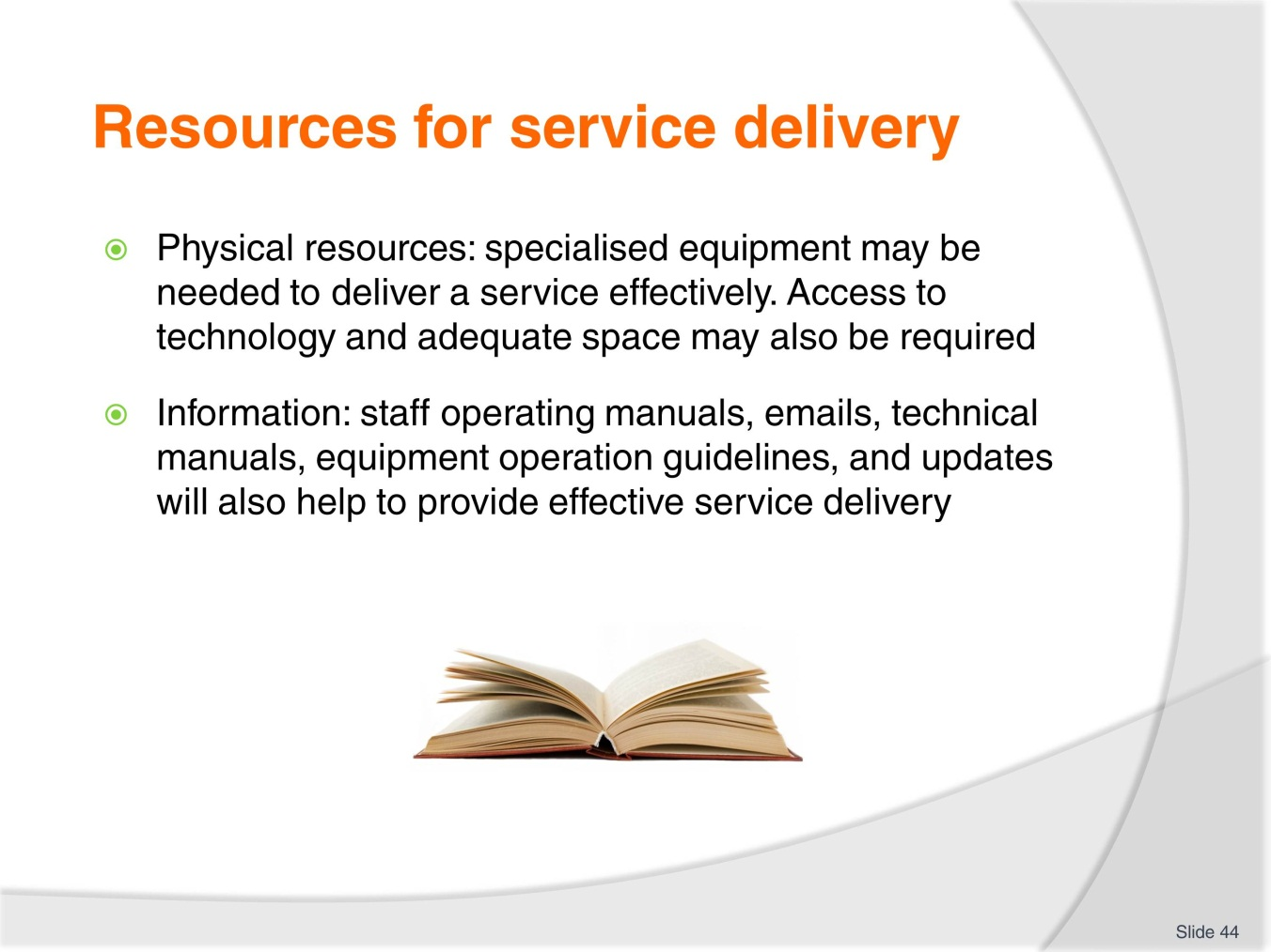
Slide No | Trainer Notes
Trainer introduces the slide and asks students to discuss the resources outlined.
Trainees describe their workplace setting in relation to the resources outlines and determine if there is enough and if the resources are appropriate for the service delivery tasks.
Trainer asks if workplace manuals are up to date, clear, reviewed regularly, and accessible.
Activity
In groups discuss all of the resources required to deliver one aspect of service delivery in your work context.
Trainer reminds students of work project and due date.
3.3. Describe a service delivery item at your workplace and the team that delivers the service. Is there enough time, people, resources allocated to the service delivery item? Bring the information to your class and discuss with your partner.

Slide
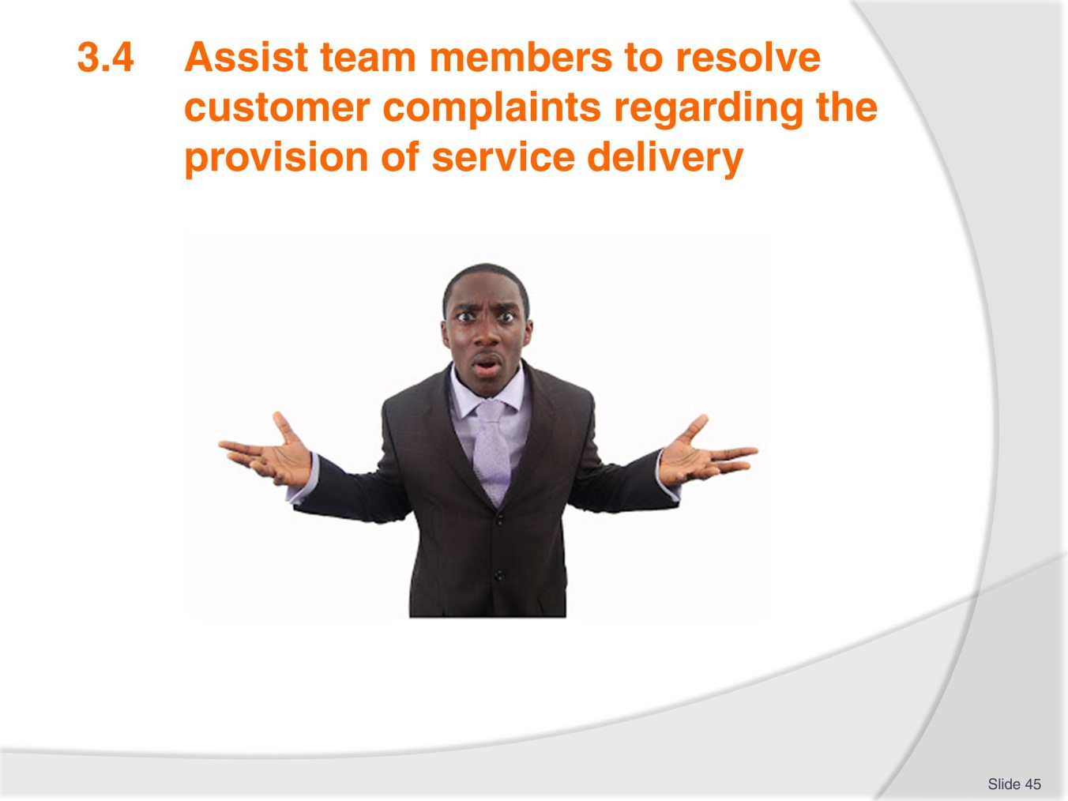
Slide No | Trainer Notes
Trainer introduces the idea of complaints in the workplace.
Trainer asks students to think about common complaints they make or receive relating to service.
Trainer asks what process they follow in dealing with complaints and who assists them in the workplace.
Students discuss common complaints and share experience of dealing with them in small groups.
Trainer can provide examples of common complaints and arrange some role plays using situational cards.
Students pretend to be the customer/service provider and show how they would deal with the complaint.
The trainer shows how a supervisor or team leader can assist in difficult situations.
Trainer takes students through the complaint process/language from the TM.

Slide
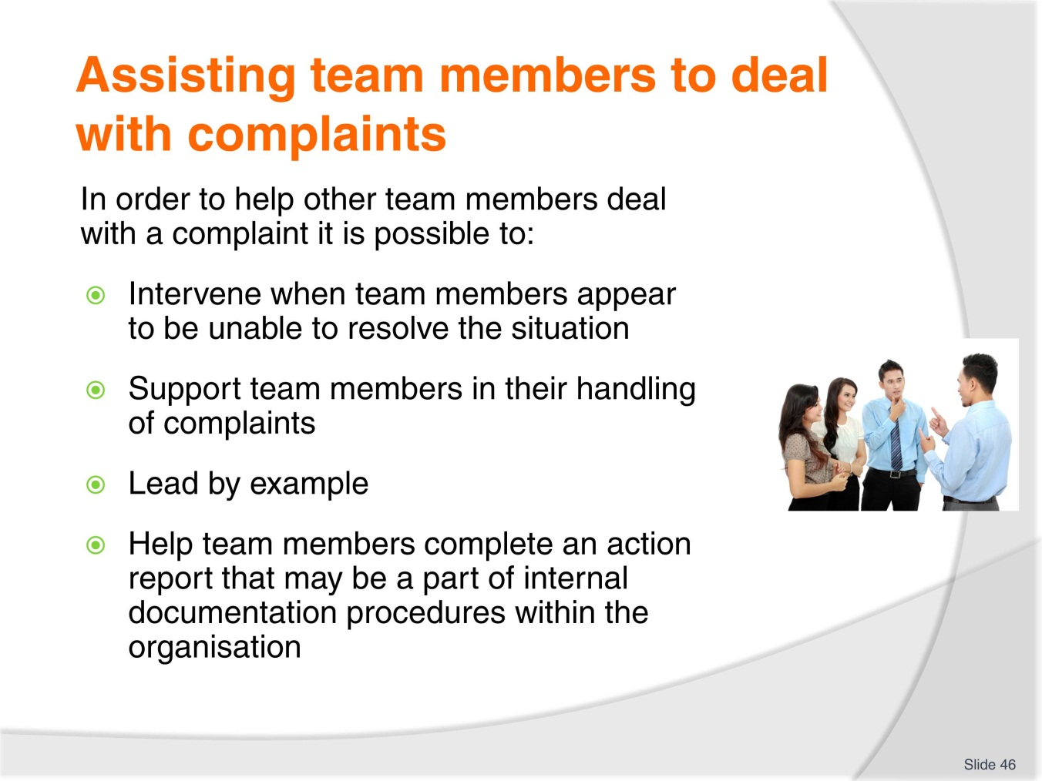
Slide No | Trainer Notes
Trainer explains that leading by example is the best way to train staff on how to deal with complaints.
Students should identify effective steps in dealing with complaints.
Trainer asks students to investigate complaint procedures from the internet and from their own workplace contexts.
Trainer asks trainees to provide examples of how team leaders or supervisors can assist in dealing with complaints.
Trainer asks if trainees feel comfortable to ask a supervisor or manager to support them when dealing with complaints.
Trainer reminds students of work project and due date.
3.4. Write down or show your trainer an example of a customer complaint and explain how you dealt with the complaint and supported a staff member. Did you follow organisation policies and procedures? What was the result?

Slide
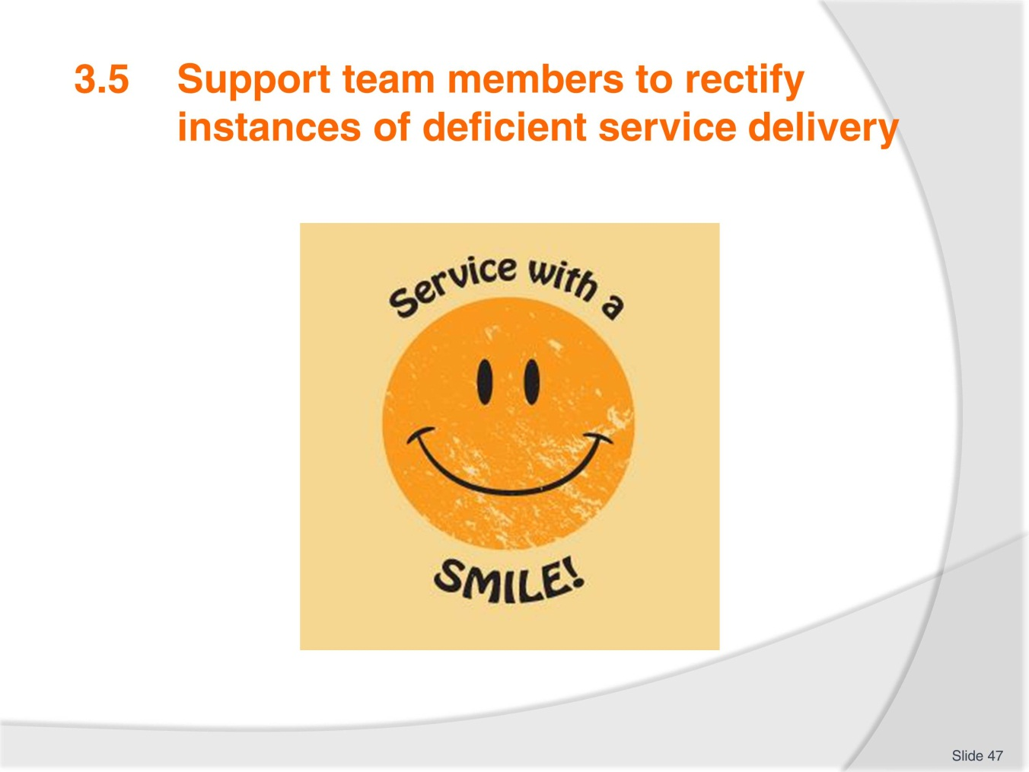
Slide No | Trainer Notes
Trainer explains that as a part of a review process or just in observation, it may become apparent that some team members are performing delivery of services at a level that is not standard.
In these cases it is necessary to help team members to adjust service delivery to meet organisational standards.
In pairs, trainees discuss situations where they have delivered service below standard or where they have observed sub-standard service delivery. This could be as a customer or as a staff member.
Trainer asks how they react when they observe sub-standard service delivery.

Slide
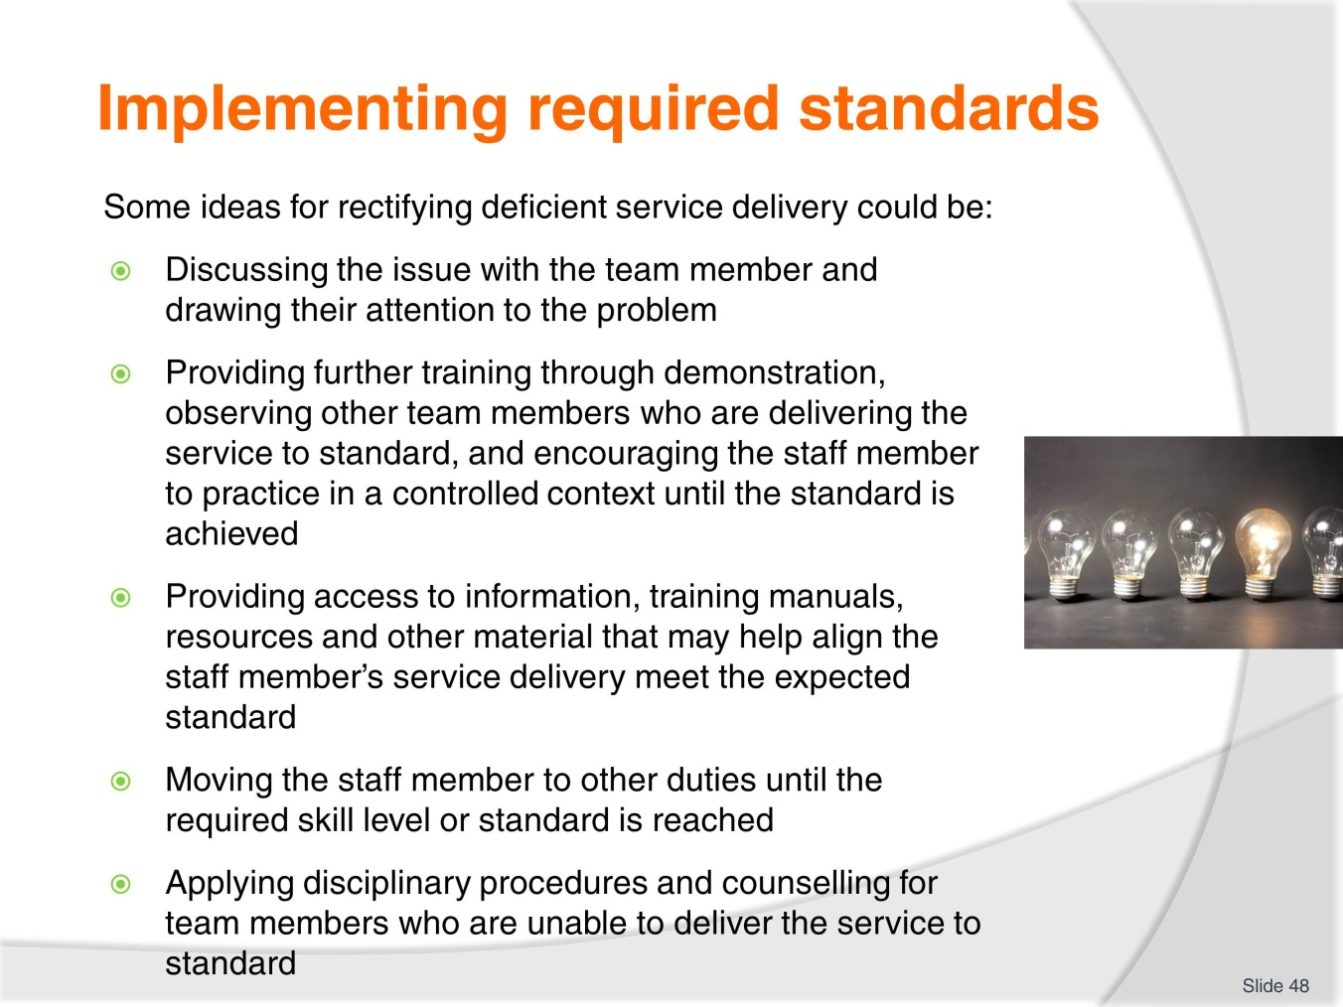
Slide No | Trainer Notes
Trainer goes through the slide with trainees and trainees offer insights and personal experience of situations where they have supported or been supported by other team members to improve service delivery.
Trainer asks how trainees’ service delivery is checked and reviewed.
Students decide if it is an effective and supportive process.
Trainer reminds trainees of work project and due date.
3.5 Describe a situation where a team member did not deliver service to the required standard. Explain how you supported the team member to lift their service delivery standard.

Slide
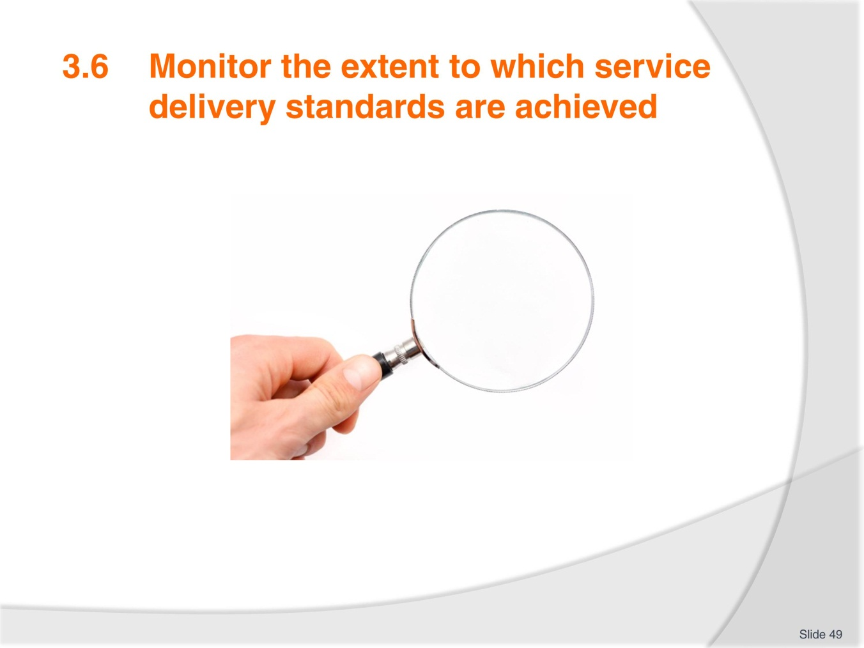
Slide No | Trainer Notes
Trainer presents the performance criterion and students consider service delivery targets in their workplace.
Trainees provide examples of service delivery targets. In small groups they discuss if targets are met and if not what makes it difficult to achieve the targets.
As has been explored in previous units, monitoring service delivery standards is critical to ensuring consistent service delivery that meets customer and organisation standards.
Monitoring needs to be regularly scheduled and based upon multiple sources of feedback or sources.
Monitoring processes need to be transparent and thoroughly explained to team members before being implemented and the outlined process needs to be adhered to.
Team members need to know how they are being assessed, when they are being monitored and what consequences or support is available if service targets are not being achieved.
Monitoring achievement of service level targets could be conducted in many ways including:
- Using objective evaluation and assessment methods which use the service standards as a guide
- Interviewing and speaking to customers formally and informally to gather their feedback regarding designated service contexts
- Gathering feedback from staff/team members
- Investigating complaints, compliments, incident reports and accident and damage reports
- Observing team members in the identified service delivery area.
If service delivery targets are not being achieved a close examination of all evidence and feedback would be required to determine where the failure in service delivery is.
This could be an isolated and minor concern or it could be a systemic failure in internal training and professional development mechanisms.
The main point is to identify if targets are being met and why they are or are not being met.
Trainer reminds students of work project and due date.
3.6 Outline service delivery standards within your service area and the targets for the service delivery. Explain which targets have been met and which have not. Offer reasons why the targets have/have not been met and what can be done to maintain or develop the service delivery item.

Slide
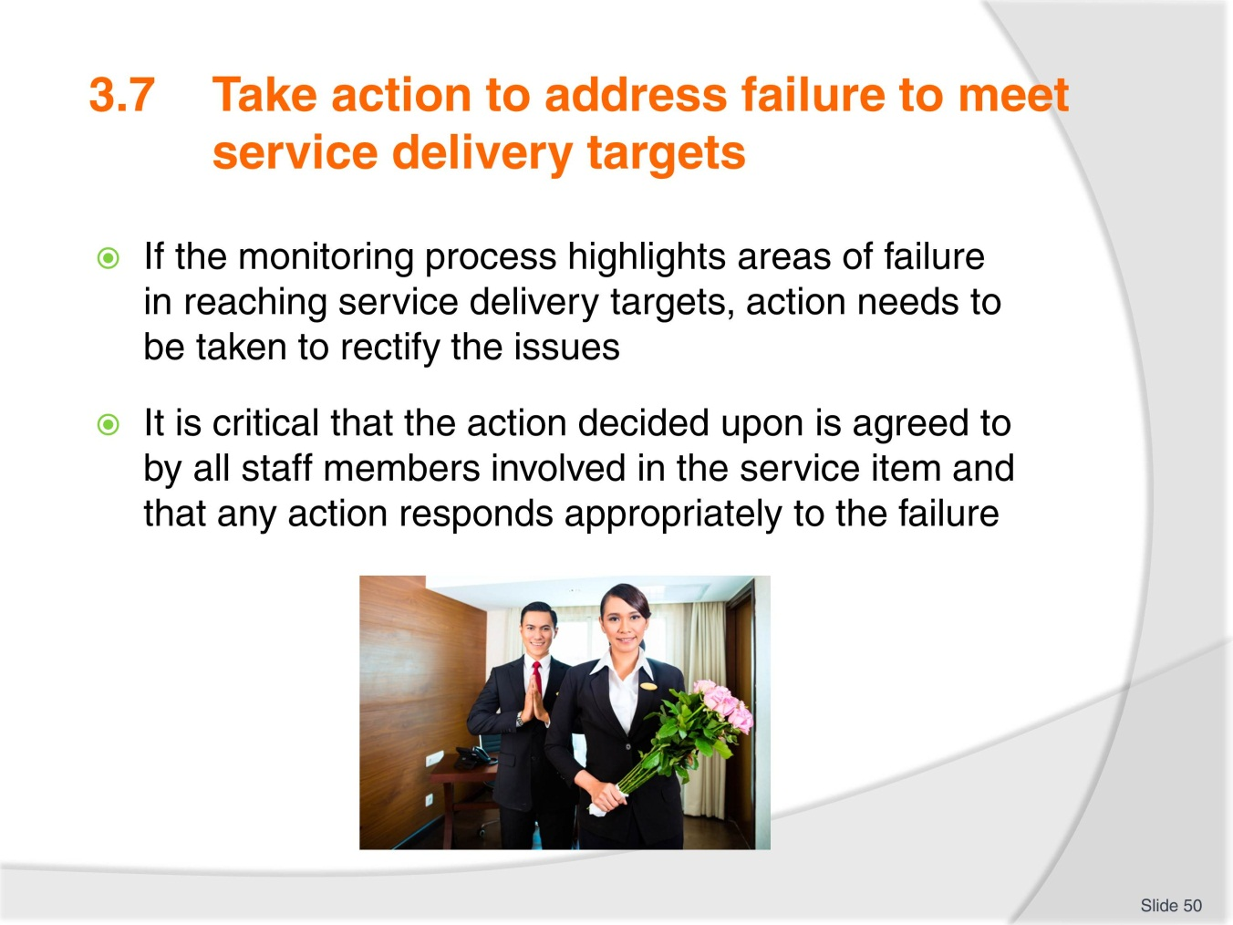
Slide No | Trainer Notes
Trainer goes through slide with trainees and explains the need to take action once service delivery standards have been deemed to be sub-standard.
Trainer explains that some action may be immediate and relate to smaller issues whereas some action may be more significant and long term.
Trainer explains that it is important that any action taken needs to be appropriate and communicated effectively.

Slide
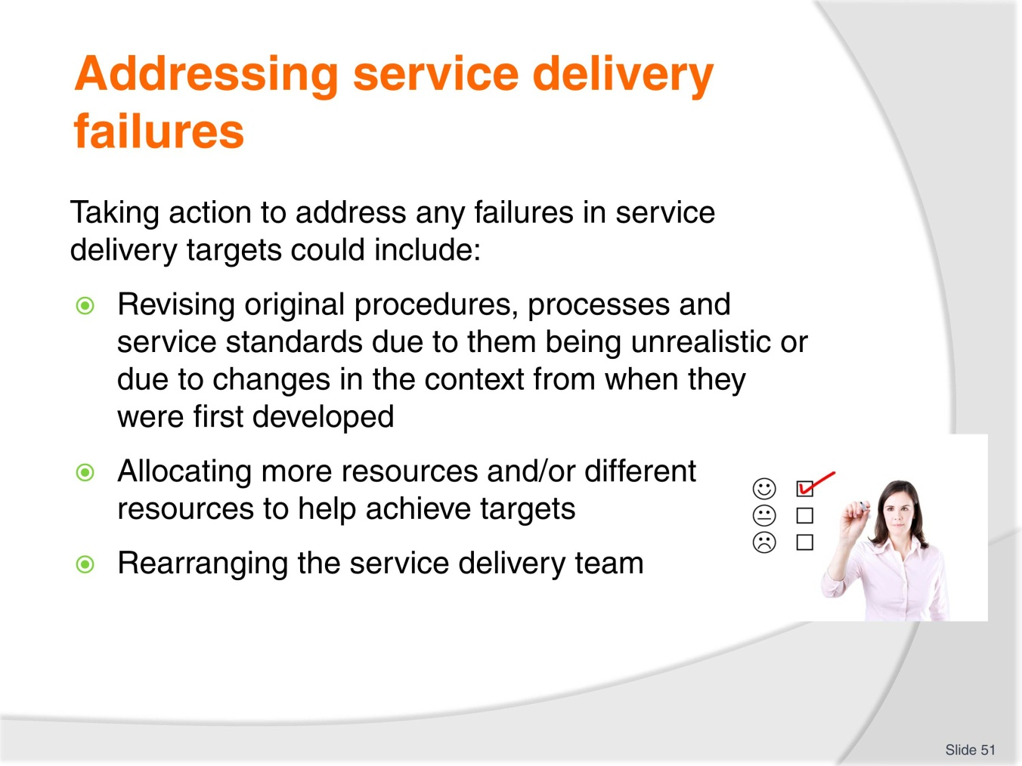
Slide No | Trainer Notes
Trainer explains that there are many different actions that can be taken to rectify service delivery failures.
Trainer goes through the slide with students and asks students for examples where service delivery action has been taken in their workplace.
Trainees offer ideas on how they can take action to improve sub-standard service delivery.
Trainer asks what process they follow.

Slide
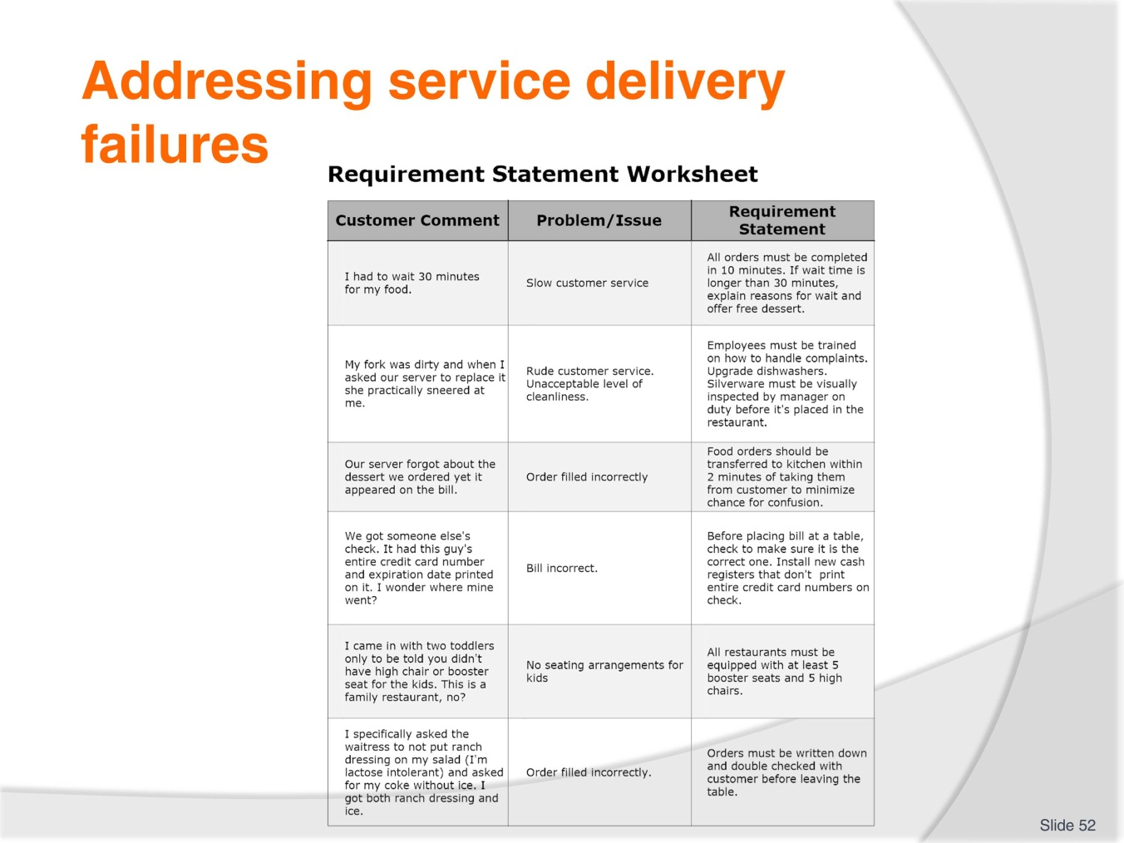
Slide No | Trainer Notes
Trainer introduces slide and students read through the content.
Trainer asks how trainees would implement the suggested actions in the example.
Trainees give other examples from their workplace and share action that they have taken to resolve the issue.
Trainer reminds students of work project and due date.
3.7 Describe a situation where you had to take action to fix a failed service delivery situation. Discuss this with your classmates and share ideas on successful ways to address a failure.

Slide

Slide No | Trainer Notes
Trainer explains that there are many records that need to be kept in any organisation.
Records allow for information to be evaluated, comparisons to be made, and they provide evidence of stated objectives or targets.
Records need to be maintained in an effective manner or they become meaningless and difficult to use.
Maintaining records is an integral part of any successful organisation and developing systems that are easily accessible and comprehensive is important in any role.
Trainer asks students to read through the information in their TM and discuss with their partner.

Slide
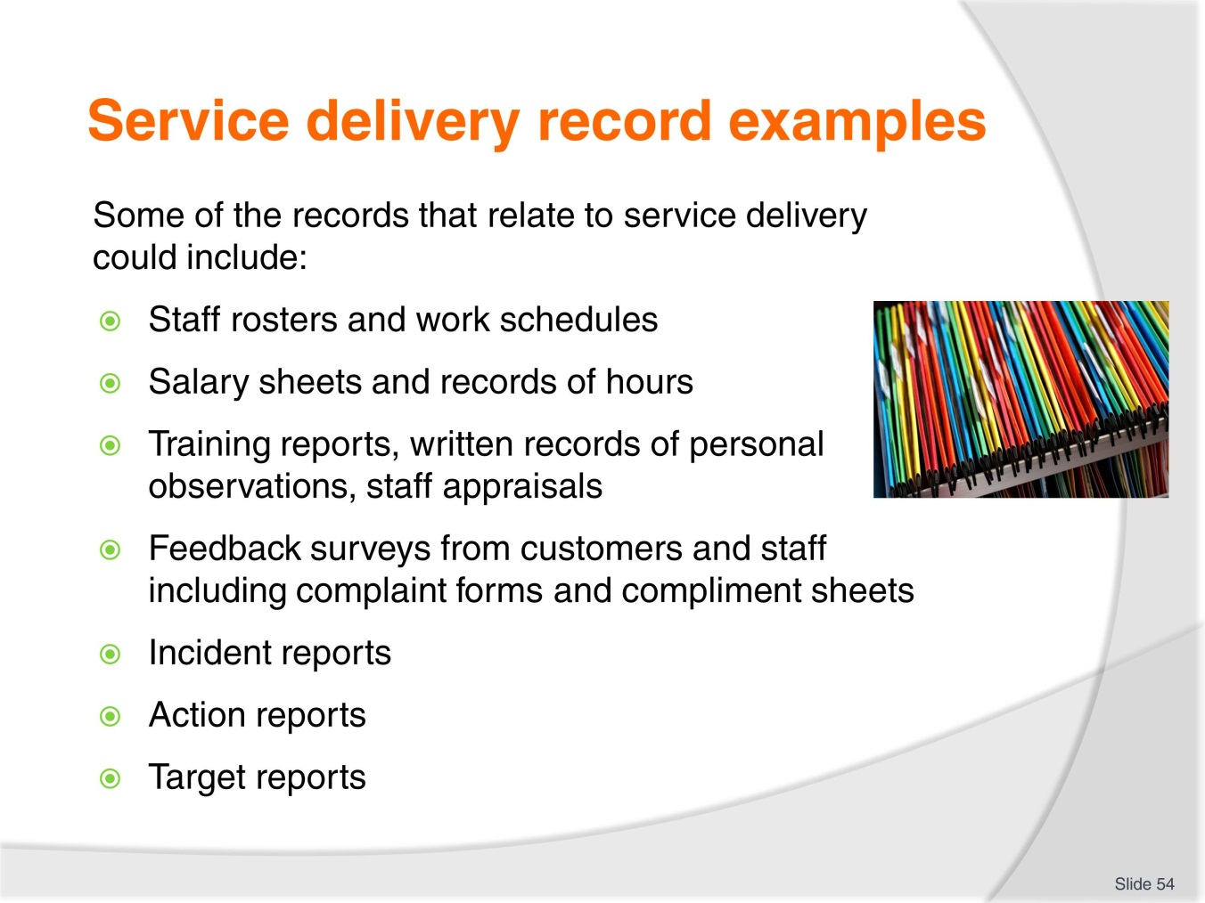
Slide No | Trainer Notes
Trainer explains that any record keeping system needs to be easy to use in order for it to be effective.
With computer technology readily available nowadays, a filing system that uses databases or computer generated filing systems is an easy and effective option for maintaining records related to service delivery. This may be combined with a paper based system which offers back-up if the technology fails.
If both paper-based and computer generated systems are used it is critical to have a system that enables both forms to updated, otherwise the system is ineffective.
It is also important to consider who and why people may need to access the records before developing a filing system.
Trainer goes through the slide with the class and students provide examples from their workplace.
Trainer asks how service delivery records are maintained in their workplace.
Trainer can bring examples sourced from the workplace, internet or other materials.
Trainer reminds students of work project and due date.
3.8 Bring examples of service delivery records from your workplace and show your trainer. Explain the process of maintaining the records.

Slide
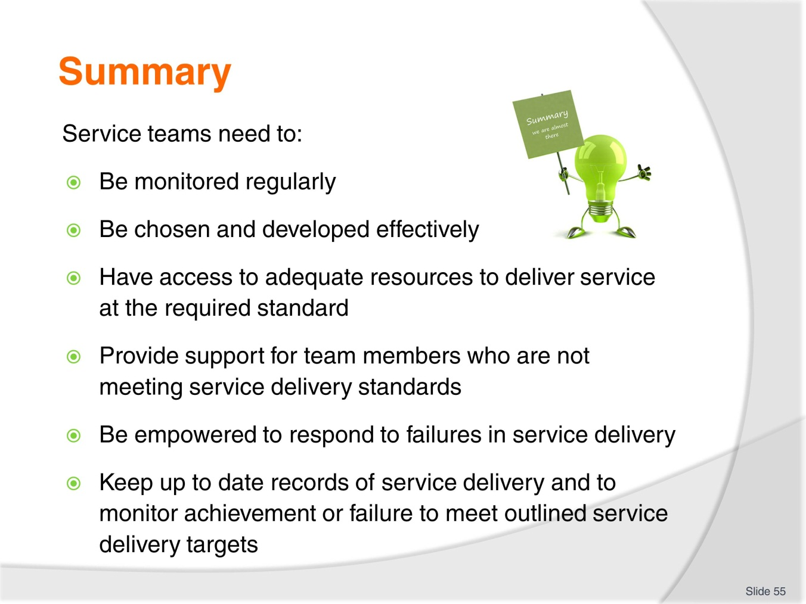
Slide No | Trainer Notes
Trainer goes through the summary of the element with the class.
Trainees ask any questions and trainer responds.
Trainer assesses students using assessment manual questions and records answers on student assessment sheets.
Trainer checks portfolios and work projects.

Slide
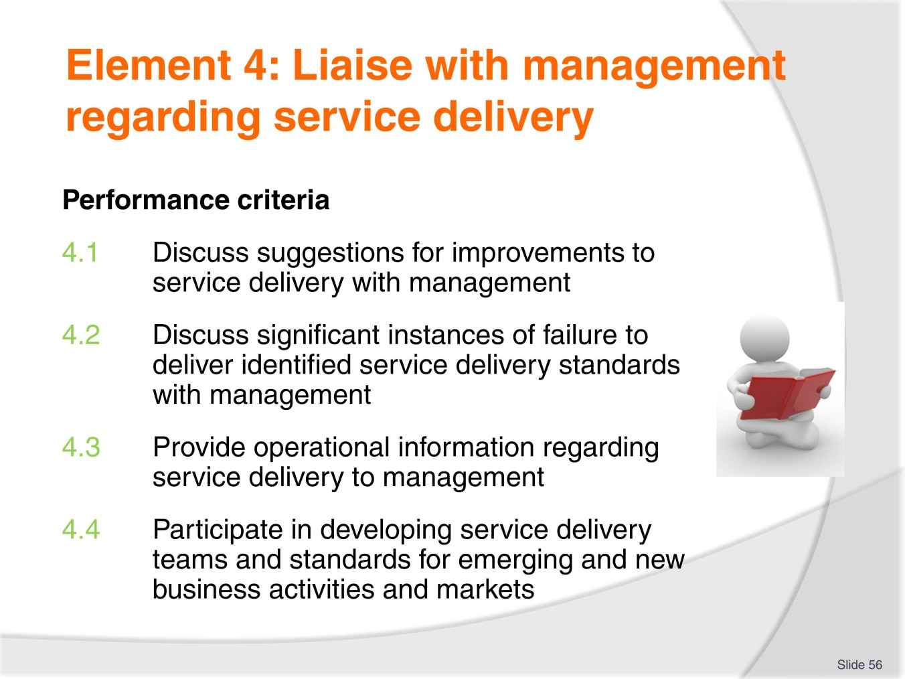
Slide No | Trainer Notes
 | Trainer goes through the element performance criteria with students and outlines work projects that will be required to be completed.

Slide

Slide No | Trainer Notes
Trainer introduces slide and explains that planning for discussions with management are important.
Trainees need to have all the relevant information, evidence and possible solutions ready to share with management.
Trainer can draw upon communication ideas from below and discuss with trainees how to communicate effectively and professionally.
Trainees provide examples of discussions with management and how they have approached the situation.
Oral Communications
People who are successful communicators take full responsibility for success in the communication process. These people take responsibility for being certain that you understand what they are saying. They recognise that barriers to good communications exist so they speak in simple, grammatical, and understandable terms. They also give examples, ask for feedback, put what they said previously in different words, and make it easy for you to gain the true intent of their communications. However, this in no way frees the listener from responsibility from the process. Without proper listening, communication does not occur.

Listening Skills
Effective listening is active participation in a conversation. It is an activity which helps the speaker become understood. The listener must actually hear and not assume what is said. A passive listener is attentive but does nothing to assist the speaker. Active listeners sit or stand alertly, maintain eye contact with the speaker, concentrate on the speaker’s words, make verbal responses, and summarise parts of what has been said when clarity is needed.
Because there is a difference in how fast one can speak and how fast others can listen, a time lag exists in conversations. Good listeners do not daydream during this lag; they use the time to organise what is being said and to relate to the message. The listener must guard against distractions to the message. The speaker’s mannerisms, accent, dress or grooming, language style, or delivery can be distracting if the listener does not learn to tune them out. Also, listeners need to learn to avoid letting first impressions of a speaker colour their ability to hear the message.
We cannot learn anything from others if we try to do all the talking. Therefore, let speakers finish out their own sentences. Don’t interrupt them to interject your own thoughts. We need to pay attention to the tone of the words and the nonverbal cues of the speaker. Sometimes, these things undermine the actual meanings of the words themselves. For instance, someone might be telling you that he or she is not upset, but the tone or the body language might tell you otherwise.
Overall, effective listening can be expressed as follows. You should concentrate so that competing external and internal distractions are eliminated. You should probe and reflect by asking questions to seek clarification and greater understanding. You might ask “Is this what you mean?” or “Could you repeat that?” or “Are you saying that…?” Finally, you should summarise (paraphrase) and feed back to the speaker what you think you have heard. When the speaker agrees that your understanding is indeed accurate, then effective listening and effective communication have taken place.

Slide
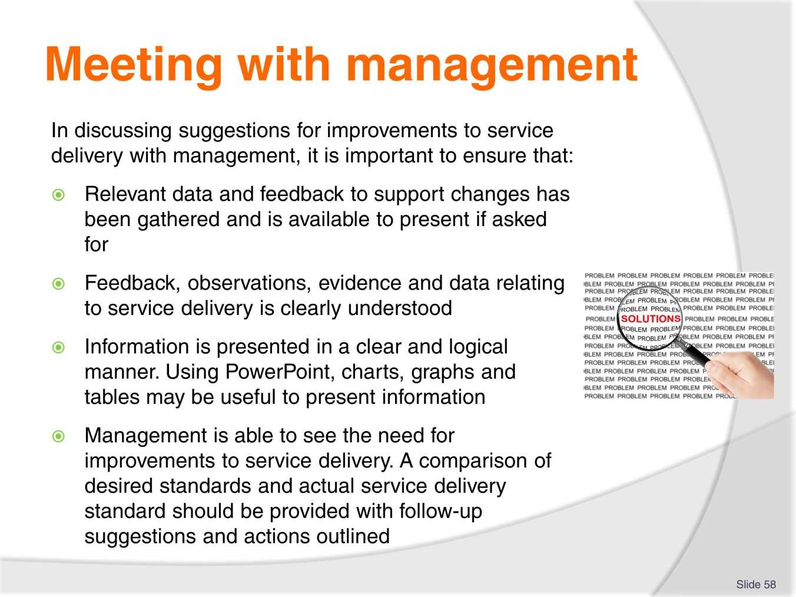
Slide No | Trainer Notes
 | Trainer presents slide and trainees ask any questions. Trainer asks trainees how they prepare for discussions with management and if they have been successful in sharing issues with management. What issues have they found difficult to deal with when discussing service delivery with management?

Slide
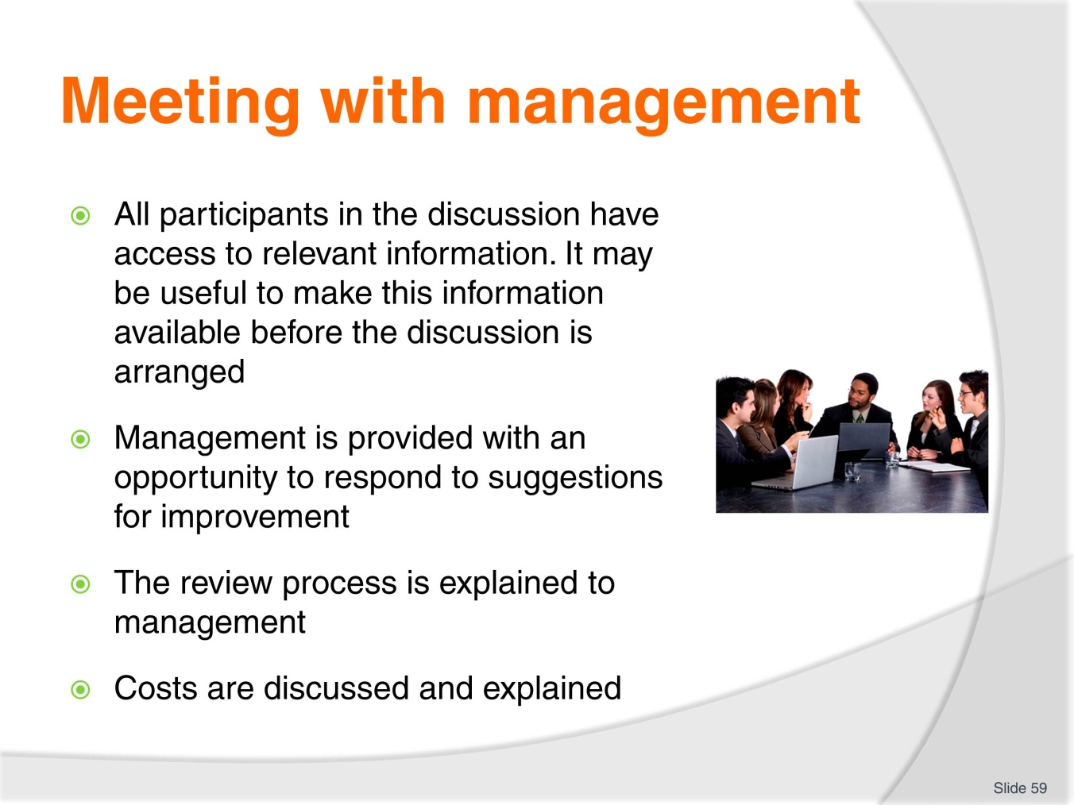
Slide No | Trainer Notes
Trainer goes through slide with trainees.
Students suggest the best way to discuss issues of service delivery with management.
Trainer shares examples of service delivery issues that may be brought to the attention of management such as the need for more human resources or new equipment.
Trainer reminds trainees of work project and due date.
4.1 Bring an example of a meeting with management that related to service delivery improvements. This could include emails, meeting notes, action plans etc. Show your trainer and explain the situation.

Slide
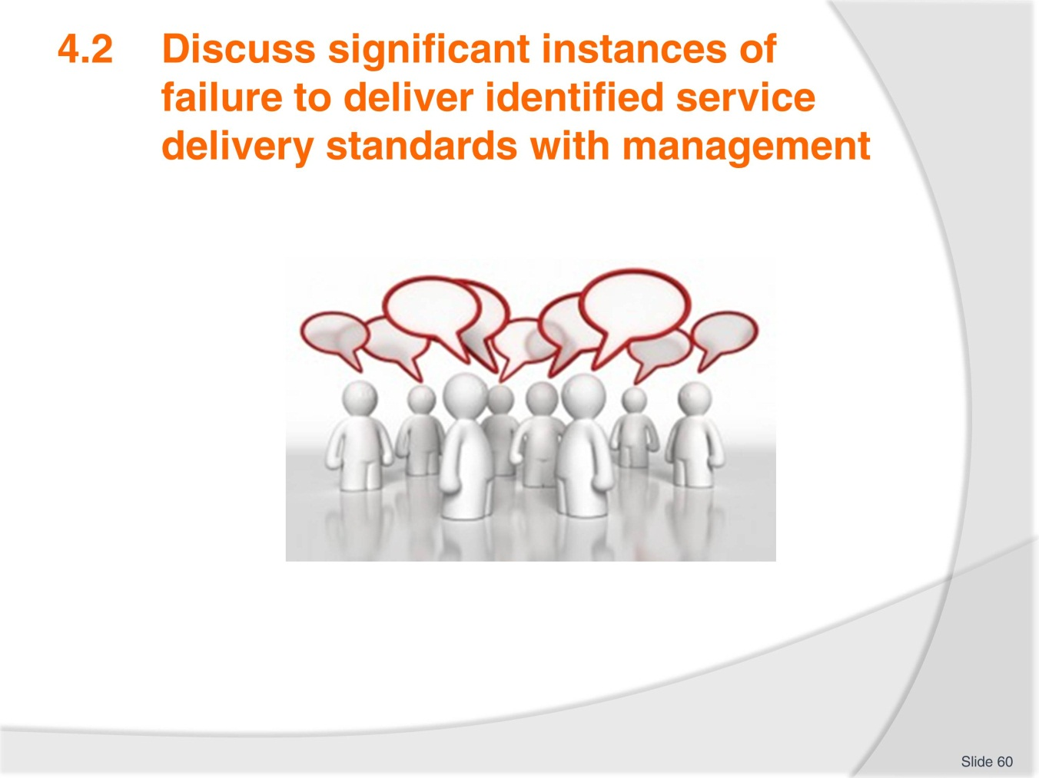
Slide No | Trainer Notes
Trainer explains that there may be many instances of sub-standard service delivery within an organisation but not all failures to meet standards will be significant.
Many instances of not meeting delivery standards can be improved easily through discussion with team members and demonstration or further training. Some instances of failure to meet delivery standards may be more serious and could be a result of many different factors.
These factors could include technology failure or inadequacies, cost issues, lack of skilled staff or rapid growth in customers. Identifying failures in service delivery standards is not something that should be avoided. Being able to identify serious issues with service delivery shows that the review system is working and it is important to address the issues as soon as possible in order to rectify them.
Keeping management informed enables them to deal with any potential negative effects of the sub-standard service delivery. Management can anticipate issues that could arise and they are able to plan a strategy to deal with any impacts caused by the service delivery failure.
Students provide examples of significant service delivery failures and discuss in small groups. Trainer monitors discussion and offers input as required.

Slide
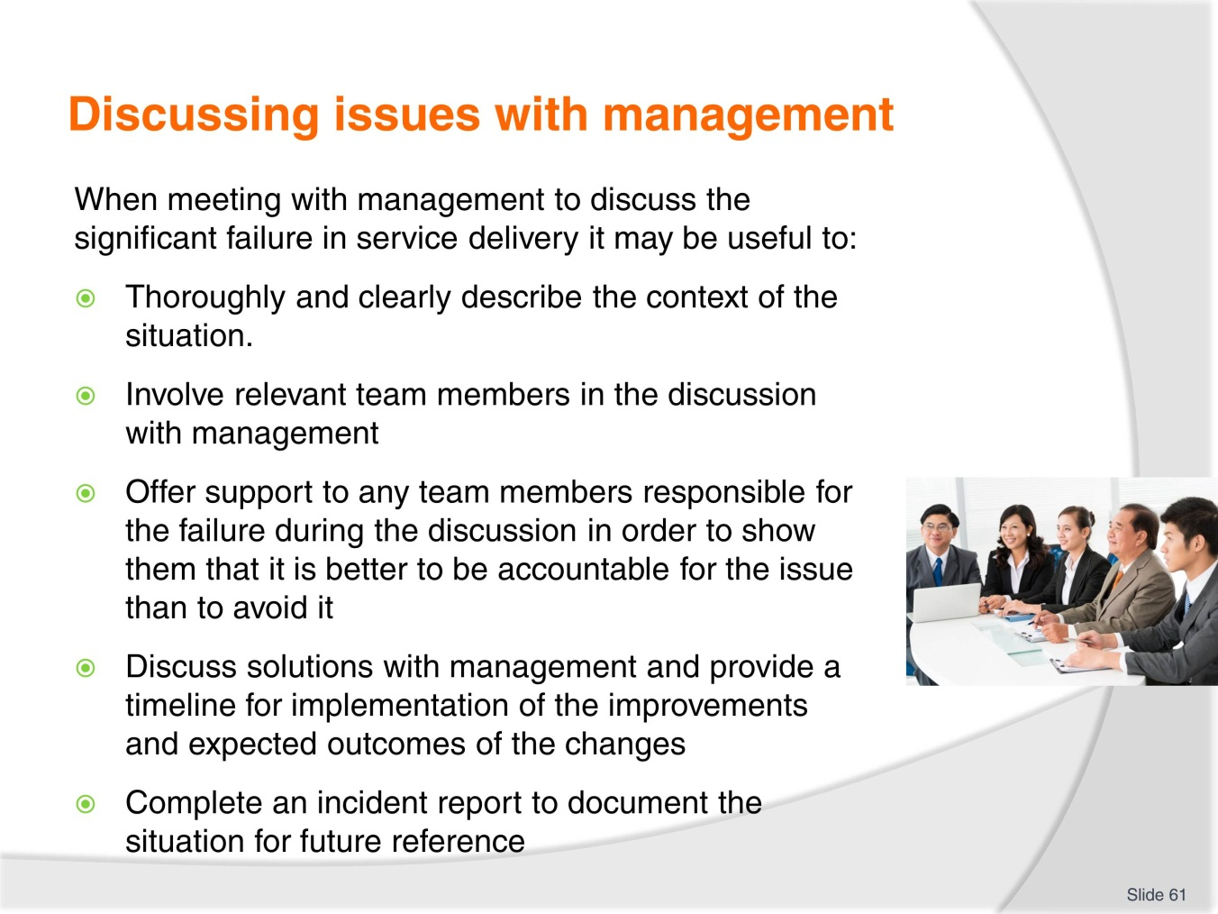
Slide No | Trainer Notes
Trainer goes through the slide content with trainees.
Trainer asks if trainees have ever performed service delivery well below standard or observed this and were they required to speak to management?
Trainer elicits that supporting staff in management meetings is crucial in developing strong rapport with team members and in establishing supportive organisational culture.
Trainer asks if trainees have had to complete an incident report before.
Trainer provides example of an incident report. There are many examples online freely available.
Trainer reminds trainees of work project and due date.
4.2. Describe a time when service delivery standards were not met. Write down what the situation was and how you raised the issue with management. Provide the written outline to your trainer.

Slide
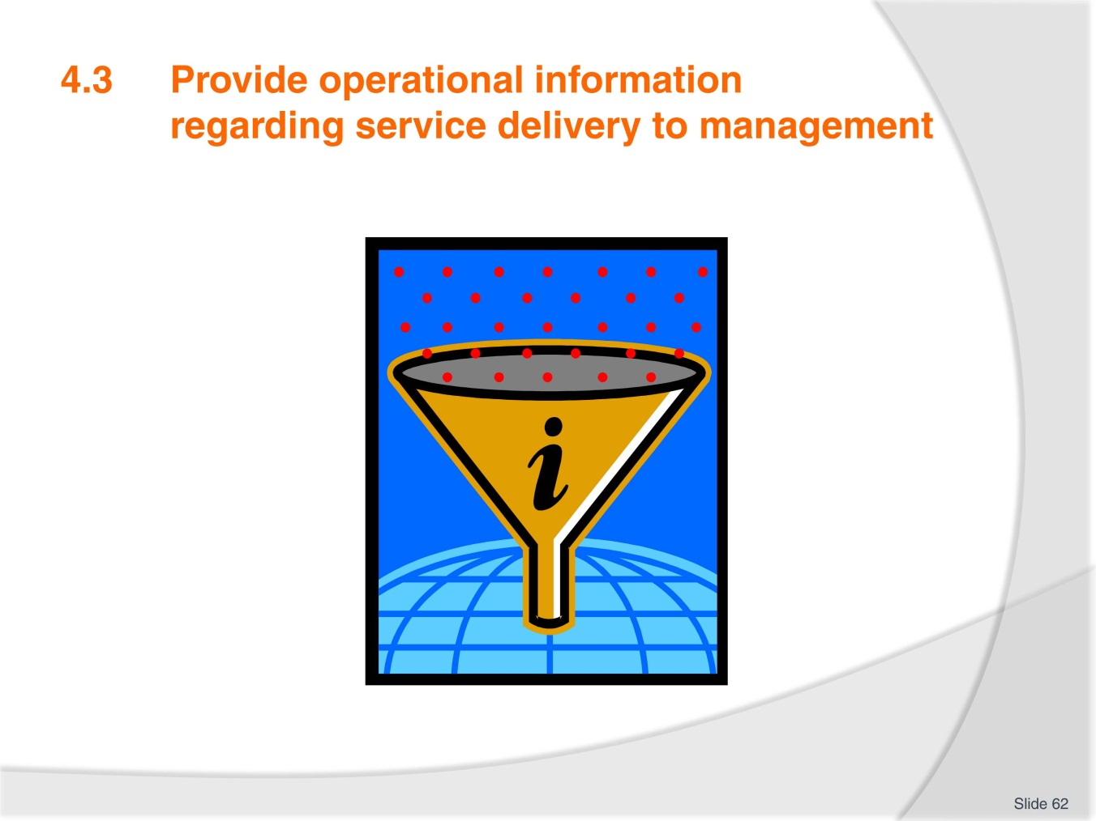
Slide No | Trainer Notes
Trainer explains that operational issues have a major influence on service delivery standards and identifying key operational information that relates to service delivery is an important step in the service delivery process.
Trainer asks trainees to brainstorm operational areas that can impact on service delivery: budget, scheduling, roster, annual leave/sick leave, equipment failure etc.

Slide
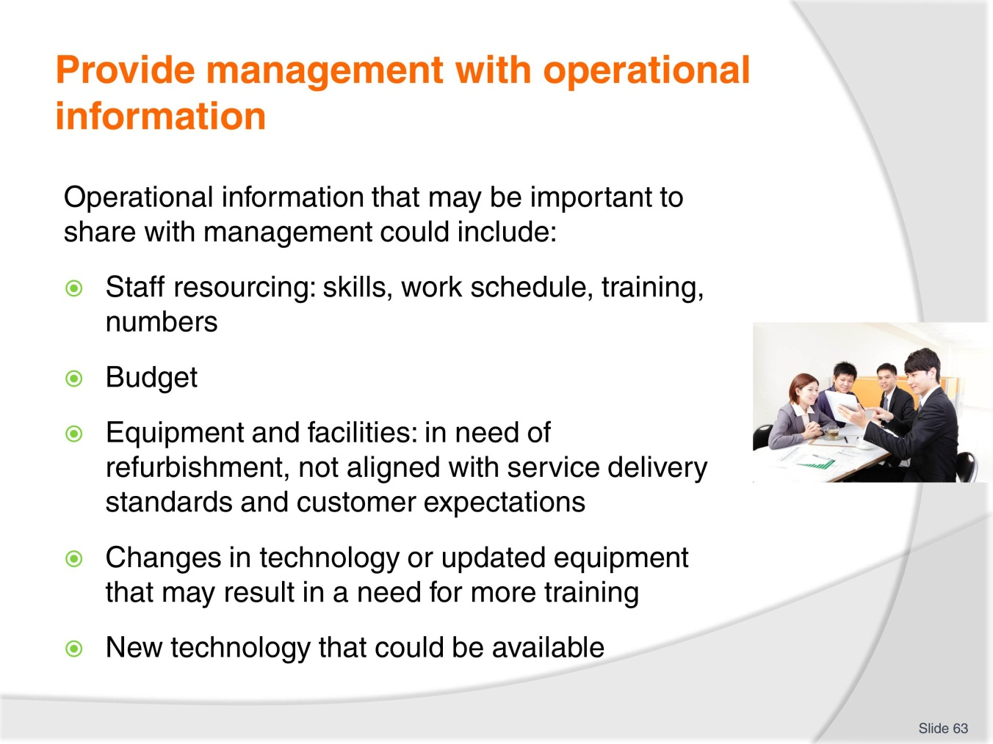
Slide No | Trainer Notes
Trainer explains that management need to be updated on service delivery challenges and success in order to plan for future targets.
Clear communication between team members, supervisors, and management enables the organisation the best opportunity to reach the service delivery targets that have been set.
There are many operational issues that impact on service delivery and this information needs to be shared with management in a timely and effective manner.
Trainees discuss issues and success they have encountered in pairs and how management dealt with the information.
Trainer reminds trainees of work project and due date.
4.3. Provide an example of operational information you have shared with management in your workplace. Show your trainer and explain what the operational information is and how it is used.

Slide
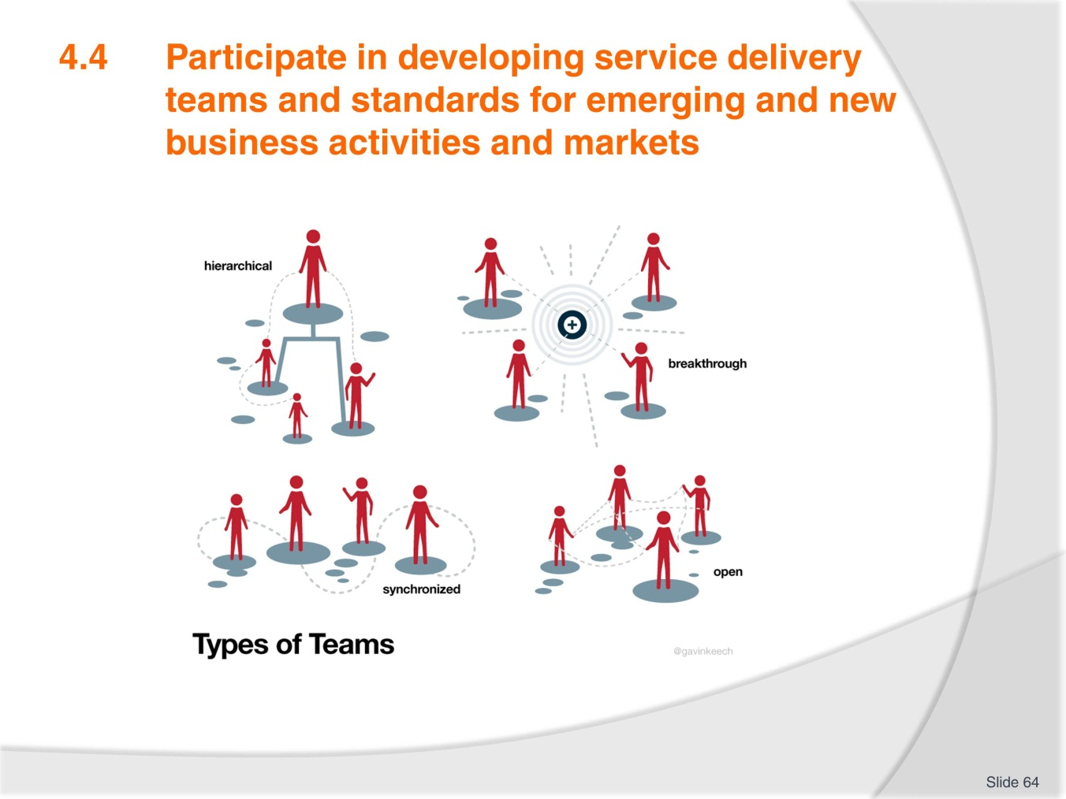
Slide No | Trainer Notes
Trainer presents slides and asks trainees to provide examples of different kinds of teams they have been a part of.
Were the team structures similar to the slide examples?
Ask participants to look at the different team types and describe their service team/organisation structure.

Slide
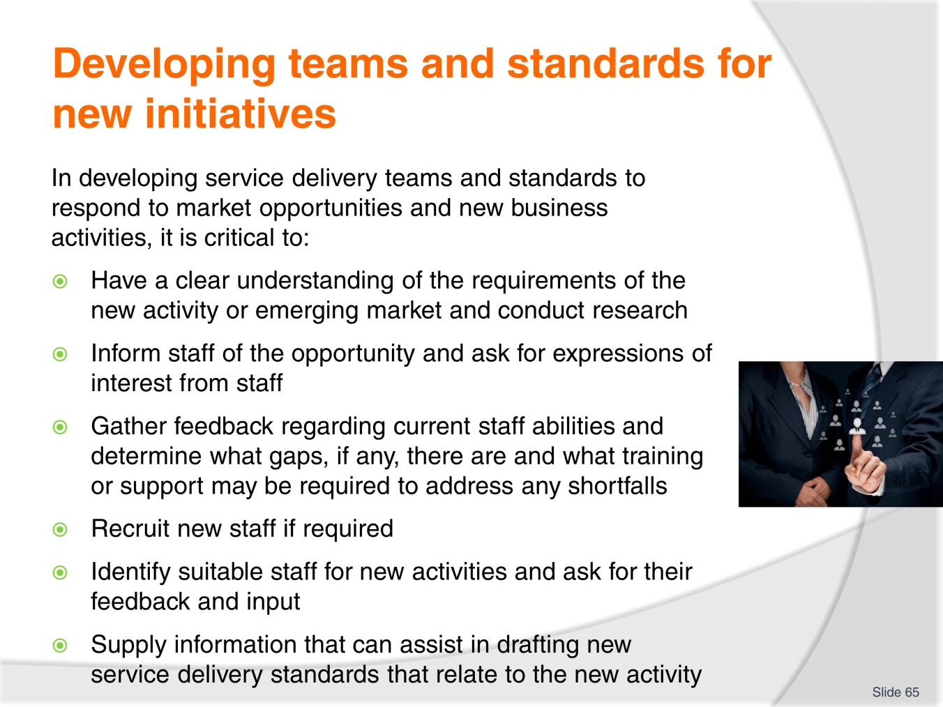
Slide No | Trainer Notes
Trainer goes through the slide with trainees and elicits the ideas of forming, norming etc. from previous element.
Trainer explains that identifying the new business activity and understanding the requirements of the activity is critical in developing an effective team to respond to the new activity or service delivery standard.

Slide
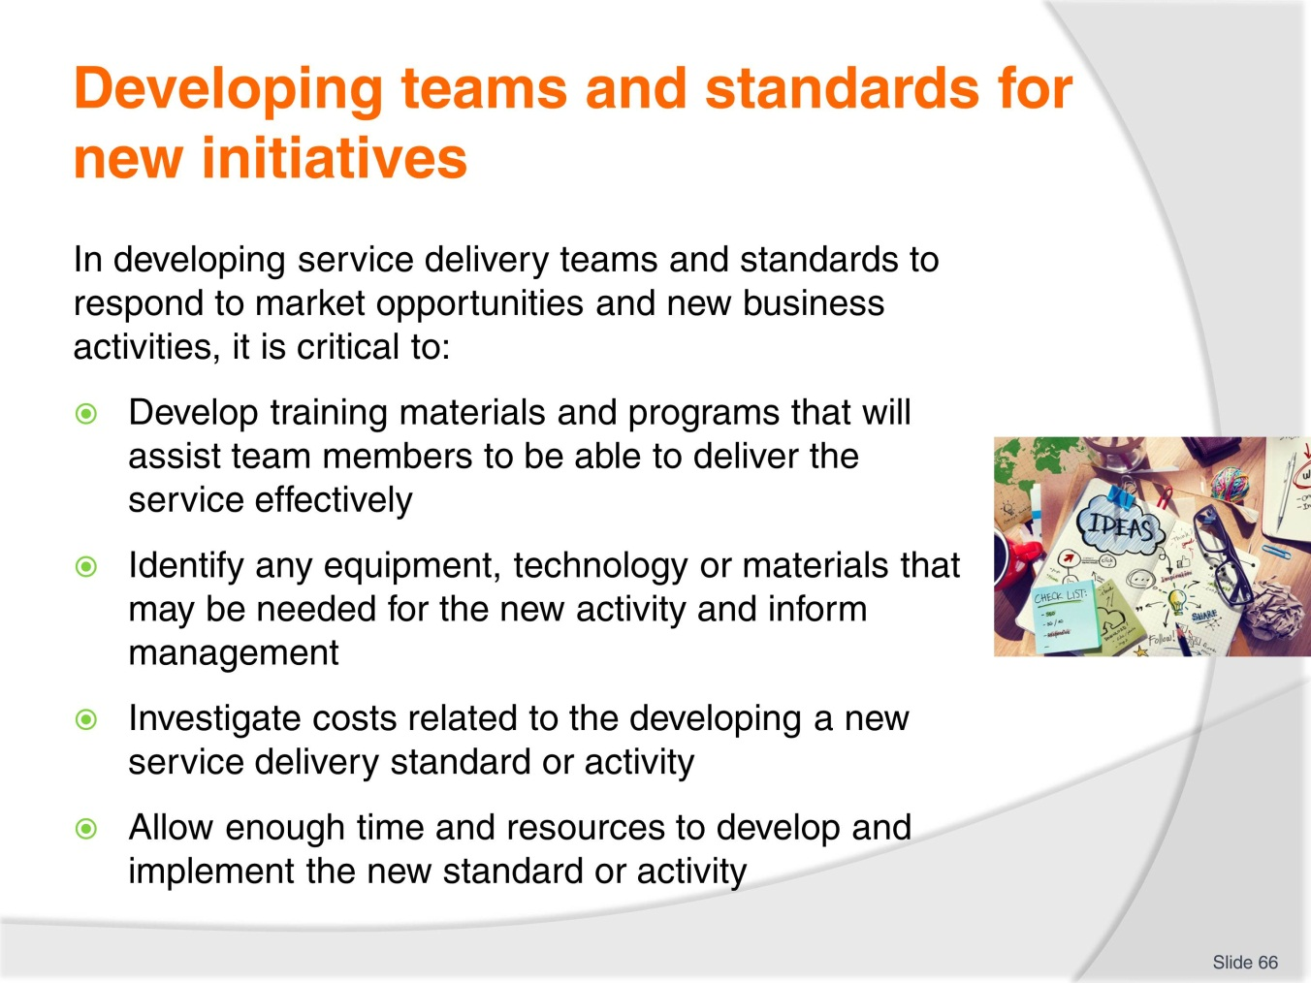
Slide No | Trainer Notes
Trainer presents slide and content to trainees.
Trainer elicits that team members need to have access to support materials and training to be able to implement new service standards.
Trainees need to be aware of cost factors that may impact on the service delivery item as well.
Trainer reminds trainees of work project and due date. Trainer assesses trainees using assessment manual questions.
4.4. Outline a new service delivery standard or business activity that your team will be implementing. Write down what the new activity is, why it has been developed and describe the process that is required to implement the new standard or service activity.

Slide
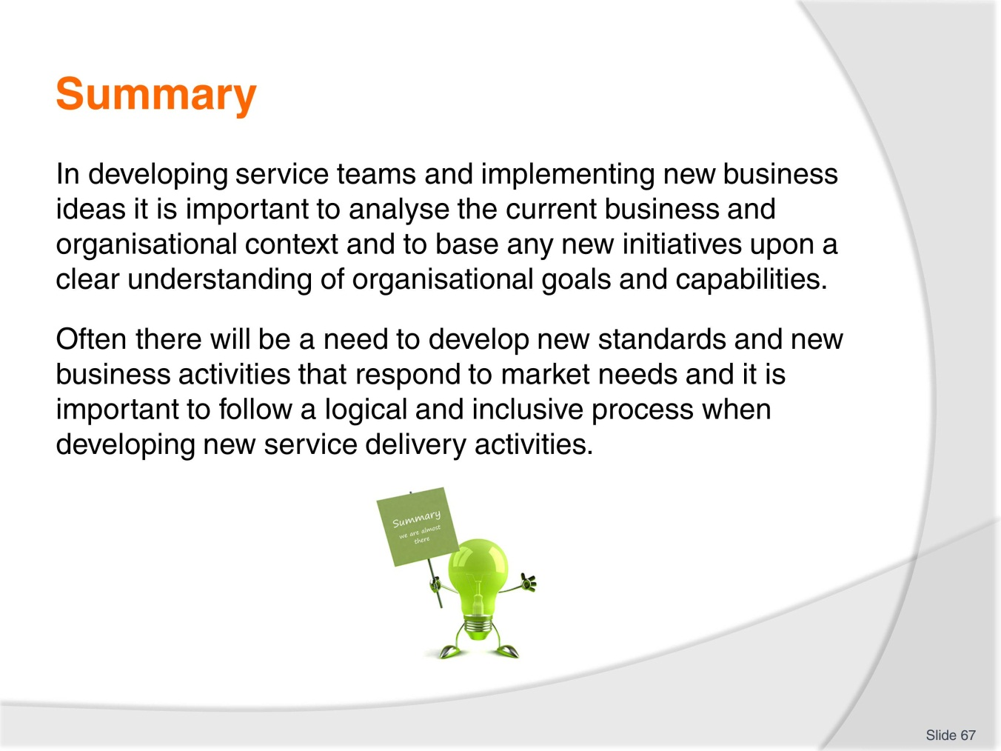
Slide No | Trainer Notes
 | Trainer elicits concepts and ideas from the element. Trainees ask for clarification or provide extra ideas.

Slide
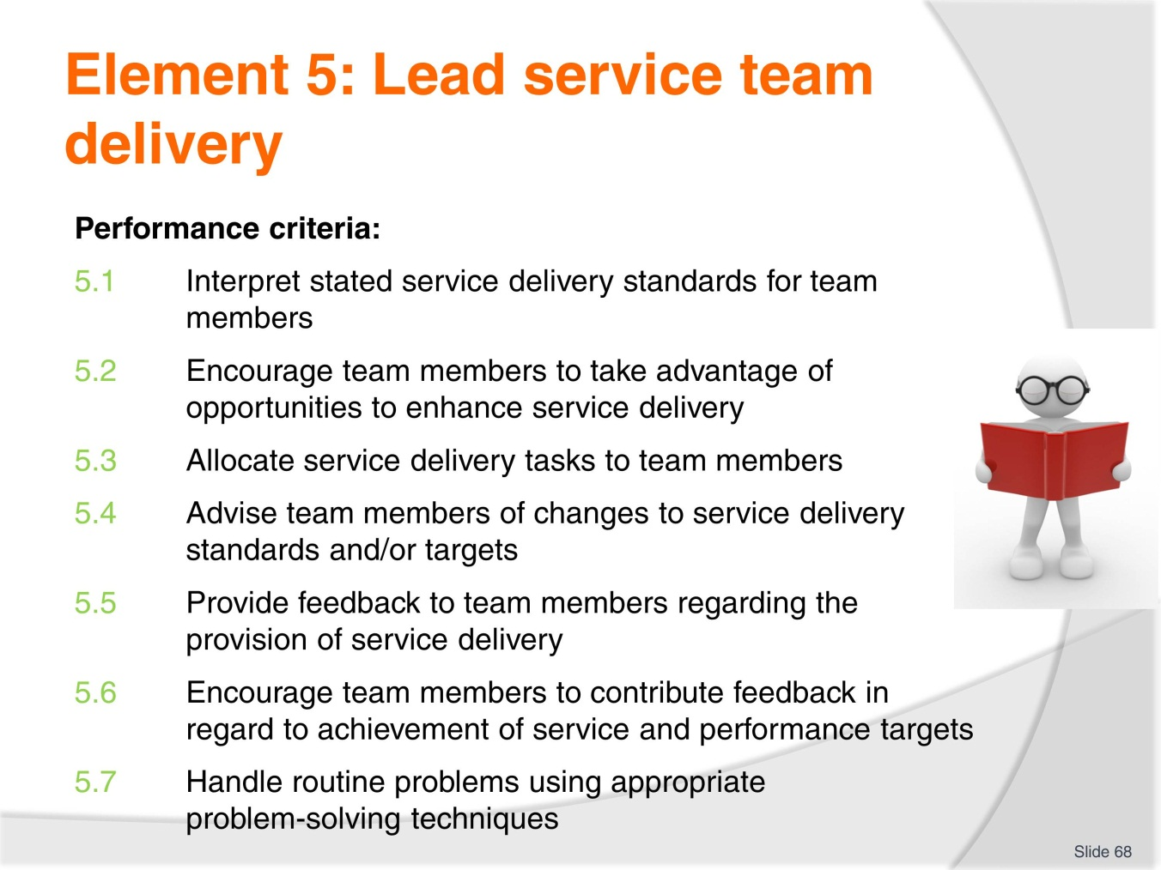
Slide No | Trainer Notes
Trainer introduces element and explains work project requirements.
Trainer can introduce a leadership questionnaire as a warm-up activity. There are many available online: http://www.sagepub.com/northouseintro2e/study/resources/questionnaires/89527_03q.pdf

Slide
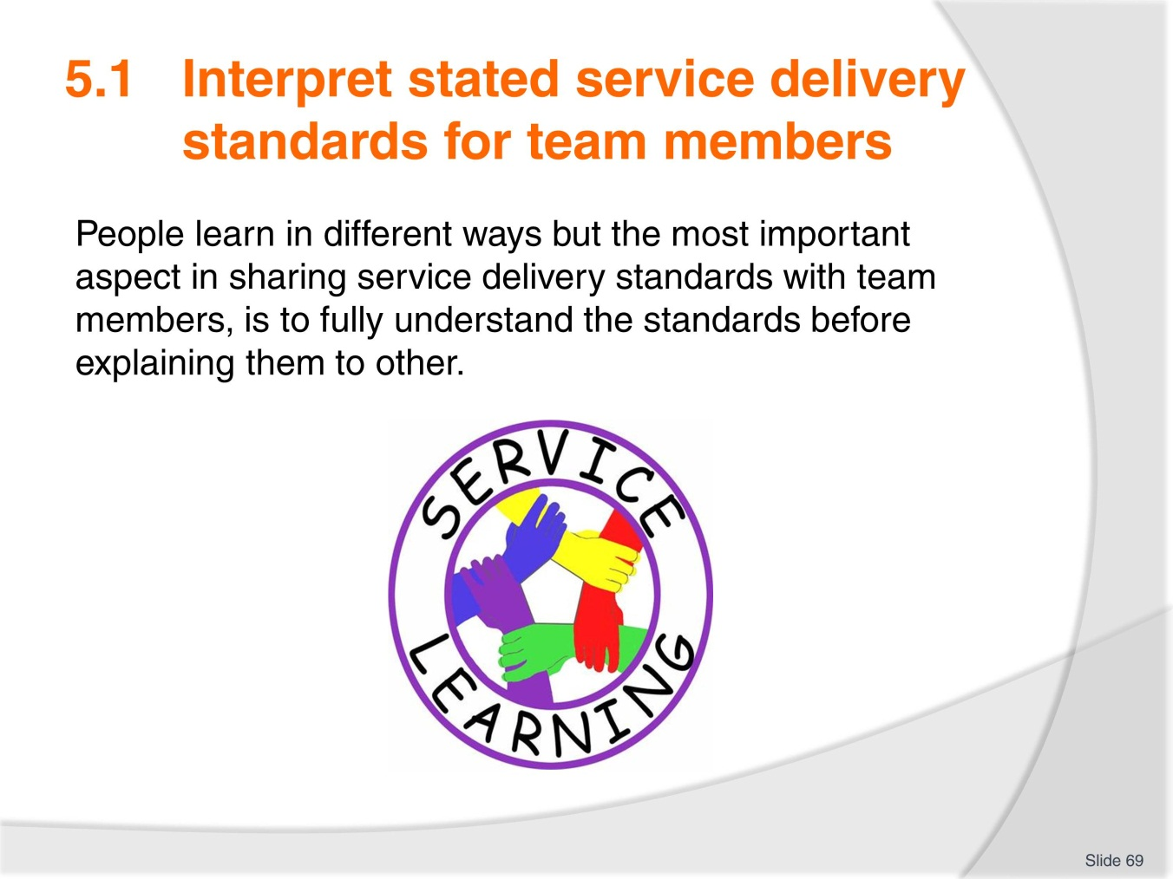
Slide No | Trainer Notes
Trainer can explore learning styles and ask trainees to identify their dominant learning styles. Ask, how can this affect team leadership and interpreting service delivery standards? Answer: through identification of team member strengths and weaknesses.
http://www.educationplanner.org/students/self-assessments/learning-styles.shtml
Trainer brings/or asks trainees to bring in some examples of service delivery standards and asks trainees to identify the most important parts or aspects of the procedures.
Trainees discuss how they would interpret the standards for training team members.
Trainees read through example in TM.
Trainer reminds trainees of work project and due date.
5.1 Provide an example of a service standard or operating procedure and explain how you would present the item to your team. You could provide a lesson plan, a video of you delivering a training session, a power point presentation or a verbal explanation to your trainer.

Slide
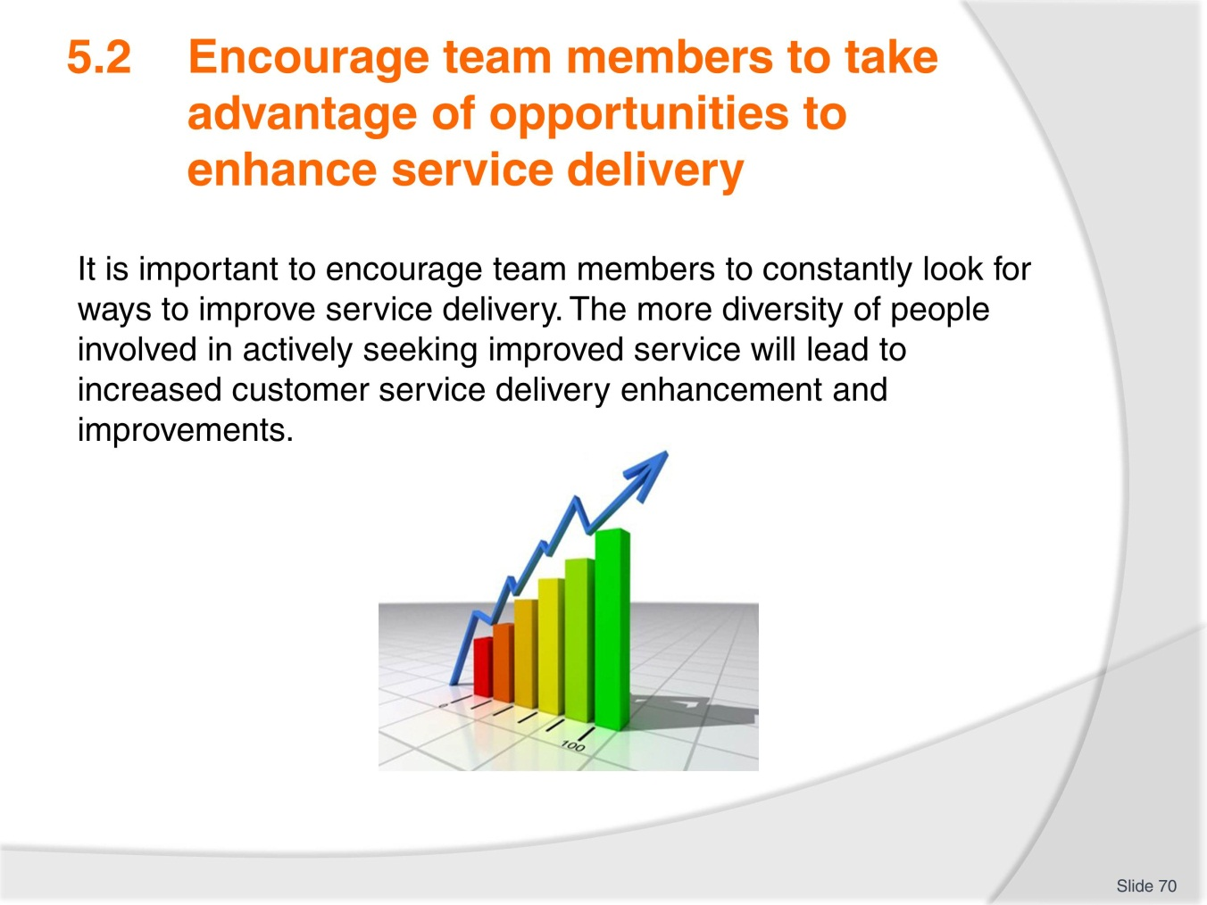
Slide No | Trainer Notes
Trainer presents the slide and explains that continual improvement is a necessary part of service delivery.
With so many changes in the workplace environment it is necessary to identify areas for improvement constantly.
Trainer asks students to identify any ideas that they have suggested to improve service delivery in their workplace. Trainees discuss with the class.

Slide
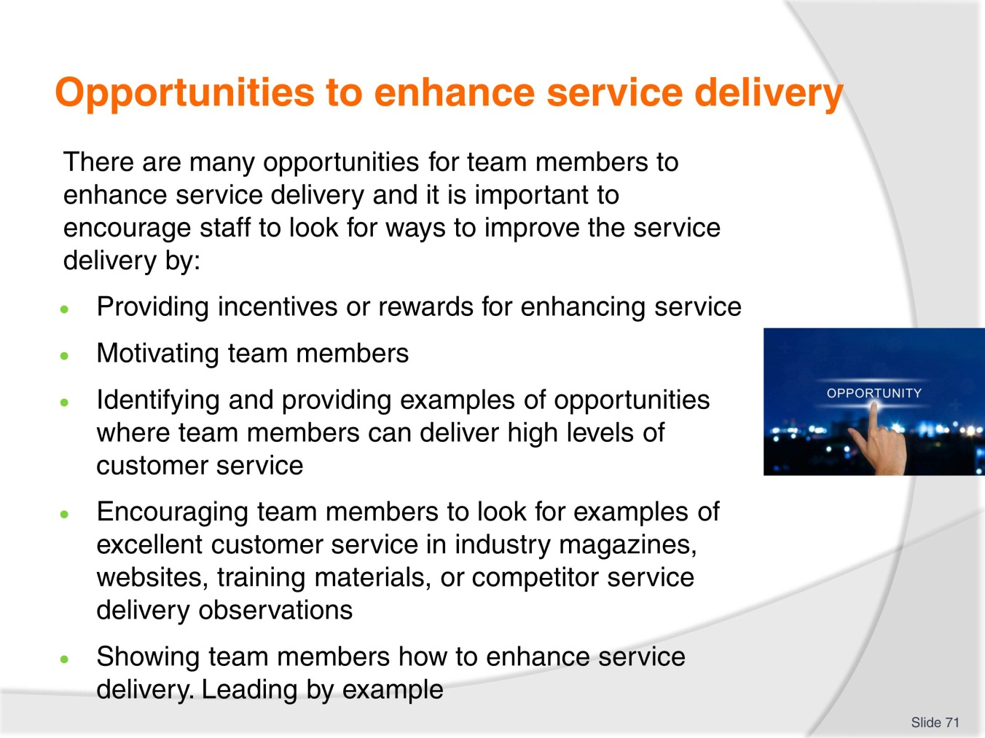
Slide No | Trainer Notes
Trainer uses the slide and TM information to explain ways to implement suggestions and improvements for service delivery.
Trainees identify aspects of improvement that they have seen or implemented in the workplace.
Trainees discuss in small groups service teams that they have been involved with that were successful or unsuccessful at implementing improvements.
How do trainees support other team members in implementing improvements to service delivery?
Trainer reminds trainee of work project and due date.
5.2. Provide your trainer with three examples of information or materials that you have researched from the internet, competitor service delivery, industry magazines, industry associations or internal feedback surveys, which have assisted in improving service delivery within your service team.

Slide
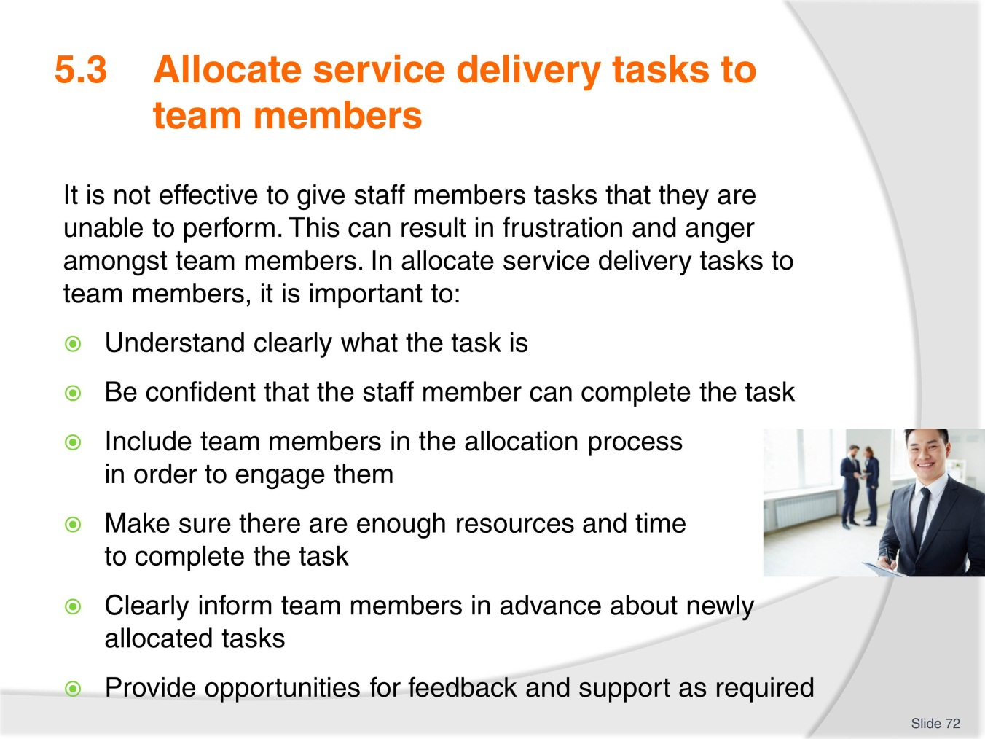
Slide No | Trainer Notes
Trainer explains that in order to effectively allocate service delivery tasks to team members, there must be a good understanding of individual members’ skills and attributes.
Some team members may enjoy doing certain service delivery than others so it is important to match the team member to the service delivery task that they enjoy, are good at, or want to try.
Sometimes it is an effective strategy to change team member service delivery tasks in order to motivate them and challenge them.
Trainer presents slide to the class and trainees discuss how teams are allocated service delivery tasks in their organisations.
Trainer reminds trainees of work project and due date.
5.3. Provide an example of a spread sheet that shows service delivery activities designated for service team members. This could be a roster, schedule or training/skills matrix.

Slide
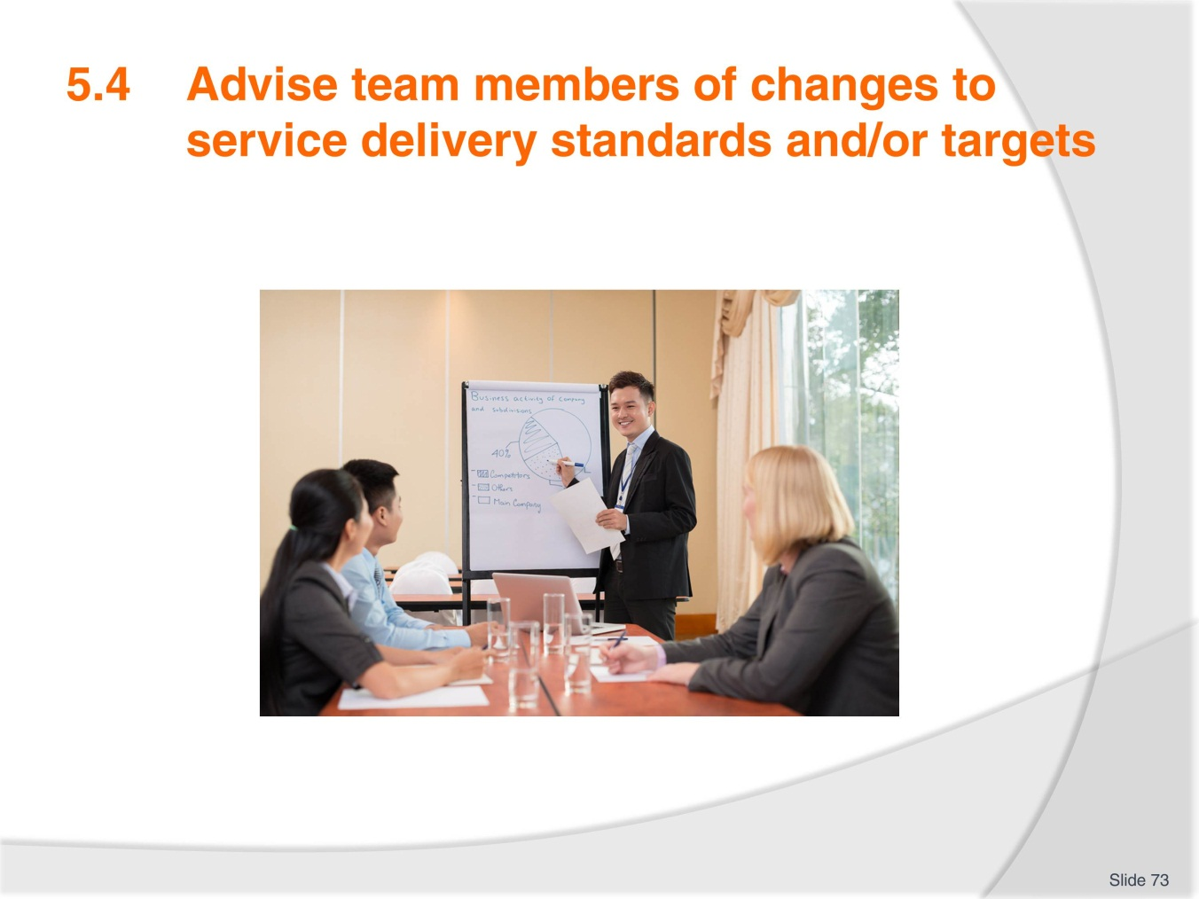
Slide No | Trainer Notes
Trainer explains that communication is an integral part of any successful team and it is important to advise team members when changes occur to service delivery standards or targets.
Changes to service delivery standards may require extra training and this would have to be arranged as well.
The most important task is to ensure that all staff members affected are aware of the changes in order for the team to be able to continue to deliver service at the required standard.
Trainees brainstorm how changes to service standards are communicated in their workplace.

Slide
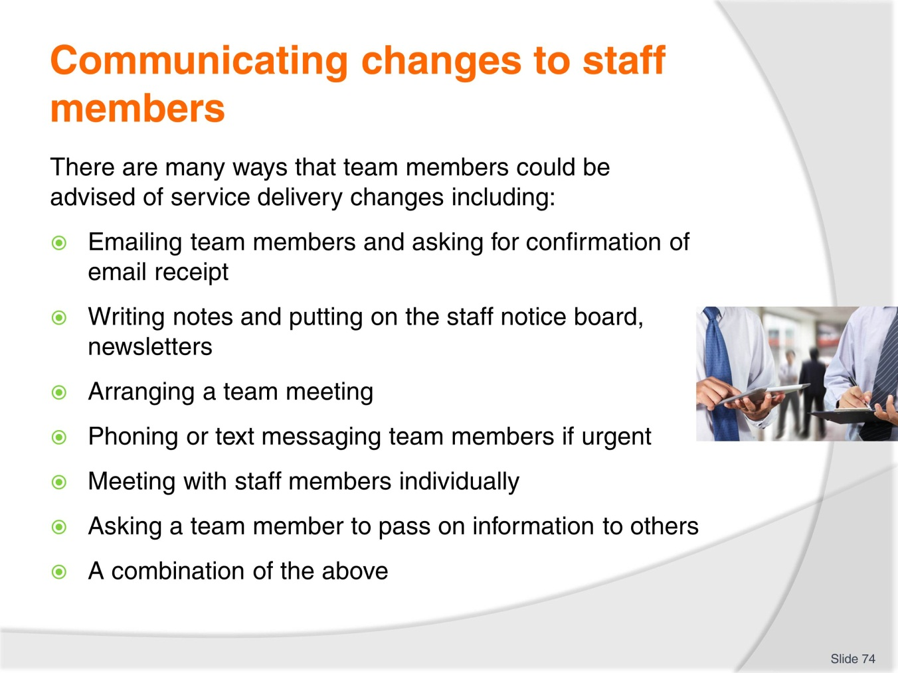
Slide No | Trainer Notes
Trainer goes through the slide with trainees and asks them to identify the most useful ways of communication changes.
Students discuss their ideas regarding communication and provide examples of both effective and ineffective communication.
Trainer could play ‘Chinese Whispers’ where a sentence is given to one trainee and whispered in another trainee’s ear and repeated to other group members. The idea is to show how difficult oral communication can be.
Trainer reminds trainees of work project and due date.
5.4. Provide an example of a memo, email or meeting agenda which outlines changes to service delivery standards.

Slide
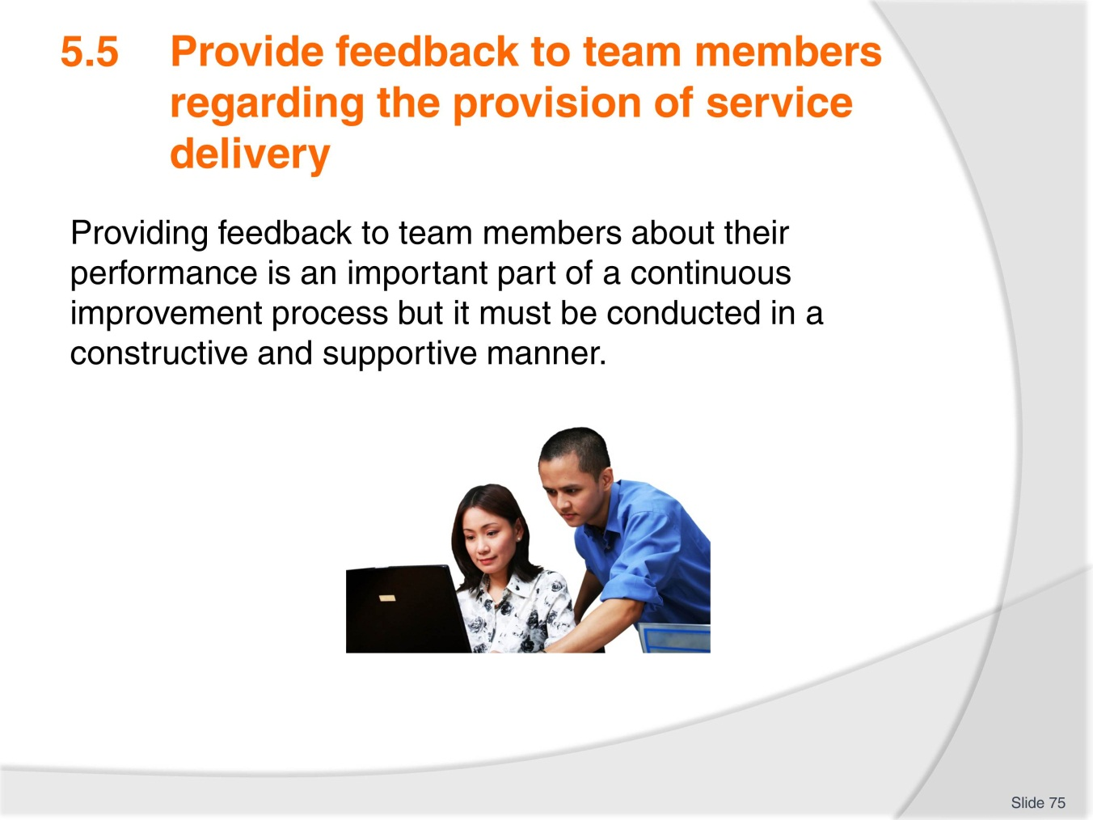
Slide No | Trainer Notes
Trainer introduces the slide.
Trainer asks students how they feel when they receive negative feedback from a customer or staff member. Students discuss in pairs and share with the class.
Trainer asks trainees to write down different forms of feedback that can be given or received in the workplace.

Slide
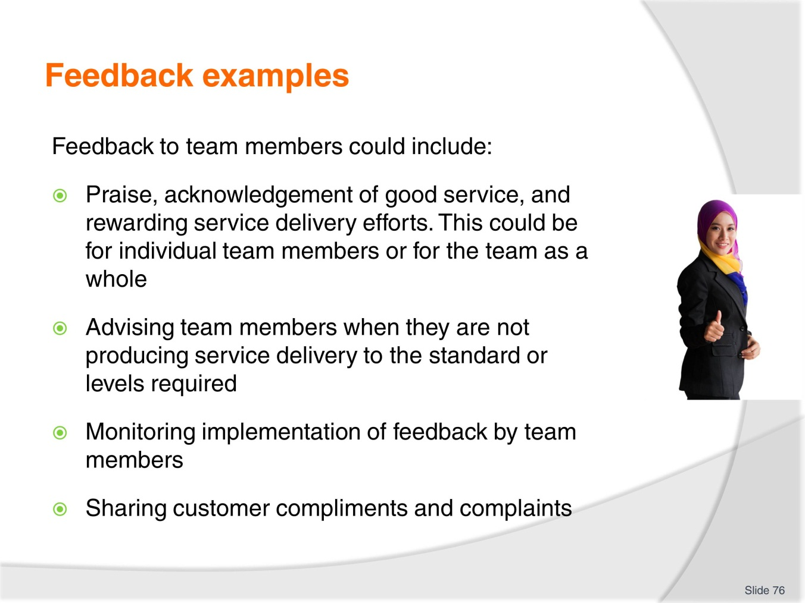
Slide No | Trainer Notes
 | Trainer presents the slide and asks students to discuss feedback they have received that corresponds to examples from the slide.

Slide
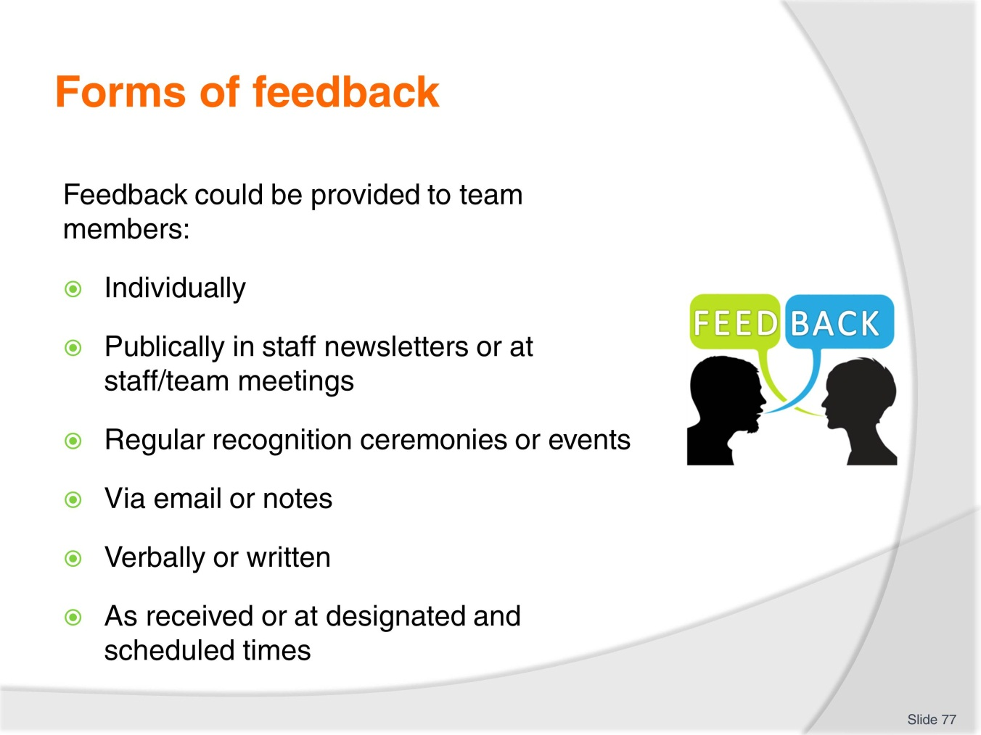
Slide No | Trainer Notes
Trainer asks trainees to describe feedback opportunities in their workplace.
How do they receive complaints or compliments? Is there a reward and recognition program?
There are many examples of feedback techniques online. Trainer can select and introduce to the class: https://www.cabrillo.edu/services/jobs/pdfs/giving-feedback.pdf
Trainer reminds trainees of work project and due date.
5.5 Outline and demonstrate to your trainer an example of when you have provided feedback to a team member about their service delivery performance. Explain what the feedback was, how you delivered the feedback and the response from the team member.

Slide
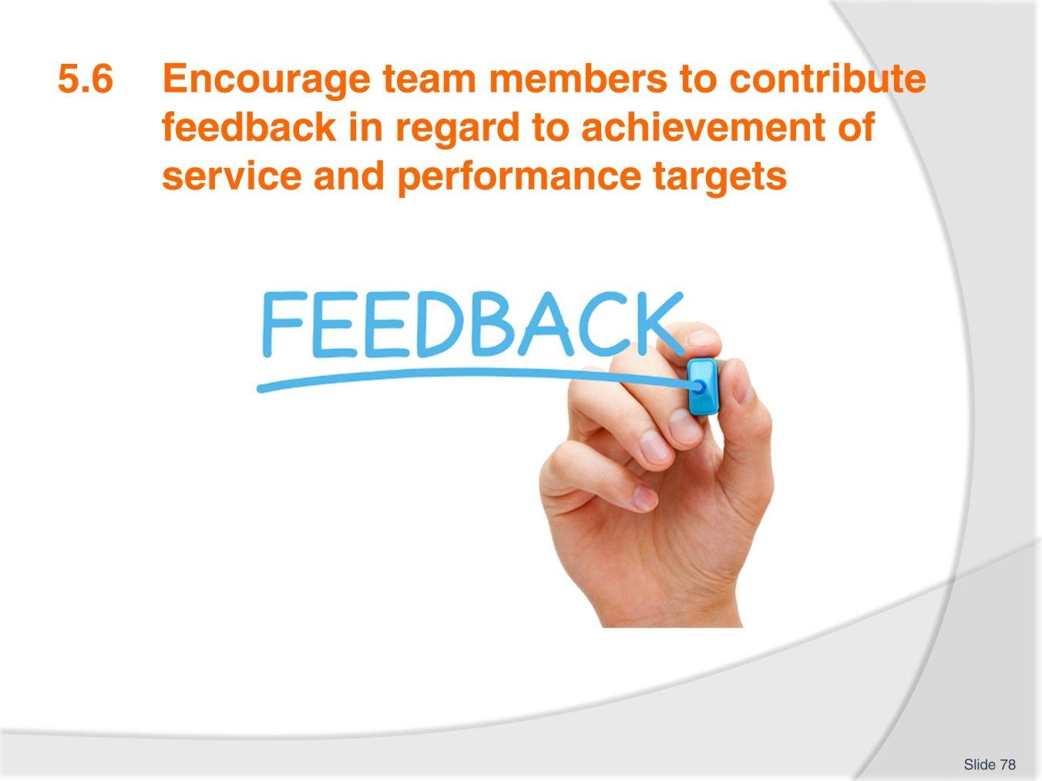
Slide No | Trainer Notes
Trainer explains that in order to obtain honest feedback from team members, it is important to make sure that team members feel confident that their feedback will be listened to and respected otherwise they will not feel comfortable to share their ideas.
It is important to encourage a feedback culture within service delivery teams, where team members are able to openly provide feedback about service delivery issues. This can be encouraged through:
- Organising regular meetings where team members can share ideas, issues and information pertaining to their job tasks
- Showing staff that their feedback is important and respected whether it is negative or positive
- Acting upon feedback received and communicating any actions taken to team members
- Taking feedback to management and supporting team member contributions.

Slide
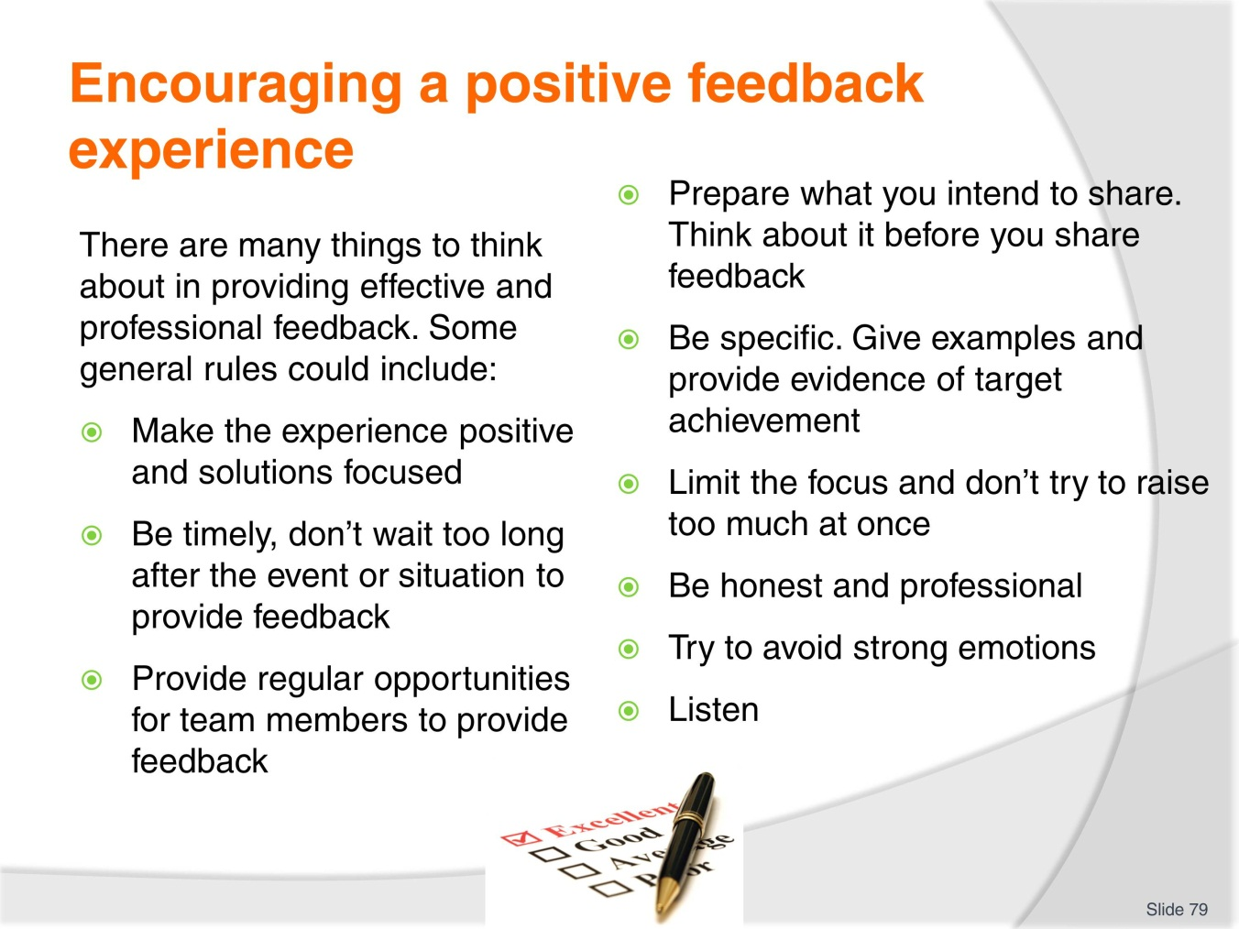
Slide No | Trainer Notes
Trainer presents slides and trainees decide which the most important points in giving feedback are.
Trainees discuss examples when they have provided feedback about service delivery in the workplace or as a customer. What are some potential challenges when providing feedback?
Trainer reminds trainees of work project and due date.
5.6 Provide your trainer with three examples of feedback collected from team members regarding service delivery. These could be emails, letters, notes, records of discussions or meeting notes.

Slide
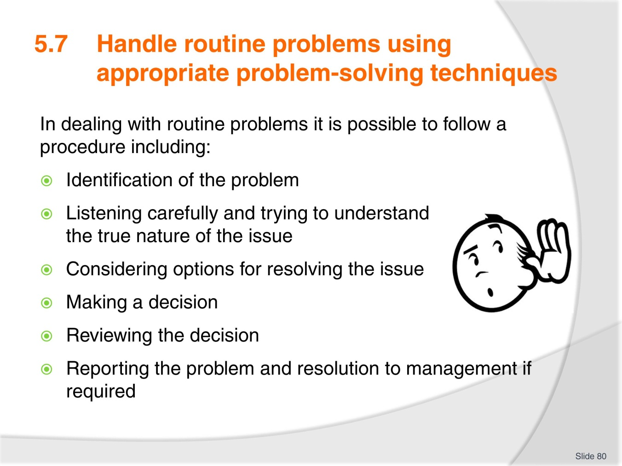
Slide No | Trainer Notes
Trainer presents the slide and asks students to discuss in small groups problems that they have experienced in service delivery and what they did to address the issues.
Could they solve the problem on their own or did they need support?

Slide
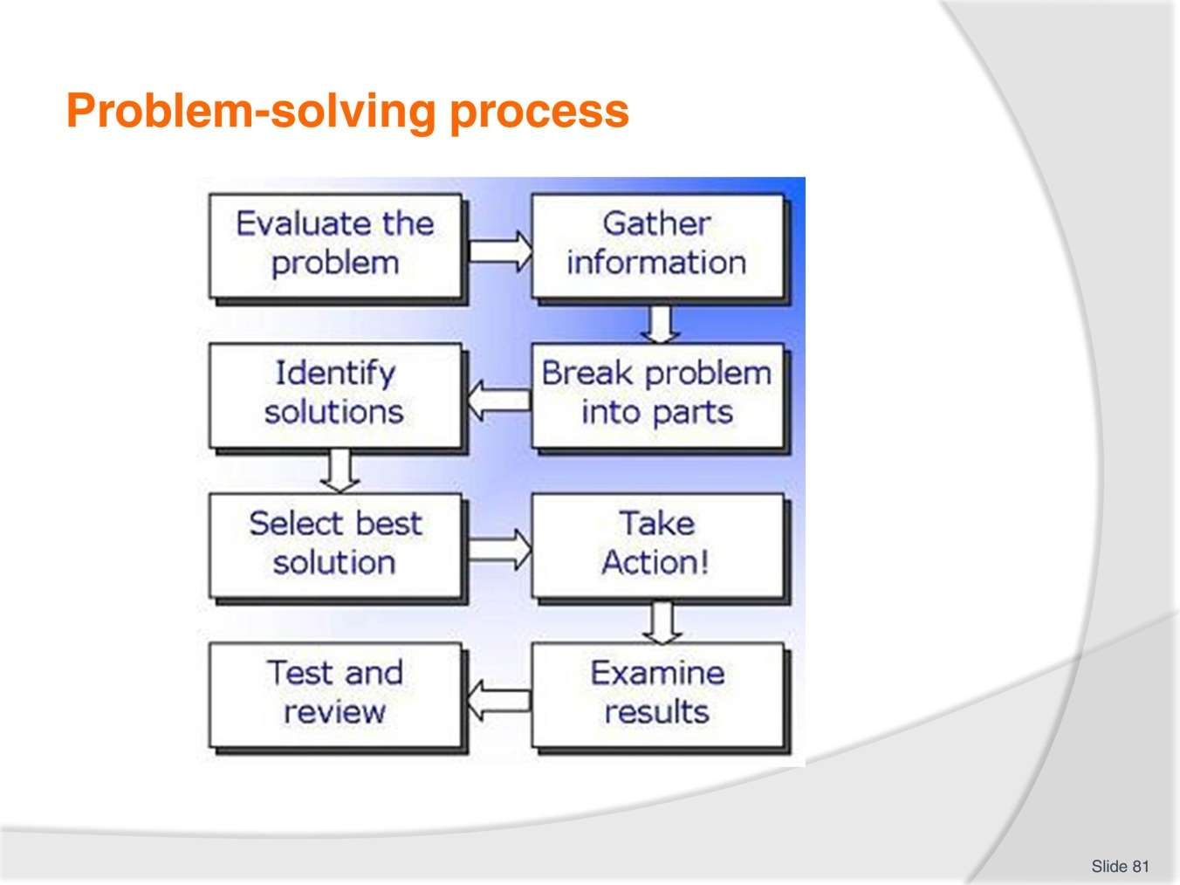
Slide No | Trainer Notes
Trainer presents the problem solving process and trainees describe if they follow a similar process.
Trainer can bring or ask trainees for examples of problems and other trainees describe how they would solve them.
Trainer presents some problem-solving activities for the class: there are some good examples online such as: http://www.learningforlife.org/exploring-resources/99-720/x09.pdf
Trainer reminds trainees of work project and due date.
5.7 Provide your trainer with two examples of routine problems that you dealt with at your workplace. Outline the process you employed to deal with the problems and the result of any actions taken.

Recommended training equipment
Sample documentation:
- Complaints/compliments examples
- Customer feedback surveys
- Staff roster
- Training records
- Training lesson plans for service delivery standards
- Skill’s assessment records
- Service delivery budget
- Meeting notes
- Meeting agenda
- Service delivery standard examples
- Operating manual
- Policies and procedures examples
- Email examples of service standard changes
- Organisation communication’s plan
Equipment:
- Computer
- Projector
- Speakers
- Internet access

Instructions for Trainers for using
PowerPoint – Presenter View
Connect your laptop or computer to your projector equipment as per manufacturers’ instructions.
In PowerPoint, on the Slide Show menu, click Set up Show.
Under Multiple monitors, select the Show Presenter View check box.
In the Display slide show on list, click the monitor you want the slide show presentation to appear on.
Source: http://office.microsoft.com
Note:
In Presenter View:
You see your notes and have full control of the presentation
Your trainees only see the slide projected on to the screen
More Information
You can obtain more information on how to use PowerPoint from the Microsoft Online Help Centre, available at: http://office.microsoft.com/training/training.aspx?AssetID=RC011298761033
Note Regarding Currency of URLs
Please note that where references have been made to URLs in these training resources trainers will need to verify that the resource or document referred to is still current on the internet. Trainers should endeavour, where possible, to source similar alternative examples of material where it is found that either the website or the document in question is no longer available online.

Appendix – ASEAN acronyms
AADCP | ASEAN – Australia Development Cooperation Program
ACCSTP | ASEAN Common Competency Standards for Tourism Professionals
AEC | ASEAN Economic Community
AMS | ASEAN Member States
ASEAN | Association of Southeast Asian Nations
ASEC | ASEAN Secretariat
ATM | ASEAN Tourism Ministers
ATPMC | ASEAN Tourism Professionals Monitoring Committee
ATPRS | ASEAN Tourism Professional Registration System
ATFTMD | ASEAN Task Force on Tourism Manpower Development
CATC | Common ASEAN Tourism Curriculum
MRA | Mutual Recognition Arrangement
MTCO | Mekong Tourism Coordinating office
NTO | National Tourism Organisation
NTPB | National Tourism Professional Board
RQFSRS | Regional Qualifications Framework and Skills Recognition System
TPCB | Tourism Professional Certification Board





